GEF-6 REQUEST FOR PROJECT ENDORSEMENT/APPROVAL
Project Type: Medium Sized Project
Type of Trust Fund: GEF Trust Fund
For more information about GEF, visit TheGEF.org


PART I: PROJECT INFORMATION
Project Title: Leapfrogging Chilean’s markets to more efficient refrigerator and freezers
Country(ies): | Chile | GEF Project ID: |  | 9496
GEF Agency(ies): | UN Environment | GEF Agency Project ID: |  | 01357
Other Executing Partner(s): | Fundación Chile, Ministry of Energy | Resubmission Date: |  | November 15, 2017
GEF Focal Area (s): | Climate Change | Project Duration (Months) |  | 36
Integrated Approach Pilot | IAP-Cities IAP-Commodities IAP-Food Security |  | Corporate Program: SGP
Name of Parent Program | Global: LF Leapfrogging Markets to High Efficiency Products (Appliances, including Lighting, and Electrical Equipment) (PROGRAM) | Agency Fee ($) |  | 132,638

Focal Area Strategy Framework and Other Program Strategies

Focal Area Objectives/Programs | Focal Area Outcomes | Trust Fund | (in $)
Focal Area Objectives/Programs | Focal Area Outcomes | Trust Fund | GEF Project Financing | Co-financing
CCM-1: Promote Innovation, Technology Transfer, and Supportive Policies and Strategies  Program 1: Promote the timely development, demonstration, and financing of low-carbon technologies and mitigation options | Outcome A. Accelerated adoption of innovative technologies and management practices for Greenhouse Gases (GHG) emission reduction and carbon sequestration  Indicator 4. Deployment of low GHG technologies and  Practices  Outcome B. Policy, planning and regulatory frameworks  foster accelerated low GHG development and emissions  mitigation  Indicator 5. Degree of support for low GHG development in the policy, planning and regulatory framework | GEFTF | 1,473,762 | 7,411,551
Total project costs |  |  | 1,473,762 | 7,411,551

Project Description Summary

Project Objective:

Accelerating transformation of Chile’s markets to more energy efficient (EE) residential refrigerators/freezers thereby achieving reduction of GHG emissions and contributing to improved energy access and energy security.
Project Components/  Programs | Financing Type | Project Outcomes | Project Outputs | Trust Fund | (in $)
 |  |  |  |  | GEF Project Financing | Confirmed Co-financing
1. Revising regulatory mechanisms, including minimum energy performance standards (MEPS) | TA | 1. Accelerated transformation of the market for Energy Efficient (EE) residential refrigerators/freezers via implementation of advanced MEPS and EE labels in line with international best practices and provision of associated capacity building | 1.1: National MEPS and EE Labels for refrigerators updated and implementation plan developed | GEFTF | 106,334 | 1,572,551
2. Enhancing monitoring, verification, and enforcement (MVE) | TA | 2. Actors comply with improved MVE labeling regulations, testing protocols and measurements methodologies to ensure residential refrigerators/freezers meet improved efficiency levels. | 2.1: MVE scheme assessed and improvements documented to ensure products’ compliance with EE labels and MEPS  2.2: National laboratories strengthened to verify compliance with updated standards and protocols  2.3: Monitoring and verification procedures and methodology to measure energy savings from the removal of old-but-operable refrigerators from service developed | GEFTF | 283,853 | 823,000
3.Developing supporting policies | TA | 3. Enhanced awareness among consumers (by gender) and market players in Chile to understand, afford, and purchase EE refrigerators/freezers | 3.1: Communication campaign developed and its impact evaluated to increase user acceptance and understanding of high efficiency products and updated labeling and MEPS, taking gender-sensitive perspective into account | GEFTF | 446,341 | 1,806,000
 | INV |  | 3.2: Replacement demonstration programmes on energy efficient refrigerators implemented in the residential sector | GEFTF | 160,000 | 1,822,000
4.Enhancing environmentally sound management | TA | 4. Voluntary implementation of the national framework for environmentally sound management of refrigerators/freezers started | 4.1: Strategy proposal for a national framework and an environmentally sound management of refrigerators/freezers developed and communicated to local stakeholders  4.2: Awareness raising and communication campaigns to promote collection and recycling of refrigerators conducted  4.3: Collection and Recycling Service Organization (CRSO) business model for spent refrigerators developed starting below voluntary scheme, including potential international coordination for the environmentally sound export/import of refrigerators waste/ refrigerant gas proposed/adopted | GEFTF | 351,299 | 1,283,000
Subtotal |  |  |  | GEFTF | 1,347,827 | 7,306,551
Project Management Cost (PMC) |  |  |  | GEFTF | 125,935 | 105,000
Total project costs |  |  |  | GEFTF | 1,473,762 | 7,411,551

Confirmed Sources of Co-financing for the Project by Name and by Type
Please include evidence for co-financing for the project with this form.
Sources of Co-financing | Name of Co-financier | Type of Cofinancing | Amount ($)
Government Contribution | Ministry of Energy | In-kind | 2,000,000
Government Contribution | Ministry of Environment | In-kind | 555,000
Government Contribution | Superintendence of Electricity and Fuels (SEC) | In-kind | 252,000
NGO | Fundación Chile | In-kind | 250,000
GEF Implementing Agency | UN Environment | In-kind | 50,000
Private Sector | Samsung | In-kind | 500,000
Private Sector | MABE | In-kind | 850,000
Private Sector | Whirlpool | In-kind | 100,000
Private Sector | Intertek | In-kind | 300,000
Private Sector | CESMEC | In-kind | 297,591
Private Sector | Lenor | In-kind | 22,000
Private Sector | MIDAS Chile Recycling | In-kind | 1,700,000
Private Sector | Regener Chile | In-kind | 240,000
Private Sector | ASHRAE | In-kind | 294,960
Total Co-financing |  |  | 7,411,551

Trust Fund Resources Requested by Agency(ies), Country(ies), Focal Area and the Programming of Funds
GEF Agency | Trust Fund | Country  Name/Global | Focal Area | Programming of Funds | (in $)
 |  |  |  |  | GEF  Project  Financing (a) | Agency Fee^{(*)}  (b) | Total  (c)=(a)+(b)
UN Environment | GEFTF | Chile | Climate Change |  | 1,473,762 | 132,638 | 1,606,400
Total Grant Resources |  |  |  |  | 1,473,762 | 132,638 | 1,606,400

(*) Refer to the Fee Policy for GEF Partner Agencies

Project’s Target Contributions to Global Environmental Benefits
Provide the expected project targets as appropriate.
Corporate Results | Replenishment Targets | Project Targets
- Maintain globally significant biodiversity and the ecosystem goods and services that it provides to society | Improved management of landscapes and seascapes covering 300 million hectares | hectares
- Sustainable land management in production systems (agriculture, rangelands, and forest landscapes) | 120 million hectares under sustainable land management | hectares
- Promotion of collective management of transboundary water systems and implementation of the full range of policy, legal, and institutional reforms and investments contributing to sustainable use and maintenance of ecosystem services | Water-food-ecosystems security and conjunctive management of surface and groundwater in at least 10 freshwater basins; | Number of freshwater basins
 | 20% of globally over-exploited fisheries (by volume) moved to more sustainable levels | Percent of fisheries, by volume
- 4. Support to transformational shifts towards a low-emission and resilient development path | 750 million tons of CO_{2e} mitigated (include both Direct and Consequential) | 7,495,660 metric tons CO_{2e}
- Increase in phase-out, disposal and reduction of releases of POPs, ODS, mercury and other chemicals of global concern | Disposal of 80,000 tons of POPs (PCB, obsolete pesticides) | metric tons
 | Reduction of 1000 tons of Mercury | metric tons
 | Phase-out of 303.44 tons of ODP (HCFC) | ODP tons
- Enhance capacity of countries to implement MEAs (multilateral environmental agreements) and mainstream into national and sub-national policy, planning financial and legal frameworks | Development and sectoral planning frameworks integrate measurable targets drawn from the MEAs in at least 10 countries | Number of Countries:
 | Functional environmental information systems are established to support decision-making in at least 10 countries | Number of Countries:

Does the Project include a “Non-grant” Instrument?
(If non-grant instruments are used, provide an indicative calendar of expected reflows to your Agency and to the GEF/LDCF/SCCF/CBIT Trust Fund) in Annex D.
N/A

PART II: PROJECT JUSTIFICATION

A.0. Describe any changes in alignment with the project design with the original PIF

The project design is fully in line with the original PIF. Outputs were not stated at the PIF stage and have been designed at the preparation phase through a consultation process. In addition some minor changes have been introduced in the wording of outcomes and in the budget, guided by new data and information collected in the project preparation phase with inputs and suggestions provided by public information and relevant stakeholders, as summarized in the Table A.0.1 below.

Table A.0.1 Summary of the changes in the project design and the original PIF

Original PIF | Changes proposed at  CEO Endorsement | Rational for changes
Objective | Project Objective: Accelerating transformation of Chile's markets to more energy efficient residential refrigerators/freezers thereby achieving reduction of GHG emissions and contributing to improved energy access and energy security. | Slight revision of the project objective stated has been proposed (see highlights in Italic) to better reflect the envisaged impact of the project on market transformation and its ancillary sustainable development benefits.
Outcomes | Outcomes 3.2 and 3.3 in the original PIF have been merged into one Outcome 3.2 (INV) “Successful replacement model for inefficient refrigerators demonstrated” | Outcome 3.2 will provide various incentives to consumers in order to encourage investment in more EE appliances thus essentially helping to overcome the barrier related to the higher initial purchase price of the product.
 | Outcomes 4.1 and 4.2 in the original PIF have been merged into one Outcome 4. “Strategy proposal for a national framework and an environmentally sound management of refrigerators/freezers developed and communicated to local stakeholders and implementation began in on a voluntary basis” | Outcome 4. will take account of government delays in enabling regulations for Extended Producer Responsibility Act (in place from June 2016) supporting the Ministry of Environment in prioritize refrigerators and accelerate regulations. Additionally, support for implementing voluntary replacement programs including CRSO schemes.
Co-financing | Co-financing at PIF stage has been tentatively estimated at USD 7.5 million and included mainly co-financing from the Government (USD 2.5 million) refrigerators manufacturers (USD 4.5 million), as well as partner NGOs and GEF Agency (USD 0.5 million). | As a result of stakeholder consultation at PPG stage, the following changes have been made:  a) Co-financing from public entities has been slightly increased from USD 2.5 million to USD 2.8 million thanks to a more active participation of Superintendence of Electricity and Fuels in the project;  b) Cofinancing from refrigerators manufacturers has been decreased from USD 4.7 million to USD 1.45 million. This is largely due to delay in enforcing mandatory policies as envisaged in the Energy Efficiency Act and Extended Producer Responsibility Act. This reduces interest of private manufacturers and increases the supporting public initiatives from Ministries and Superintendence. This is also due to the fact that one of the key private actors in the market for internal reasons is not able to confirm specific amount of co-financing though is interested in participating in the project, as per letter included at the end of Annex L.  c) To overcome the shortfall in expected co-financing, new private sector partners were identified and were involved in the consultation process. As a result, the number of private sector partners with confirmed co-financing has been increased from 3 (at PIF) up to 9 (at CEO endorsement stage). Such diversity of private actors contributing to co-finance shows the strong commitment of many local stakeholders including laboratories, manufacturers, recycling companies.  d) One of the co-financers can only commit the budget for one year, but is willing to renew its commitment every year.  All in all, the total amount of co-finance remain only marginally changed, i.e. 7,411,551 USD; however the range and type of commitments has been expanded contributing to overall sustainability and ownership of the project by various market stakeholders.
Global environmental benefits | At PIF approval, annual CO2 Emissions to be avoided by 2030 due to increased energy efficiency of refrigerators have been estimated at 620,000 tCO2e through a reduced demand of energy consumption based on the United for Efficiency (U4E) Country Assessment using CLASP‘s and LBNL's Policy Analysis Modeling System (PAMS) to forecast the impacts from implementing policies that improve the energy efficiency of new household air conditioners and refrigerators. | At CEO Endorsement, GHG emission reduction benefits have been assessed using relevant GEF-STAP guidance, including direct and post-project direct, as well as consequential GHG emission reductions. Also, an agreement regarding distribution of global environmental benefits between Global and Child projects have been taken into account. Consequently, the following results have been obtained, which are much higher than the original total estimates at PIF:  Direct: 547,462 tCO_{2e}  Post-project direct: 3,093,088 tCO_{2e}  Consequential: 12,355 tCO_{2e} (bottom-up) and 3,855,109 tCO_{2e} (top-down)
Executing Agency | The Ministry of Energy has delegated the Execution of the project to Fundacion Chile. | This is requested by the Ministry in a letter to UN Environment (see letter in Annex H, page 99). The Ministry has used the same approach than for the GEF project “Delivering the transition to energy efficient lighting in Chile” which is currently being executed by Fundacion Chile.

A.1. Project Description.

1) Baseline scenario or any associated baseline projects
  - Summary of national energy situation

- Chile has an installed capacity of 23,360 MW (See Table 1). In 2016, the power matrix was composed of large-scale hydropower (26.7%), thermal generation, mainly coal, natural gas and diesel (57.1%) and non-conventional renewable energy (NCRE) (16.2%).

Table 1 Chile's Electricity Market: Installed Capacity and Power Generation

Great North Interconnected System (SING)  Installed capacity: 4,405 MW  Max. Demand: 2,162 MW  Generation: 17.6TWh  Thermal Generation: 100%  Population: 6%  Emission factor: 0.73 MWh/tCO2e | Central Interconnected System (SIC)  Installed capacity: 16,011 MW  Max. Demand: 6,881 MW  Generation: 52.2TWh  G. Hydro: 45% - 65%  Population: 92%  Emission factor: 0.38MWh/tCO2e | Aysen Region System  (SEA)  Installed capacity: 52.3 MW  Max. Demand: 26 MW  Generation: 155GWh  Population: 1% | Magellan Region System  (SEM)  Installed capacity: 102 MW  Max. Demand: 53 MW  Generation: 297GWh  Population: 1%

- Taking into account expected economic and population growth trends, according to the National Energy Strategy 2012-2030 electricity consumption is expected to grow by approximately 7% per year, implying that Chile needs to add over 8 GW of new electricity generation by 2020 in order to be able to meet expected energy demand increases. This would be a huge undertaking. Chile is predominantly an importer of energy resources; significant variations in fossil fuels prices in recent years resulted in an increase of the marginal costs of energy generation and, consequently, higher electricity prices. To reduce reliance on imported energy sources, while being able to meet future power demand, the Government has redesigned terms of reference of public bids for regulated clients, enacted the New Law of Electric Transmission, and is committed to reduce energy demand by 20%, as well as increase NCRE-based generation up to 20% by 2025.

- Residential sector is responsible for 17% of national electricity consumption. Refrigerators are responsible for the largest share of residential power demand (29% or 516.3 KWh/y), as illustrated in Figure 1. As incomes have risen, household appliances have become an essential part of the lives of practically all citizens – women and men, across all age categories, regions, and income levels: annual sales of refrigerators have been constantly growing, i.e. from 394,675 to 472,449 units/year or by 20% in the period 2007 to 2012, and the stock is expected to increase by around 2% per year between now and 2030. Major market players are national brands Fensa and Mademsa (made in Chile by Electrolux) and international brands: Samsung, LG and Daewoo.

Figure 1 Residential electricity consumption

Source: Estudio de usos finales y curva de oferta de la conservación de la energía en el sector residencial, Ministerio de Energía, 2010

- Average specific energy consumption of refrigerators has decreased by approximately 4%/year (from 31.96 kWh/month in 2007 down to 23.83 kWh/month in 2012) as driven by technological innovations and thanks to the National Energy Efficiency Labelling Program started in 2007 and the introduction of the Minimum Energy Performance Standards (MEPS) in 2015. These policies while did allow to quickly influence the sales of new appliances, could not influence the large stock of installed fridges with lifetime of 15 years and more. Therefore, additional efforts are needed to promote and accelerate replacement of old refrigerators to achieve larger energy savings and GHG emission reduction, as well as to avoid the need for additional investments in new power infrastructure to utilities. Accelerated replacement of old inefficient refrigerators could also bring additionally economic benefits for low income families and other vulnerable groups of population. Currently, an average monthly electricity bill (180kWh) varies between Ch$ 19,344 (29 USD) in Santiago and Ch$ 36,159 (54 USD) in Linares (279 km southern of Santiago), so the monthly cost of operating a refrigerator is about Ch$ 5,611 - Ch$10,486 (8 USD – 16 USD) per household, which represent 2 to 4 % of the poor households’ income.

  - Summary of policies and strategies promoting energy efficient refrigerator and freezers

b.1. Key Policies
Energy 2050 is the key national energy policy document which formulates a vision of Chile's energy sector by the year 2050 as being reliable, inclusive, competitive and sustainable. This vision is part of a systemic approach in which the main goal is to achieve and maintain the reliability of the entire energy system while meeting sustainability and inclusion criteria and contributing to the competitiveness of the nation’s economy. It is sustained by four pillars: Quality and Security of Supply, Energy as a Driver of Development, Environmentally-friendly Energy, and Energy Efficiency and Energy Education. In reference to energy efficiency, the policy states that 100% of the main categories of appliances and equipment sold in the market will correspond to energy efficient equipment.

- Energy Agenda (2014) established a number of policy goals and targets, including inter alia, fostering the efficient use of energy as an energy resource, and achieving 20% energy savings or a total of 20,000 GWh/year by the year 2025.

- Innovation, Productivity and Increasing Agenda 2014-2018 was established by the Ministry of Economy for moving the country economy from one based on natural resources to one more sophisticated economy. Refrigerators are one of the strongest industries in the extremely open market Chilean economy. The Chilean refrigerators industry generates 2,000 jobs and is currently exporting to Andes region (Peru, Bolivia, Ecuador, Paraguay, Uruguay and Colombia), which can directly and indirectly help neighboring countries (today most of them without mandatory quality certifications and energy efficiency labels) to move to more efficient products supplied from Chile.

- Energy and Gender Agenda, launched in March 2017 by the Ministry of Energy, envisages four areas of work: promotion and empowerment of women, providing support to women entrepreneurship and innovation; design and implementation of energy policy, establishing a gender clause in agreements, contracts and terms of reference, along with participation in the design of policies; strengthening of women capacities in the energy field; and access to goods and services offered, focusing and subsidizing, disseminating and sensitizing around the gender variable through workshops and seminars.

- Management Plan for hydro chlorofluorocarbons (HCFC) phase-out in Chile (2012-2030), in the context of the Montreal Protocol, Chile supports the process of phasing out chlorofluorocarbons (CFC) gases and HCFC gases. The national plan sets two phases. The first, between 2011 and 2015, established activities to reduce the consumption of HCFCs in the refrigeration sector, with the support of regulatory aspects and public dissemination. Afterwards, between 2015 and 2030, reduction and phase-out activities are being implemented for the consumption of HCFCs in the refrigeration, air conditioning and foam sectors, with regulation support and public dissemination measures.

- HFC Kigali amendment of Montreal Protocol. Chile should freeze its HFC consumption at the level of its baseline, starting in 2024, and then reach 10% reductions by the year 2029. The reduction targets increase to reach 80% by the year 2045. The problem of HFCs in Chile arises from the progressive reduction of HCFCs in the country given the commitments made in the context of the Montreal Protocol, which has led to a substantial increase in the use of HFCs in recent years. This increase was confirmed in the Elaboration of National Hydrofluorocarbon Inventory (May 2017). Chile is a partner of the Climate and Clean Air Colition (CCAC), an initiative launched in 2012 by the United Nations Environment Programme (UN Environment) and a group of countries, to exercise a Collective action to reduce Short Life Pollutants (SLCPs) such as black carbon, methane and HFCs. In this context, one implementing experience of transcritical CO2 refrigeration in a supermarket in the Valdivia city has taken place.

b.2. Relevant EE Laws, Regulations and Programmes

- The Energy Efficiency Act aims to achieve a total savings of 20,000 GWh/year by 2025. The design of the law was made through a process lead by University of Chile with participation of all national stakeholders on 2015.This act was originally scheduled to enter Congress by the end of 2015 and has not yet had legislative priority. It is expected that the next government (2018-2021) would give a higher priority and present the law again to the National Congress for approval. Nevertheless two regulations that could include energy efficiency benefits has been prioritized, they are: the Norma técnica de calidad de servicios para sistemas de distribución (products, supply and commercial quality) and the Norma Técnica sobre Servicios Complementarios Decree 130 of 2011.

- The Extended Producer Responsibility Act (No.20920) was published on June 1st, 2016. This Act makes producers directly responsible for collection, recovery and disposal of their products, which includes refrigerators as one of the priority areas. The Ministry of Environment has to put in place corresponding supreme decrees with specific and detailed regulations enabling the law application by mid-2017. In the meantime, the Ministry may require producers to report annually through the Register of Emissions and Transfers of Contaminants, the following: a) Number of priority products marketed in the country during the immediately preceding year. b) Collection, recovery and disposal activities carried out in the same period and their cost. c) Quantity of waste collected, recovered and disposed of during said period d) Indication of whether the management for collection and recovery activities is individual or collective. The information must be delivered for the first time within a maximum period of June 2017.

- Implementation of Energy efficiency labeling and Minimum Energy Performance Standards (MEPS) started in Chile in 2005 within the framework of the Energy Efficiency National Program (PPEE). This effort was institutionalized in early 2010 with the creation of the Division of Energy Efficiency at the Ministry of Energy focused on policy development, and the Chilean Energy Efficiency Agency (AChEE) focused on implementation of policies. In the framework of the PPEE, Fundación Chile with support from CORFO (Corporación de Fomento de la Producción) created the Chilean Energy Efficiency Standards and Labeling Program (Programa Nacional de Etiquetado de Eficiencia Energética en Chile – PEEE) in 2005 as a strategic activity, including:

- A regulatory framework, which defines: (i) the requirements for development, adoption and application of technical regulations and procedures for conformity evaluation, (ii) the certification systems and procedures for electrical products, and (iii) the authority of the Superintendence for Electricity and Fuels (Superintendencia de Electricidad y Combustibles – SEC) to authorize and supervise the certification and inspection bodies, testing laboratories and certification procedures;
- International energy efficiency testing procedures have been adopted as Chilean Standards (Normas Chilenas – NCh) for a range of appliances and equipment;

- Today, there is a robust EE labeling program, administered by SEC, with the following characteristics (see also Table 2):

- Mandatory EE labeling has been implemented for incandescent lamps; self-ballasted compact fluorescent lamps (CFLs); single-capped and double-capped fluorescent lamps; refrigerators, freezers and refrigerator-freezers; three-phase electric motors; and microwave ovens; stand-by (music equipment, Televisions, DVD players) and room air-conditioners.
- Mandatory labeling is under consideration for household clothes washers; gas cookers, as well as halogen and LED (Light Emitting Diode) lamps (for domestic and general uses)

Table 2 Existing labeling standards for refrigerators and freezers

Product | Date | Energy efficiency standard | Safety standard
Refrigerators and freezers  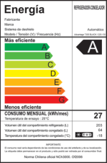 | Refrigerators – freezers 2 doors  31.05.2007  Refrigerators 1 door  31.08.2007  Freezers  30.11.2007 | IEC 62552:2007-12  Household refrigerating appliances - Characteristics and test methods | IEC 60335  Household and similar electrical appliances - Safety - Part 2-24: Particular requirements for refrigerating appliances, ice-cream appliances and ice makers
NCh 3000 2006 Energy Efficiency – refrigerators, freezers and refrigerators-freezers for domestic use– Classification and labelling

PE 1/17/2 2006
Protocol defining the procedure for refrigerators, freezers and refrigerators-freezers certification of performance and energy efficiency labelling

- Mandatory energy efficiency labels for refrigerators have been effective in moving the market for refrigerators from 3 to 39 models in Class A++, from 12 to 112 models in Class A+, from 75 to 106 models in Class A, from 88 to 52 models in Class B, from 12 to 3 models in Class C, while Classes D to G were moved to zero models in 2012. As a result, over 80% of the models sold annually in Chile have label A or higher.

- In addition, MEPS for refrigerators and freezers have been implemented, as follows:
- MEPS regulation (Res 74/2014) for refrigerators provides certificates only to refrigerators with Class B, A, A+, A++ since April 1st, 2015 and became more strict by providing certificates only to refrigerators with Class A, A+, A++ from July 1st, 2016;
- MEPS regulation (Res 74/2014) for freezers provide certificates only to freezers with Class B, A, A+, A++ from January 1st, 2016, and became more strict by providing certificates only to freezers with Class A, A+, A++ from January 1st, 2017;
- Decree DTO 97/2012 approved the regulation and procedures for establishing MEPS and it created a Technical Committee (TC) aiming to evaluate the results of the public consultation stage. This TC will assess the necessity of improving MEPS and Energy Efficiency labels starting in mid-2017.

- To complement EE labels and MEPS policies, a number of PR and communication programmes have been implemented by various Ministries (See Figure 2), including:
- Ministry of Energy and Ministry of Housing and Urbanism have made general public campaigns to raise awareness of energy efficiency. The messages conveyed the importance of selecting high energy efficient refrigerators and comprehension of energy efficient behavior as shown in the images below. However, this campaign has been rather generic in nature and didn’t specifically focused on the benefits of EE refrigerators and how to select them. Key performance indicators of this campaigns are presented in terms of number of publications in newspapers, digital media and TV and radio appearances, those indicators could be completed with number of people by gender reached and better understanding level and changes produced in behaviors of citizens;
- Ministry of Energy is actively promoting the access, capacity building and participation of women in energy sector, after recognizing that this sector is one of those “that presents the greatest gender inequality in our country” said Minister Andrés Rebolledo.

Figure 2 Examples of PR and Communication campaigns

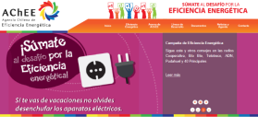 | 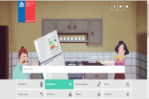
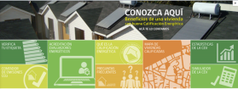 | 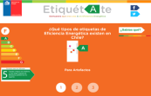

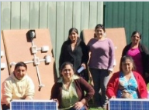 |  | 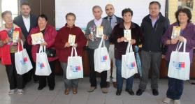

b.4. Other initiatives

- There is also an initiative named Top-Ten Chile, which is a tool and digital platform that allows consumers to access information about some products, such as energy consumption, and then compare their prices and energy consumption to the most inefficient models. Thus, the user can choose and have a properly informed purchasing decision. The presence of "Top-Ten Chile" leads to a major transformation of the market where both companies and consumers, show the energy impact of each product through the delivery of real and reliable data that will increase progressively over time: appliances, electronics, lighting and vehicles, among others.

2) Global environmental problems, root causes and barriers that need to be addressed
a. GHG emissions in Chile and international commitments on climate change

- Chile’s total GHG emissions (2013) amounted to 119 million tCO2eq, an increase by 113% since 1990 and by 19% since 2010. More than 77% of total GHG emissions in 2013 came from the energy sector (85 million tCO2eq), this represents an increase by 156% since 1990 and 22.5% since 2010. This is mainly due to the increase in energy consumption, including the consumption of coal and natural gas for electricity generation and consumption of liquid fuels, mostly diesel and gasoline, for road transportation. Energy Industries (electricity and heat production) were the leading source of GHG emissions with 45.3%, followed by 28.9% from Transport (mainly road transportation), 16.8% from Manufacturing industries and construction, and 8.0% derives from other sectors (mainly Residential).

- According to U4E Savings assessment for Chile, potential for annual energy saving and GHG emission reduction from application of minimum energy performance standards in line with international benchmarks will account for 5 TWh or 2.4 million tCO2eq for 2030 specifically or cumulatively by 21.72 million tCO2eq between 2020-2030. Residential refrigerators represent the second largest, after lighting, end-user sub-sector with significant potential for energy saving and GHG emission reduction (See Table 3).

Table 3 Potential energy saving and GHG emission reduction in Chile from application of MEPS consistent with international benchmarks

Equipment/Appliance Type | Energy savings (TWh) in 2030 | Avoided CO2 emissions (million tonnes) in 2030 | Cumulative CO2 emission reductions, 2020-2030 (million tonnes)
Lighting | 2.1 | 1.0 | 9.33
Residential refrigerators | 1.3 | 0.6 | 3.41
Room air conditioners | 0.5 | 0.2 | 2.78
Distribution transformers | 0.4 | 0.2 | 2.42
Industrial electric motors | 0.7 | 0.4 | 3.78

- Chile´s Intended Nationally Determined Contributions (INDC) was submitted to the UNFCCC in 2015. INDC set the following Carbon Intensity Targets comparing with 2007 baseline level:

- Unconditional target: to reduce national CO2 emissions per Gross Domestic Product by 30% by 2030, and
- Conditional target (subject to receipt of international assistance): to reduce national CO2 emissions per GDP by 35% to 45% by 2030.

b. Barriers to be addressed

b.1 Energy Efficiency Standards and Labels (EE S&L) are not updated and not aligned with international best practices

- The refrigerator/freezers available in the market in Chile have an average energy efficiency index of 50 (class A). Additionally, the number of model per class (82% in classes upper A) in Chile proves that the market is able to respond to more stringent labeling regulations. EE classes of products could be further improved since more efficient products are already being produced and significant efficiency gains have been achieved since EE labeling was introduced in 2012. Those improvements in products efficiency are not, however, reflected in the classification, as is the case, for example, in the European Union were Class A+++ is defined for products with Energy Efficiency Index (EEI) below 20. A+++ class does not exist in the Chilean market, whereas A++ refers to products with Energy Efficiency Index (Iα) below 30 (See Table 4). Further, the Energy Label in the EU is also currently being updated and the adoption of the new global standard (IEC62552) is expected soon. EU is considering removing the "+" signs in order to reduce confusion amongst consumers and removing classes that do not contain products on the market.

Table 4 Energy Efficiency Class and Index in EU and Chile

Energy Efficiency class | Energy Efficiency Index (EU) | Energy Efficiency Index (Chile) | Number of models per class in Chile
A+++ | EEI < 22 | Doesn’t exist | 0
A++ | 22 ≤ EEI < 33 | I_{α} < 30 | 39
A+ | 33 ≤ EEI < 42 | 30 ≤ I_{α} < 42 | 112
A | 42 ≤ EEI < 55 | 42 ≤ I_{α} < 55 | 106
B | 55 ≤ EEI < 75 | 55 ≤ I_{α} < 75 | 52
C | 75 ≤ EEI < 95 | 75 ≤ I_{α} < 90 | 3
D | 95 ≤ EEI < 110 | 90 ≤ I_{α} < 100 | 0
E | 110 ≤ EEI < 125 | 100 ≤ I_{α} < 110 | 0
F | 125 ≤ EEI < 150 | 110 ≤ I_{α} < 125 | 0
G | EEI ≥ 150 | I_{α} ≥ 125 | 0

- Price difference for A and A++ products is not significant either, as illustrated in the Table 5. This fact reinforces the assumption that Chilean market would be ready to respond to more stringent MEPS and updated EE labeling regulation in line with relevant international benchmarks and standards which could drive demand for more EE products and help realize significant additional EE and GHG emission reduction potential. However, Chilean policy makers and regulators currently lack technical knowledge and information on cost, benefits and environmental aspects of more EE refrigeration products, as well as refrigerant gases, which is essential to prepare and justify such revision of MEPS and labeling regulation.

Table 5 Prices of refrigerators in the Chilean market at stores and by internet, May 2017

Manufacturer | Model | Class | Consumption  KWh/month | Volume  (l) | Normal Price  (USD) | Price through Internet  (USD)
Mademsa | Nordik 700INOX | A | 29.5 | 333 | 451 | 436
Daewoo | RGE3300 | A | 30.08 | 317 | 496 | 436
LG | GT31BPP | A+ | 24.17 | 312 | 496 | 406
LG | GT31WPP | A+ | 24.17 | 312 | 571 | 436
LG | GB35SP | A++ | 19.4 | 314 | 902 | 677
Sindelen | RD6500SI | A++ | 13.17 | 240 | 511 | 436

b.2 Deficiencies in the monitoring, verification, and enforcement (MVE)

- The Superintendence of Electricity and Fuels (SEC) is responsible for maintaining the database of certified products (safety and energy efficiency), with information coming from the National Customs Agency and information reported from producers for getting authorization of selling their products in the national market. Data coming from these two sources have to be matched internally in SEC for detecting inconsistencies of products that could be sold with or without accepted certifications. It is important to improve database management and enforcement to avoid the presence on the market of the products without safety and energy efficiency certifications.

- Another critical element of the national MVE infrastructure is the availability of and capacity of testing laboratories and certification bodies. Effective certification of refrigerators in terms of their compliance with advanced MEPS and qualification for new EE labels requires credible testing in laboratories that have proper equipment and training.

- The PPEE is built on appliance labelling mandated by the Ministry of Energy. For more than 10 years, independent test laboratories have been authorized by Superintendence of Electricity and Fuels and accredited by the Instituto Nacional de Normalización for undertaking these tests to measure energy use and performance of appliances and to confirm the accuracy of comparative efficiency labels attached to those appliances. If the government is requiring suppliers to improve the energy efficiency of their products, it is important to transparently demonstrate the capacity of testing laboratories to accurately measure compliance with the new regulatory requirements. The Testing Labs (3) and Certification Bodies (6) accredited by the National Standard Agency (INN) and authorized by Superintendence of Electricity and Fuels (SEC) for offering services on energy efficiency to manufacturers and importers of refrigerators and freezers are summarized in the Table 6. Even though testing labs and certification bodies have been investing in their production base, their capacities fall short of the market needs in view of growing demand for refrigerators and freezers certifications; also the quality of their services is highly uneven and has to be checked by a third independent party to assure the accuracy and consistency of measurements. As a temporarily measure to address shortcomings in testing lab capacities, the SEC issued Legal Resolution No. 2145 in 2013 which extended for 12 months the validity of the originally issued Energy Efficiency Certificates for refrigerators and freezers. Capacity strengthening is urgently required to ensure the effective and timely implementation of advanced MEPS and EE labeling policy.

- Last time the Interlaboratory Test was executed by the Laboratorio Custodio Patrón Nacional de Magnitudes Eléctricas (LCPN-ME) back in 2012. In the process, a Daewoo RFD-320W refrigerator-freezer was sent to each participating laboratory (CESMEC (CTI), CYC, INGCER, SILAB/SICAL y LENOR) to perform the tests indicated in the LCPN-ME SEC 2012 protocol. In this protocol the most relevant were the useful volume measurement and the energy consumption test, both key parameters to determine the Energy Efficiency class, also requested in the protocol. Almost one year of work delivered classes A+, A and B for the same sample. Lack of technical teams’ experience with such testing has been the primary reason for delay. Argentinian Lab (LENOR) received the highest technical level comparing to the Chilean labs participating in the test. There is no regularly established system of interlaboratory testing and it is needed to ensure that all testing laboratories have sufficient capacities to deliver services required by the market in line with international quality standards.

Table 6 List of Certification Bodies and Testing Labs accredited by INN and authorized by SEC
Certification Bodies | Testing Labs | Protocol on EE | Standard on EE
SICAL  Accredited by INN Authorized by SEC R.E.1556 19.11.2007 | SILAB  Accredited by INN Authorized by SEC R.E.1554 19.11.2007 | PE_1_17_2 12.05.2015 | IEC 62552:2007-12 NCh 3000:2006
LENOR  Accredited by INN Authorized by SEC R.E.570 26.03.2009 | LENOR Argentina | PE_1_17_2 12.05.2015 | IEC 62552:2007-12 NCh 3000:2006
INGCER  Accredited by INN Authorized by SEC R.E.2172 20.11.2009 | INGCER  Accredited by INN Authorized by SEC R.E.2171 20.11.2009 | PE_1_17_2 12.05.2015 | IEC 62552:2007-12 NCh 3000:2006
N/A | FARADAY  Accredited by INN Authorized by SEC R.E.1964 21.07.2011 | PE_1_17_2 12.05.2015 | IEC 62552:2007-12 NCh 3000:2006
CESMEC  Accredited by INN Authorized by SEC R.E.1553 19.11.2007 | N/A | PE 1-17-2  26-11-2013 | IEC 62552:2007-12  NCh3000.Of2006
TUV Rheinland  Accredited by INN Authorized by SEC R.E.0335 14.02.2013 | N/A | PE 1-17-2  26-11-2013 | IEC 62552:2007-12  NCh3000.Of2006
Energia Ltda  Accredited by INN Authorized by SEC R.E.3187 17.11.2011 | N/A | PE 1-17-2  26-11-2013 | IEC 62552:2007-12  NCh3000.Of2006

b.3 Insufficient consumer awareness about EE labels and appliances

- Insufficient awareness among consumers and other market stakeholders about EE refrigerators and freezers, in particular about EE labeling is also an important barrier. Despite campaigns in the past, surveys have shown that there is still a need to educate consumers and to support role of sellers as to how to read and interpret the information provided on the energy label, especially the relation class level and KWh/month. In particular, individual consumers are not fully aware of the benefits of efficient refrigerators over its lifetime; they don’t have information and can’t assess potential annual electricity bill savings resulting from the purchase of more EE product. Women, as primary users of refrigerators and often decision-makers regarding household purchases, have not been specifically targeted by the campaigns; their specific needs and situation will have to be taken into account in the design of similar campaigns in the future.

- The “Qualitative Study Energy Efficiency Labeling of Refrigerators and Light bulbs Perception of its use, assessment and understanding of Information by sales agents and consumers” was developed by the National Consumers Agency (SERNAC) and it conclude that:
- Classification letter (A-B-C ... etc.) reported in the label is decoded by buyers as efficiency in expenditure, it is believed that a refrigerator A, saves more energy or consumes less than one B and so on. The letters are decoded intuitively, A or A + as the best and G as the least efficient or most energy consuming. That is, the efficiency is homologated to electrical consumption.
- The consumption information kWh / month is not understood, only absolute numbers are compared between refrigerators and it is expected that the A will have less consumption than the B and so on. It is the sellers who show a greater management and control of this information on consumption and make the calculation to the consumer multiplying the price according to commune energy price by the number of consumption indicated in the label.
- Sellers consider that they have an adequate handling of 'important' information for them in the label.
- Information about manufacturer, brand, deicing system, model, useful volume and temperature is not considered because it is available in the refrigerator or on the product description of commercial houses, however.

- In addition, to actively promote and accelerate transformation of refrigerator market, more specific awareness raising and communication work is needed to target and promote expedited replacement of existing large stock of old inefficient refrigerators (estimated at 7.7 millions) with a lifetime of fifteen years or so.

b.4 Inadequate system and capacity for environmentally sound waste management

- Chilean system for appliances’ waste management is very underdeveloped. There exist only a few points of appliances collection and a few companies disassembling and recycling residential refrigerators and freezers. Statistics regarding quantity of residential refrigerators and freezers reused, disassembled, cumulated, or abandoned do not exist. It is estimated that just 1.4% of total waste is recovered. There is no estimate of the degree of informality in the domestic market of recyclers of large and small household appliances, it is estimated from interviews to the sector that the percentage of informal recyclers is high. There is also a lack of information regarding the amount of equipment illegally disposed in landfills as well as regarding the amount of refrigerant gases released to the atmosphere. Only two small recycling companies are offering their services for disassembling and recycling refrigerators/freezers but the market is limited, mainly due to the absence of a legal and accountability framework for management of such waste. Also, there is no local solution for final disposition of refrigerants gases. Although, the legal framework (in the form of the Extended Producer Responsibility Act) does exist, regulations and by-laws enabling its practical implementation are lacking and will have to be developed and enforced to ensure that producers are directly responsible for collection, recovery and disposal of their products, in particular refrigerators. Neither, there are specific regulations in place regarding sustainable management of refrigerators residues, in particular gas recovery. In addition to the abscense of the legal framework in Chile, the sales price of the recycled products is very low compared to the cost of production. Therefore, to recycle refrigerators in Chile is not yet cost-effective as it is in Europe for instance and will not be an incentive for recycling companies. The project aims to contribute to raise the value of recycling components and make viable and operational the sound management and recycling of refrigerators and freezers products.

3) Proposed alternative scenario

- Recognizing the value of energy efficiency standards and labels (EE S&L), as well as the need to accelerate implementation more broadly worldwide, in 2014 UN Environment and a wide array of partners created a new global initiative called United for Efficiency (U4E), to support developing countries in moving their markets toward EE appliances and equipment. Building upon UN Environment’s highly successful global en.lighten program for lighting, U4E compiles global best practices in policy guides and offers tailored assistance to governments via expert task forces for the development and implementation of EESL. This project is one of several “child projects” of a global U4E program, funded by the GEF, entitled Leapfrogging Markets to High Efficiency Products (Appliances, Including Lighting, and Electrical Equipment). The project taps U4E’s core strengths – its global network of experts, private-sector collaborators, and compiled best practices – in policy and program development as well as quantitative assessment.

- The objective of the project is to accelerate transformation of Chile’s markets to more EE residential refrigerators/freezers thereby achieving reduction of GHG emissions and contributing to improved energy access and energy security. The project seeks to achieve five main outcomes:
- Accelerated transformation of the market for EE residential refrigerators/freezers via implementation of advanced MEPS and EE labels in line with international best practices and provision of associated capacity building.
- Actors comply with improved MVE labeling regulations, testing protocols and measurements methodologies to ensure residential refrigerators/freezers meet improved efficiency levels.
- Enhanced awareness among consumers and market players in Chile to understand, afford, and purchase EE refrigerators/freezers
- Successful replacement model for inefficient refrigerators
- Strategy proposal for a national framework and an environmentally sound management of refrigerators/freezers developed and communicated to local stakeholders and implementation began in a voluntary bases

- In order to achieve the desired outcomes and address barriers, the project consists of integrated activities placed under the four components, as detailed in Table 7. In addition, the project will conduct dedicated monitoring and evaluation (M&E) activities under all four components and the project overall.

Table 7 Alternative scenario: components, barriers, outcomes

Project Component | Barrier to be addressed | Intended Outcome
1. Revising regulatory mechanisms, including minimum energy performance standards (MEPS) | EE labels and MEPS are not updated and not aligned with international best practices | Accelerated transformation of the market for EE residential refrigerators/freezers via implementation of advanced MEPS and EE labels in line with international best practices and provision of associated capacity building
2. Enhancing monitoring, verification, and enforcement (MVE) | Deficiencies in the monitoring, verification, and enforcement (MVE) | Actors comply with improved MVE labeling regulations, testing protocols and measurements methodologies to ensure residential refrigerators/freezers meet improved efficiency levels.
3.Developing supporting policies | Insufficient consumer awareness about EE labels and appliances | Enhanced awareness among consumers and market players in Chile to understand, afford, and purchase EE refrigerators/freezers  Successful replacement model for inefficient refrigerators demonstrated
4. Enhancing environmentally sound management | Inadequate system and capacity for environmentally sound waste management | Strategy proposal for a national framework and an environmentally sound management of refrigerators/freezers developed and communicated to local stakeholders and implementation began on a voluntary basis

Component 1: Revising regulatory mechanisms, including Minimum Energy Performance Standards (MEPS)

In this component a proposal of new energy label classification and MEPS update will be developed supporting activities of Ministry of Energy who is the entity with legal competence for making this mandatory. This component is focused on the need of update energy efficiency labelling to open market opportunities to more efficient refrigerators and increase consumers opportunities of informed purchase.

Outcome 1: Accelerated transformation of the market for EE residential refrigerators/freezers via implementation of advanced MEPS and EE labels in line with international best practices and provision of associated capacity building. To achieve this outcome, the project will work closely with Ministry of Energy, which is the entity with legal authority to adopt such policies, and will conduct activities leading to the following specific outputs.

Output 1.1: National MEPS and EE Labels for refrigerators updated and implementation plan developed
Activity 1.1.1: Carry out market and regulatory framework analysis

- First, the project will develop market and regulatory assessment for establishing the baseline of refrigerators and freezers that are currently being sold in Chile and how the energy efficiency labeling and MEPS regulations has been driving offer and demand.

Activity 1.1.2: Update energy label classification for refrigerators and freezers

- After that and recognizing the space given by new innovative technologies and availability of more efficient products, the labels and MEPS for residential refrigerators and freezers will be updated using as a model more stringent standards, such as the EU standards, allowing for greater energy savings.

Activity 1.1.3: Define new MEPS application/implementation plan

- Modeling tools will be used to establish a cost effective level to set MEPS and to define periodic re-scaling to keep up with technology trends, as Chilean Law defines it. The Ministry of Energy will lead the process and define scopes and times for entry into force. International experience, technical and market data will be the principal added value to the process.

Activity 1.1.4: Carry out gender mapping

- A gender consultant will be hired to undertake a stakeholder mapping study in order to identify gender gaps and any vulnerable population that could be negative or positively impacted by the project. The study will include rapid assessments, structured interviews or observations to provide insights that will help to take into consideration gender and socio-economic aspects for the design of communication campaigns, and the selection of the refrigerator model that will be used for the replacement model.

Component 2: Enhancing monitoring, verification and enforcement (MVE)

- Under this component deficiencies in the existing MVE system will be addressed. First, the project will assess current MVE for EE labels and MEPS in Chile in order to obtain quality information for evaluating impact of policies and regulations (new products offered in the market) and second, improve accuracy of testing labs protocol applications and its results, avoiding wrong classifications. The third aspect will be related to development of methodologies for measuring impact of replacement of old and non-efficient refrigerators campaigns (stock). The barrier addressed in this component is the necessity to improve information quality and the insufficient testing capacities perceived by the refrigerators importers and manufacturers and potentially inaccurate results of applying energy efficiency testing protocols.

Outcome 2: Actors comply with improved MVE labeling regulations, testing protocols and measurements methodologies to ensure residential refrigerators/freezers meet improved efficiency levels. To achieve this outcome, the project will conduct activities leading to the following specific outputs.

Output 2.1: MVE scheme assessed and improvements documented to ensure products’ compliance with EE labels and MEPS
Activity 2.1.1: Develop an assessment on MVE practices in Chile and validate with Ministry of Energy (MoE) and Superintendence of Electricity and Fuels (SEC)

- This activity will include an assessment of current MVE practices in Chile and validation of the findings with MoE and SEC. During the process, the international experts will provide capacity building and technical support to MoE, SEC and Customs. Technological advances such as high EE, natural refrigerants and smart fridges would be included paving the process of the future updating.

Activity 2.1.2: Provide capacity building and technical support to public agencies

- Public agencies (MoE, SEC, Customs, others) will have technical information of efficient products available in the international markets and future innovations coming at level of products, components and control systems, with this information the national authorities will be in a better position to negotiate scope and time of entry into force of new regulations. The information will come mostly, but not only, from Top-ten data base and activities in Chile crossing with data of Top-ten International allowing to compare markets at least between Europe (France) and Chile.

Output 2.2: National laboratories strengthened to verify compliance with updated standards and protocols

Activity 2.2.1: Develop an interlaboratory performance test

- Interlaboratory comparison testing (or round robin test) will be developed to test the same samples by different laboratories and compare results with, in this case, the objective to determine the uncertainty of results, via the determination of the standard deviation of repeatability or reproducibility. So, the repeatability (the ability to obtain the same result on the same machine in the same laboratory) and reproducibility (the ability to obtain the same result on the same machine in a different laboratory) of the various test standards will be tested, below minimized variability requirements to be defined. Authorized and accredited testing laboratories in Chile will be invited to participate but also suppliers testing laboratories could be part of testing process with the same units used in the “round robin”.

Activity 2.2.2: Improve capacities and facilities for refrigeration safety and efficiency test protocols according to international experts recommendations

- The public (and the industry) will be aware of the testing issues through general comments on the possible reasons for the differences in results of measurements done in the interlaboratory procedures and any measures suggested in order to improve labs testing capacities in getting more accurate the results. Detailed comments will be in separated laboratory specific report, which will be available to the participating laboratories.

- The results would be shared (below confidentiality terms) with other stakeholders as part of the process of continually improving public confidence in both appliance labelling and minimum energy performance standards. This support will include training (learning by doing) to testing laboratories delivered by the experts leading interlaboratory activities and focused in filling identified gaps from interlaboratory process.

Output 2.3: Monitoring and verification procedures and methodology to measure energy savings from the removal of old-but-operable refrigerators from service developed

Activity 2.3.1: Improve monitoring and verification procedures and methodology to measure energy savings from the removal of old-but-operable refrigerators from service

- Refrigerator recycling programs are designed to save energy through the removal of old-but-operable refrigerators from service. By offering free pickup, providing incentives, and disseminating information about the operating cost of old refrigerators, these programs are designed to encourage consumers to: discontinue the use of secondary refrigerators, relinquish refrigerators previously used as primary units when they are replaced (rather than keeping the old refrigerator as a secondary unit) and prevent the continued use of old refrigerators in another household through a direct transfer or indirect transfer (resale on the used appliance market).

- The evaluation protocol by a Certified Measurement & Verification Professional (CMVP) will be developed to estimate energy savings from retiring operable-but-inefficient refrigerators. An application of this protocol will be associated with the Replacement demonstration project (under Outcome 3.2)

Component 3: Developing supporting policies

Supporting Policies are necessary to ensure the smooth implementation of EE labels and MEPS and to achieve their broad public acceptance. Most often in the international practice, such supporting policies include information and communication campaigns that inform end-users in order to change or modify their behavior. The envisaged outcomes of this component are related to improved awareness among consumers about EE products and labeling scheme and demonstration of successful replacement model for inefficient refrigerators.

Outcome 3: Enhanced awareness among consumers (by gender) and market players in Chile to understand, afford, and purchase EE refrigerators/freezers

Output 3.1: Communication campaign developed and its impact evaluated to increase user acceptance and understanding of high efficiency products and updated labeling and MEPS, taking gender-sensitive perspective into account

Activity 3.1.1: Design dissemination and communication plan for consumers awareness of the benefits of efficient refrigerators/freezers for increasing active acceptance of new efficient products and awareness of new EE labeling and MEPS

- The project will develop gender sensitive communication campaigns through social networks and public media campaigns to advise end-users of how they can pay less in their electricity bills and reduce CO2 emissions by making the right purchase decision. Awareness will let end-users fully understand the benefits of more efficient products. During the campaign design phase, the project will contact the National Ozone unit in order to exchange information of any coming campaign related to HCFC/HFC thus ensuring alignment with the Montreal Protocol or even assessing potential synergies.

Activity 3.1.2: Implement gender sensitive dissemination and communication campaigns (including specific guide about EE labelling and MEPS) and impact evaluation indicators

- In the framework of Ministry of Energy´s Agenda Energía y Género, specifically under Axis 3, strengthen the capacities of women in the energy field and Axis 4, Inclusion actions aimed at reducing gender gaps dissemination and communication campaigns will be designed and applied.

Activity 3.1.3: Evaluate dissemination and communication campaigns indicators and suggest measures for improving

From the experience of Agencia Chilena de Eficiencia Energética (AChEE) and Ministry of Energy indicators of numbers of publications and appearance in public or specialized media is not enough. It is considered of high relevance to use continuously communication campaigns indicators allowing options for measuring efficacy of used resources an indicators composed by number of citizens reached, behavior changes and investments. Those indicators will be used and shared year by year to improve efficacy and deliver better practices to private companies and public agencies interested.

Output 3.2: Replacement demonstration programmes on energy efficient refrigerators implemented in the residential sector

Activity 3.2.1: Evaluate relevant international experience

- International experience with designing and implementing replacement demonstration programmes will be analyzed and evaluated with a view of drawing lessons and applicable examples for Chile. This research will include an analysis on the different alternatives of financing model, considering the most suitable way to obtain affordable price for consumers, that can be applied in Chile in the design and implementation of the demonstration programme. At least replacement campaigns of México, EEUU and Canada will be analyzed in terms of participants, type of appliances, users and cofinancing or financing models.

Activity 3.2.2: Design and implement demonstration programmes

- The project will design and implement demonstration projects of replacement for consumers to become familiar with benefits of energy efficient refrigerators in conjunction with developing monitoring and verification procedures and methodology to measure energy savings from the removal of old-but-operable refrigerators from service developed (under Output 2.3). Further, the demonstration projects will lay the groundwork for larger future projects conducted by public or private stakeholders. Three areas could be distinguished at this time: i) social replacement project focused on families of lowest incomes, organized and financed with public resource from Ministry of Energy; ii) promotions from manufacturers directly or through retailers as part of their marketing campaigns giving substantial discounts and recovering their margins from increased levels of sales (existing experience of Samsung Chile) and/or iii) distributions utilities companies looking for demand management and reduction of investment (existing experience of Chilquinta). When doing so, MVE protocol to be developed under Component 2 will be used to monitor and evaluate the results.

Component 4: Enhancing environmentally sound management

On June 2016, Law REP was approved; actions of Ministry of Environment are concentrated in developing the Rules for enabling the implementation of the Law. The focus of this component is to get refrigerators as one of the prioritized products, having a high mandatory quota of products recycled and economic and technical feasible model for recycling.

Outcome 4: Voluntary implementation of the national framework for environmentally sound management of refrigerators/freezers started

Output 4.1: Strategy proposal for a national framework and an environmentally sound management of refrigerators/freezers developed and communicated to local stakeholders

Activity 4.1.1: Develop a strategy proposal for an environmentally sound management of refrigerators/freezers including refrigerant gases

- The strategy proposed must be in the legal framework of Law REP (approved on June 1st, 2016) and its rules and probably will must have a voluntary context in the first years until required rules will be in place (estimated for 2019), delivering important technical support for the rules. The work will be made jointly with the Minister of Environment and taking account of international country compromise, as Montreal Protocol and the Kigali Amendment.

Activity 4.1.2: Conduct dissemination to the private sector and key public actors to promote collection and recycling of refrigerators

- The dissemination will be addressed to Municipalities and small recyclers who will have a relevant role in the logistic of collecting old out of use refrigerators and freezers, and final disposal e-waste companies. The objective will be to integrate them under a systemic scheme that could allow to get information today unavailable, because it is an informal market. To design the communication campaign to the consumers, a survey among the target audience will be realized during the first months of the project in order to understand the level of knowledge and awareness of refrigerators recycling.

Output 4.2.: Awareness raising and communication campaigns to promote collection and recycling of refrigerators conducted

Activity 4.2.1: Design, implement, monitor and evaluate communication campaigns for collecting and recycling old refrigerators with best available technologies

- The project will support the adoption of a legal framework on environmentally sound management to safeguard the environment throughout the full lifecycle of the residential refrigerators/freezers. This will be coupled with communication campaigns to inform customers of how to safely dispose of the old refrigerator at the end of its life and refrigerant gases capture and inertization.

Output 4.3: Collection and Recycling Service Organization (CRSO) business model for spent refrigerators developed starting below voluntary scheme, including potential international coordination for the environmentally sound export/import of refrigerators waste/ refrigerant gas proposed/adopted

Activity 4.3.1: Develop CRSO business model for end of life refrigerators able to start below voluntary scheme, including potential international coordination for the environmentally sound export/import of refrigerators waste/ refrigerant gas

- Collection and environmentally sound disposal of old refrigerators will be part of any of this initiative and their costs considered and supported by the new Producer Extended Responsibility Law valid in Chile from June 2016 and future mandatory regulations. Coordinated activities with other initiatives as the “Management plan for the elimination of HCFCs in Chile” will be pursued, especially for potential synergies on refrigerant gases capture solutions.

Activity 4.3.2: Provide training on potential private business models to governmental authorities, retailers and recycling companies

- Technical assistance will be provided for developing the business model jointly with and validated by private companies interested in the business opportunity. It also will be based on the future mandatory regulation and it will be required as economically sustainable without any subsidies. The company who will participate in the business model construction will have the first option of investment, if it refuses to take the option, a Road Show will be organized for identifying who will be the implementer of collecting and recycling of old refrigerators below a voluntary scheme.

4) Incremental/additional cost reasoning
- Barriers, gaps and challenges were mentioned in section II and they are summarized in the table below.

Description of gap or barrier | Results pursued by Ministry of Energy and Ministry of Environment | Outputs expected from GEF support  (incremental reasoning)
Barrier 1: EE labels and MEPS are not updated and not aligned with international best practices
• Need of update energy efficiency labeling and MEPS to open market opportunities to more efficient refrigerators and increase consumers’ opportunities of informed purchase.  • Policy makers, regulators and citizens lack of technical knowledge on cost, benefits and environmental aspects of coming refrigeration products | MEPS and labeling for refrigerators and freezers updated  Market monitoring of sales of refrigerators and freezers products (suppliers, technologies, prices) and measurement of impacts of MEPS; | Strengthen competencies of professional staff at regulatory entities, Ministry of Energy and SEC. Strengthen facilities and capacities of certification entities and testing labs  Output 1.1: National MEPS and EE Labels for refrigerators updated and implementation plan developed
Barrier 2: Deficiencies in the monitoring, verification, and enforcement (MVE)
• Testing labs and certification bodies have been investing for taking the opportunity of demand for refrigerators and freezers certifications, as other appliances. It is necessary to check by a third independent part the accuracy of measurements | Market monitoring of sales of refrigerators and freezers products (suppliers, technologies, prices) and measurement of impacts of MEPS;  Operation of system of monitoring, verification and enforcement (MVE);  Capacity strengthened of SEC, testing laboratories; Harmonization of certification processes with other Latin American countries | Output 2.1: MVE scheme assessed and improvements documented to ensure products’ compliance with EE labels and MEPS  Output 2.2: National laboratories strengthened to verify compliance with updated standards and protocols  Output 2.3: Monitoring and verification procedures and methodology to measure energy savings from the removal of old-but-operable refrigerators from service developed
Barrier 3: Insufficient consumer awareness about EE labels and appliances
• Consumers (residential) are not fully aware of the benefits of efficient refrigerators over its lifetime and do not have more information of potential energy/annual electricity bill savings  • Despite campaigns in the past, surveys have shown that there is still a need to educate consumers and to support role of sellers as to how to read and interpret the information provided on the energy label, especially the relation class level and KWh/month | Pilot projects designed and implemented, replacement with high efficient refrigerators;  Information dissemination campaign (with SERNAC) on energy standards and labeling and new technologies | Supporting policies to increase user acceptance and demand for high efficiency products and systems  Output 3.1: Communication campaign developed and its impact evaluated to increase user acceptance and understanding of high efficiency products and updated labeling and MEPS, taking gender-sensitive perspective into account  Output 3.2: Replacement demonstration programmes on energy efficient refrigerators implemented in the residential sector
Barrier 4: Inadequate system and capacity for environmentally sound waste management
• No control or regulations exist regarding sustainable management of refrigerators residues, in particular gas recovery; No regulations regarding extended responsibility of manufacturers.  • No collection system in place and companies that would be able to process refrigerators waste for recycling and gas recovery  • Lack of information on the quantities of appliances managed, recycled and finally disposed in authorized landfills, nor on the costs associated with their management, revealing the existence of a non-structured waste management system | Framework developed for environmentally sound management of refrigeration products wastes, including approved legislation on extended responsibility of producers;  Support companies on recollection, refrigerant gases capture and inertization and disposal of refrigeration residues | National framework and strategy developed for environmentally sound management of refrigerating products  Output 4.1: Strategy proposal for a national framework and an environmentally sound management of refrigerators/freezers developed and communicated to local stakeholders  Output 4.2: Awareness raising and communication campaigns to promote collection and recycling of refrigerators conducted  Output 4.3: Collection and Recycling Service Organization (CRSO) business model for spent refrigerators developed starting below voluntary scheme, including potential international coordination for the environmentally sound export/import of refrigerators waste/ refrigerant gas proposed/adopted

- The project will address the above-mentioned barriers and help Chile achieve the objectives of its energy efficiency strategy by strengthening the capacity of the Government of Chile, raising awareness among consumers and interest of refrigerating industry key players about efficient refrigeration technologies. The project will speed up the transfer of low-carbon, high efficiency technologies for the refrigerating sector, which will be translated into comprehensive national policy and regulatory frameworks and create the necessary conditions for technology transfer benefiting Chile. As part of the financing public resources for energy efficiency, GEF support is sought to mobilize international experience and expertise, for example for studies and analyses on labeling and MEPS and harmonization with standards and labeling systems with other countries in the region; establish a framework for environmentally sound handling of refrigeration products waste (including gases) and practical definition and implementation of a recollection and waste disposal system; strengthening of testing laboratories and certification and harmonization of protocols with countries in the region.

5) Global environmental benefits (GEFTF)
- Appliance and equipment efficiency standards are well known as being among the most cost-effective instruments for achieving energy and cost savings for consumers, and GHG emissions reduction at scale. Lawrence Berkeley National Laboratory estimated in 2004 that standards implemented at a cost of $2 in federal government spending per household had triggered investment in energy-saving features equaling $1,000 per household, resulting in $2,170 gross savings per household in fuel costs, and an increase of more than $1,000 of net present value per household to the U.S. economy during the operating lifetimes of the affected products. A similar analysis in 2003 by the International Energy Agency determined that EE S&L in OECD countries would lead to cumulative net cost savings of 137 billion euros by 2020.

- Standards and labelling offer such remarkable cost-effectiveness because they affect entire market sectors involving annual sales of tens or hundreds of thousands of electricity-intensive products, using policy and an efficient laboratory-based enforcement process, leading ultimately to market transformation that is sustained mostly through consumer demand and competition among producers.

- The U4E Country Assessment for Chile (Annexes O and P) estimates a potential cumulative savings in 2020-2030 of about 7 TWh and 3.41 million tonnes of CO₂ emissions from adoption of MEPS in Chile, including post-project energy savings and avoided emissions out to 2030.

- This project seeks similar cost-effectiveness at scale. The project has a target of 0.5 million tonnes of direct avoided CO₂ emissions during the project period, or about US $ 2.7 of GEF expenditure per tonne. If the cost-effectiveness considers the total direct emissions (including post-project), then the GEF expenditure would be under US $0.4 per tonne of avoided CO₂ emissions. Project targets for direct and post-project direct represent 50% of the estimated GHG emission reductions in line with the agreement with the GEF Secretariat that remaining 50% of the estimated reductions will be included in the targets of the GEF-funded Global U4E program “Leapfrogging Markets to High Efficiency Products (Appliances, Including Lighting, and Electrical Equipment)” and reported separately. Estimates of the consequential GHG emission reduction from the project include the full amount of estimated benefits to be realized beyond project life-time.

- The proposed targets are based on analysis of avoided GHG emissions using the methodology and spreadsheet tool developed by the GEF Scientific and Technical Advisory Panel (STAP) for energy efficiency projects has been conducted, using the same input data as the UN Environment Country Assessment where possible. The GEF STAP tool provides a breakdown of direct savings achieved during the project period and consequnetial emissions to be achieve after the project ends, during its 10 year influence period. Results of this assessment are presented below in Table 8 and in the attached GEF EE Tool (See Annex J-2). The target for direct GHG emission reduction during the project period adopted by the project in its results framework (Annex A) is 547,462 tCO2e and represent only 50% of the estimated value of GHG emission reduction to be achieved. The calculation is in line with the Global U4E project.

- Direct GHG Emission reductions: 1,094,995 tCO2, including:
- Component 1: Introduction of new MEPS: 1,092,596 tCO2 eq
- Component 3: Demonstration project (old refrigerator replacement): 2,329 tCO2

- Direct post-project GHG emission reductions: 6,186,176 tCO2e

- Consequential GHG Emission reduction:
- Bottom-up: 12,355 tCO2e
- Top-down: 3,855,109 tCO2e

Table 8 Estimated GHG Emissions Reductions
Direct | 1,094,995
Direct post-project |  | 6, 186,176
Consequential (bottom-up)) |  | 12,355
Consequential (top-down) |  | 3,855,109

6) Innovativeness, sustainability and potential for scaling up
- The proposed project supports the GEF climate change focal area objective CCM-1 that deals with development, demonstration, and financing of low-carbon technologies and mitigation options, particularly high efficiency refrigerators and freezers technologies.

Innovativeness
- The proposed project supports the GEF climate change focal area objective CCM-1 that deals with the promotion, demonstration, deployment, and transfer of innovative low-carbon technologies, particularly high efficiency refrigerators and freezers technologies.

- There is a pressing need to reduce the energy consumption and environmental impacts of domestic appliances. In the total energy consumption of household appliances, domestic refrigerator plays a vital role. Alternate refrigerants and improvement in the performance of the components can contribute to tackle the above issue in a domestic refrigeration system. Nevertheless, all manufacturers efforts in R&D need to be complemented with public policies, financial schemes, market transparency and communications campaigns for really moving the market in two levels: a) availability of new efficient products in the market with buyers demand coupling it and b) programs to accelerate large stocks of old inefficient refrigerators/freezers with a lifetime over fifteen years over-consuming energy at homes. The challenge is more than technology innovations is also to promote in an integrate manner and at the same time social, management and financial innovative schemes.

Sustainability and Potential for scaling up
- As demonstrated in numerous countries around the world, standards and labelling for appliances and equipment are inherently conducive to scaling up, as they apply across entire chosen technology sectors, nationwide, encompassing tens or hundreds of thousands of units of appliances and equipment per year. Furthermore, standards and labelling lead to permanent market transformation by prompting changes in manufacturers’ product lines, shifts in consumers’ preferences and knowledge, and new competitive dynamics in the market regarding energy performance as a measure of value and quality for consumers. A number of risks may affect the likelihood of continuation of the project’s benefits after the project ends. These are listed in the next section A.5 and possible risk mitigation measures are assessed.

- The implementation of the updated EE labeling and standards together with the capacity building efforts and information, and awareness campaign will lead to a larger market of high-performing refrigeration products. Specifically, as it can be seen below Iα < 30 new classes A (Iα < 15), B (15 ≤ Iα < 22), and C (22 ≤ Iα < 30) would be defined and consequently distribution of number of models by classes would move to more efficient levels as it is represented in the Figure 3.

Figure 3 Scaling-up potential for EE S&L in Chile
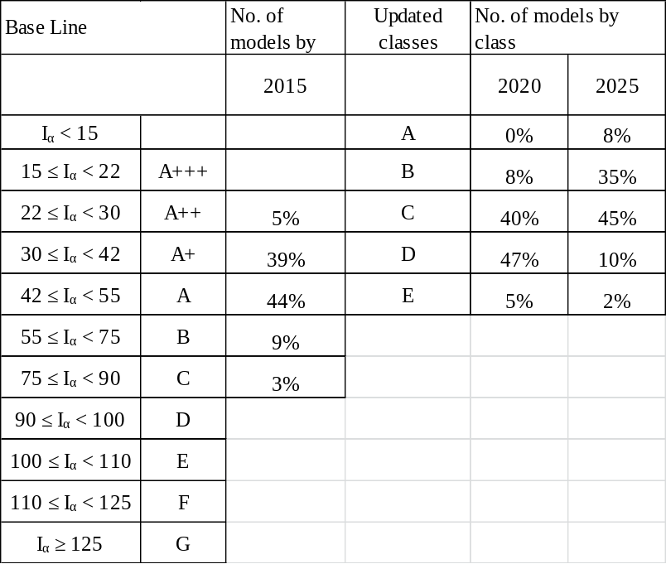

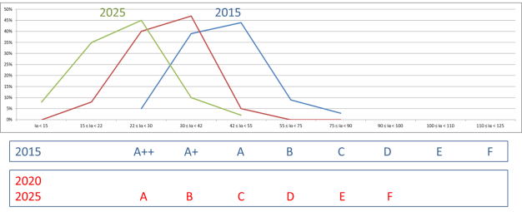
Source: Fundación Chile

A.2. Child project
If this is a child project under a program, describe how the components contribute to the overall program impact.

- The UN Environment proven integrated policy approach was used in Chile by first time on 2013 allowing the country to be now on the way of implementing its National Efficient Lighting Strategy 2013 – 2017 (ENIE) . Currently, the GEF project “Delivering the transition to energy efficient lighting in Chile” (2015-2017) is being executed.

- This project is part of the United for Efficiency (U4E) launched in 2014 by United Nations Development Programme (UNDP), International Copper association (ICA), Collaborative Labeling and Appliance Standards Program (CLASP), Natural Resources Defense Council (NRDC) and United Nations Environment Programme (UN Environment), it aims to join forces with private and public sector to expand the en.lighten approach to the next high impact opportunities, supporting the second goal of the Secretary General’s Sustainable Energy for All (SE4ALL) initiative: double the global rate of improvement in energy efficiency and it is part of the SE4ALL Energy Efficiency Accelerators on Lighting and Appliances & Equipment.

- The current project is hosted under the program “Leapfrogging markets to high efficiency products (appliances, including lighting, and electrical equipment)” lead by UN Environment. The Program builds on the UN Environment-GEF global project “Establishing the Foundations of a Partnership to Accelerate the Global Market Transformation for Efficient Appliances and Equipment” (UN Environment Project #5831), hereinafter called the “SE4ALL Global Project”. The project is called this due to its contribution to the UN Secretary General’s Sustainable Energy for All (SE4ALL) initiative’s Lighting and Appliance & Equipment Accelerators. The SE4ALL Global Project has formed a global partnership, recently named United for Efficiency (U4E), which compiles international organizations, like-minded organizations, and private sector companies. Further, by the end of the project, it will have the commitment from at least thirty countries to transform their markets to energy efficient lighting, appliances, and equipment.

- The program “Leapfrogging markets to high efficiency products (appliances, including lighting, and electrical equipment” proposed GEF program, hereinafter called the “Global Leapfrogging Program” utilizes the resources already developed under SE4ALL Global Project, such as country assessments and best practice policy guides to increase the number of countries committing to advance energy efficient products. Further, it follows the consensus recommendations on the policy framework when developing technical guides and training under the Global Leapfrogging Program. This relationship is reflected in the figure below and the text describing each component.

Figure 4 Relationship between SE4ALL Global Project and the Global Leapfrogging Program

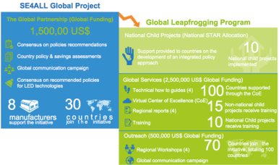

- The Global Leapfrogging Program was originally submitted (GEF Council October 2015) with child projects of Costa Rica, Kazakhstan, and Sudan and a projected eight additional countries are expected to join. The project was re-submitted (GEF Council March, 2016) with child projects in Myanmar, Indonesia, Tunisia, South Africa, and Chile. Other countries interested in submitting a child project under Global Leapfrogging Program, include China and Lesotho. For each child project, a concept note included national background, policy status, baseline scenario, description of individual national components, and potential savings.

- The Leapfrogging Program is divided into three components:
- Component 1: National child projects on lighting, appliances, and equipment
- Component 2: Global services for partner countries
- Component 3: Outreach on Efficient Appliances and Equipment

- The current project’s components contribute to the Leapfrogging Program as described below:

- Creation of monitoring, verification and enforcement (MVE) capacities to ensure an effective transition to efficient appliances and equipment markets. Outputs 2.1, 2.2. and 2.3. of the proposed project specifically address the challenge of improving MVE scheme to ensure safe efficient products in the market, supporting Chile in advancing to a better well-functioning system of monitoring, surveillance, control, and testing facilities.

- Supporting policies for the market transformation to energy efficient products, such as communication and information actions are considered to raise awareness about new efficient refrigerators available in the market and environmentally sound end-of-life integrated management. Other supporting policies such as demonstration projects are considered to showcase successful examples of inefficient refrigerators and freezers replacement, in such a way that suppliers, utilities and retailers could continue after the project with large scale replacement projects. Technical trainings are transversal to the project to make sure market transparency and cost economic opportunities for private suppliers, utilities and citizens. The project will raise awareness of citizens creating market transparency and an energy efficiency refrigerators demand through Output 3.1 Communication campaigns developed to increase user acceptance and understanding of high efficiency products and updated labelling and MEPS, Output 3.2 will contribute with replacement demonstration project.

- Ensuring environmentally sound management and sustainable transition to efficient appliances and equipment. Environmentally sound management systems ensure that precautions are taken to safeguard the environment and human health throughout the full lifecycle of appliances and equipment. Output 4.1. will deliver a strategy proposal for a national framework and an environmentally sound management of refrigerators/freezers that would be implemented using the Output 4.3. proposed CRSO business model for spent refrigerators that will include potential international coordination for the environmentally sound export/import of refrigerators waste/ refrigerant gas proposed/adopted

A.3. Stakeholders
Identify the key stakeholders and elaborate on how their engagement is incorporated in the preparation and implementation of the project. Mention whether they include civil society organizations and indigenous peoples.

Stakeholder | Role | Participation | Activities
Government and national standards-setting bodies | Policy makers, officials and technical staff within government ministries will play a crucial role in the implementation of the proposed project. The Ministry of Energy is responsible for policy and regulatory actions to promote energy efficiency and to get goals of 20% of savings to 2025, Ministry of Energy is actively promoting women participation in the energy sector. | Ministry of Energy will participate in:  - the new label classification analysis and application  - to evaluate MEPS and define future values for MEPS based on technical results  - replacement campaigns of installed old refrigerators  - communication campaigns | Activity 1.1.1: Market and regulatory framework analysis  Activity 1.1.2: Update energy label classification for refrigerators and freezers  Activity 1.1.3: Definition of a new MEPS application/implementation plan  Activity 2.1.1: Develop an assessment on MVE practices in Chile and validate with Ministry of Energy (MoE) and Superintendence of Electricity and Fuels (SEC)  Activity 2.1.2: Provide capacity building and technical support to public agencies  Activity 2.3.1: Improve monitoring and verification procedures and methodology to measure energy savings from the removal of old-but-operable refrigerators from service  Activity 3.1.2: Implement gender sensitive dissemination and communication campaigns (including specific guide about EE labelling and MEPS) and impact evaluation indicators  Activity 3.1.3: Evaluation of dissemination and communication campaigns indicators and suggested measures for improving
 | Superintendence of Electricity and Fuels (SEC) is responsible for safety and EE labelling of electric products. From regulations, data base and verification products, lab test and certification bodies accreditation until enforcement process, including fine applications and requirement of getting out from shops those non certified products | SEC will participate in:  - Improving MVE process jointly with Customs  - Improving testing labs capacity  - Capacity building teams on new testing procedures  - Interlaboratory testing (design and implementation)  - The new label classification analysis and application  - To evaluate MEPS and define future values for MEPS based on technical results | Activity 1.1.1: Market and regulatory framework analysis  Activity 1.1.2: Update energy label classification for refrigerators and freezers  Activity 1.1.3: Definition of a new MEPS application/implementation plan  Activity 2.1.1: Develop an assessment on MVE practices in Chile and validate with Ministry of Energy (MoE) and Superintendence of Electricity and Fuels (SEC)  Activity 2.1.2: Provide capacity building and technical support to public agencies  Activity 2.3.1: Improve monitoring and verification procedures and methodology to measure energy savings from the removal of old-but-operable refrigerators from service
 | The Ministry of Environment will also play a key role because climate mitigation activities as well as ozone layer depleting substances control competencies rely on this body. | Ministry of Environment will give legal base and will support recycling activities considering technologies, waste management and refrigerant gases.  Communication campaigns and accountability of GHG reductions for being included in National Communication and other Climate Change Reports.  The National Ozone Unit of the Ministry of Environment acts as the focal point for the Montreal Protocol to coordinate efforts to reduce and eliminate HCFC as a ozone depleting substance (ODS). | Activity 4.1.1: Develop a strategy proposal for an environmentally sound management of refrigerators/freezers including refrigerant gases  Activity 4.1.2: Dissemination to the private sector and key public actors to promote collection and recycling of refrigerators  Activity 4.1.3: Design, implement and monitoring and evaluating communication campaigns for collecting and recycling old refrigerators with best available technologies
Energy utilities | Energy utilities have an incentive in the longer term to encourage energy efficiency in order to lower capital costs for infrastructure (deferred investment in capacity expansion). Utilities can provide key inputs to the projects as they often have the best information regarding consumer demand patterns. Finally, they can be a key partner for the implementation of demonstrative programs and financial incentive programs. | Energy utilities would participate in replacement of old refrigerators campaigns as they can be the link with the final consumer (cover the cost of the equipment in the energy bill) and monitor the energy savings of the replacement. | Activity 3.2.1: Evaluating relevant international experience  Activity 3.2.2: Designing and implementing demonstration programmes
Testing laboratories and Certification bodies | Test protocols and energy efficiency labels represent the technical basis for MEPS and the energy label. | Testing laboratories and certification bodies would actively take part in the process of standards and quality control. If necessary, they could participate in improving facilities and technical capacities.  Moreover, they could participate in the replacement programs to demonstrate the energy savings. | Activity 2.2.1: Develop an interlaboratory performance test  Activity 2.2.2: Improve capacities and facilities for refrigeration safety and efficiency test protocols according to international experts recommendations  Activity 3.2.2: Designing and implementing demonstration programmes
Refrigerators and freezers manufacturers, importers, distributors and retailers | Refrigerators and freezers manufacturers, importers, trade associations, distributors and retailers are directly affected by energy efficiency regulations. They have valuable information about technical aspects of their products, production costs and market structures. MEPS necessarily impose some burdens on manufacturers and importers, but these can be acceptable as long as they affect all companies equally and are communicated in advance. MEPS also introduce new business opportunities.  Domestic and international firms will play a crucial role by providing their input. Equipment retailers will participate in the proposed project implementation by characterizing the market and consumer response to refrigerating product efficiency and pricing.  Moreover, with the Extended Producer Responsibility law, the manufacturers are responsible of the environmental sound management of their products. | Manufacturers will participate in:  - Establishing the current market situation.  - The design and application of the new energy label.  - The replacement programs  Moreover, manufacturers and importers could start below voluntary model to recycling old refrigerators in that way to be prepared when mandatory regulation will come into force. | Activity 1.1.1: Market and regulatory framework analysis  Activity 1.1.2: Update energy label classification for refrigerators and freezers  Activity 3.2.2: Design and implement demonstration programmes  Activity 4.1.1: Develop a strategy proposal for an environmentally sound management of refrigerators/freezers including refrigerant gases  Activity 4.1.2: Conduct dissemination to the private sector and key public actors to promote collection and recycling of refrigerators  Activity 4.3.1: Develop CRSO business model for end of life refrigerators able to start below voluntary scheme, including potential international coordination for the environmentally sound export/import of refrigerators waste/ refrigerant gas
Collectors and recycling companies and persons | Environmental sound recycling of refrigerators | Private collectors and recyclers will participate from design to implementation of replacement old but operable refrigerators.  Moreover, they will be part of the design of the CRSO business model. | Activity 3.2.2: Design and implement demonstration programmes.  Activity 4.3.1: Develop CRSO business model for end of life refrigerators able to start below voluntary scheme, including potential international coordination for the environmentally sound export/import of refrigerators waste/ refrigerant gas
Top-ten Chile | It is a digital tool platform, where the consumer can consult the most energy-efficient products and equipment in the Chilean market. They can also compare the prices and consumptions of appliances against standard models in the country in different categories, so that the user can make an informed purchasing decision.  By providing reliable and transparent data on the energy consumption of household appliances, Top-Ten Chile seeks to transform the market in line with energy efficiency. | Top-Ten Chile will provide EE data of the refrigerators market for the development of the MEPS and the EE label. For instance, they already provided data to establish the baseline during the preparation phase of the project.  They will also support with diffusion and communication. | Activity 1.1.1: Carry out market and regulatory framework analysis.  Activity 1.1.2: Update energy label classification for refrigerators and freezers  Activity 3.1.1: Design dissemination and communication plan for consumers awareness of the benefits of efficient refrigerators/freezers for increasing active acceptance of new efficient products and awareness of new EE labeling and MEPS
World Wildlife Fund (WWF) – Chile | WWF does strong articulation with its network in global initiatives such as the Market Transformation Initiative. | WWF Chile can support the diffusion of all the communication campaigns of the project, in order to increase their impact. | Activity 3.1.1: Design dissemination and communication plan for consumers awareness of the benefits of efficient refrigerators/freezers for increasing active acceptance of new efficient products and awareness of new EE labeling and MEPS  Activity 4.1.3: Design, implement and monitoring and evaluating communication campaigns for collecting and recycling old refrigerators with best available technologies
Organisation of Consumers and Users of Chile (ODECU) | It is a private nonprofit organization, made up of about a hundred natural persons, whose purpose is to inform and educate consumers and assume their representation and defense. | ODECU will provide information about the consumers experience with refrigerators products, as well as guidance regarding the main objectives related to consumers such as MVE. | Activity 2.1: Develop an assessment on MVE practices in Chile and validate with Ministry of Energy (MoE) and Superintendency of Electricty and Fuels (SEC)  Activity 3.1.1: Design dissemination and communication plan for consumers awareness of the benefits of efficient refrigerators/freezers for increasing active acceptance of new efficient products and awareness of new EE labeling and MEPS  Activity 4.1.2: Dissemination to the private sector and key public actors to promote collection and recycling of refrigerators  Activity 4.1.3: Design, implement and monitoring and evaluating communication campaigns for collecting and recycling old refrigerators with best available technologies
Chile Sustentable | The Sustainable Chile Program is an initiative of environmental organizations, activists, academics, professionals and citizens committed to promoting the elaboration of a citizen proposal for the social, political and economic transformation of Chile from the current model towards a development based on sustainability criteria.  Chile Sustentable participates in the discussion and processing of institutional and normative reforms in the areas of energy and socio-environmental rights, in order to consolidate a space for the democratic participation of citizens in decision-making on public policies. | Chile Sustentable will support the diffusion of communication campaigns of the project in order to increase their impact. | Activity 3.1.1: Design dissemination and communication plan for consumers awareness of the benefits of efficient refrigerators/freezers for increasing active acceptance of new efficient products and awareness of new EE labeling and MEPS  Activity 4.1.3: Design, implement and monitoring and evaluating communication campaigns for collecting and recycling old refrigerators with best available technologies
Environment Institute (IDMA) | In order to fulfill its institutional mission, IDMA has implemented an action strategy that involves the training of students with academic excellence and specialists in environmental technical areas, such as environmental management and energy efficiency. | IDMA will support the diffusion of the communication campaigns. It will also participate in the trainings to consumers, and retailers regarding EE benefits for refrigerators and freezers. | Activity 3.1.1: Design dissemination and communication plan for consumers awareness of the benefits of efficient refrigerators/freezers for increasing active acceptance of new efficient products and awareness of new EE labeling and MEPS  Activity 4.1.3: Design, implement and monitoring and evaluating communication campaigns for collecting and recycling old refrigerators with best available technologies
Other environmental advocates and consumer groups | Non-governmental organizations that advocate responsible energy policies will contribute their perspectives during the development of MEPS. They will provide a balancing perspective to manufacturers with regard to the stringency of MEPS and MVE schemes. Inputs from civil society consumer groups can ensure that regulations do not require overly expensive or less functional products. | NGOs and consumer organization would be part of design, application and efficacy evaluation of communication campaigns. | Activity 3.1.1: Design dissemination and communication plan for consumers awareness of the benefits of efficient refrigerators/freezers for increasing active acceptance of new efficient products and awareness of new EE labelling and MEPS

A.4. Gender equality and an women’s empowerment
Gender Equality and Women's Empowerment. Elaborate on how gender equality and women’s empowerment issues are mainstreamed into the project implementation and monitoring, taking into account the differences, needs, roles and priorities of women and men.

- According to official data, women account for 52.7% of the country's total population, the wage gap is 26.6% on average, and the percentage of households with female heads of household is 37.9%, where poverty and extreme poverty reach 15.4% and 5.3%, respectively.

- Young women have higher enrolment rates in secondary education and higher graduation rates from tertiary education. However, girls are less likely to choose fields of study as science, technology or engineering, and even when they do, they are less likely to pursue a career in these areas, perpetuating this way the gender segregation in the labour market. Female labour force participation in Chile has increased significantly since the mid-1990s, but in international comparison it is still low compared with an OECD average. As in many other OECD countries, one of the major obstacles Chilean women face to participate more fully is the traditional gender roles towards work and care. Gender gaps in employment outcomes are also reflected in other domains: Chilean women earn less than men; they are under-represented in senior management positions; they are less likely to own a business; and, they hold few seats in parliament. Chile has introduced several measures to reduce gender inequalities, the most important one is the creation of the Ministry of women and gender equality in 2015. This Ministry is in charge of the design, coordination and evaluation of policies, plans and programs aimed to promote gender equality.

- In March 2017 the Ministry of Energy has launched the “Agenda de Energía y Género” with four areas of work: the promotion and autonomous development of women, providing support to entrepreneurship and innovation; the design and implementation of energy policy, establishing a gender clause in agreements, contracts and terms of reference, along with participation in the design of policies; the strengthening of capacities in the energy field, through training; and access to goods and services offered, focusing and subsidizing, disseminating and sensitizing around the gender variable through workshops and seminars.

- Just to mention two activities designed for solving gender and centralization challenges. The first one took place in Concepción where more than 100 women celebrated jointly the energy efficiency day (March 5th) and the Women International Day (March 8th) the ceremony was led by the Ministry of Energy regional authority, Carola Venegas. Both celebrations were linked to topics such as female labor insertion in the energy sector, and at the same time they delivered simple and practical tips that allow them to reduce their consumption rates, both in their homes and workplaces, for which they were given a kit of efficient light bulbs and a certificate of participation. The second one is programmed for 2017, the Ministry of Energy will train about 5 thousand people in Atacama region, through the programme "My efficient home", in accordance with axis 5 of the Energy Agenda, called "An efficient energy sector and that manages the consumption".

- This GEF project will perform the following gender-sensitive activities:
- Take at least the gender inclusive models used by the Ministry of Energy complemented with others coming from international experience.
- Women participation on trainings will be registered and encouraged and pilot replacement campaigns will require at least 50% of women as beneficiaries.
- Whenever it is possible and/or relevant, the project will aim to include sex-disaggregated data.
- Documents and communication campaigns will be designed and targeted considering gender sensitiveness to assess and evaluate potential impact and related policy integration of specific gender considerations.
- All training material must avoid gender stereotypes, employ inclusive language and use appropriate illustrations.
- Significant women representation will be encouraged during capacity building workshops (both, among trainers and trainees) to promote gender parity.
- Gender will be addressed in the project team and stakeholder meetings, to help identify other areas where gender goals could be established.
- Through the work of the gender consultant, the project will reach out the targeted consumers by undertaking rapid assessments and carrying out structured interviews or observations to better design communication campaigns and better select the model of refrigerators for the replacement programme taking into consideration gender and socio-economic aspects,
- The project will also compel/motivate manufacturers to carry on these market researches, structures interviews and observations that take into consideration gender and socio-economic dimensions when designing efficient refrigerators.
- The project will work with close coordination with the gender focal point of the Ministry of Energy, mainly for communication campaigns and the demonstration programme.

A.5. Risk
Elaborate on indicated risks, including climate change, potential social and environmental risks that might prevent the project objectives from being achieved, and, if possible, the proposed measures that address these risks at the time of project implementation.(table format acceptable):

- The project is subject to risks that can be anticipated. Adequate risk management and mitigation strategies ensuring successful project implementation may be developed and implemented. The possible risks are:

Risk description | Mitigation measure | Level of risk
Policies might be recommended but not implemented.  Changes of staff in policy-making bodies, especially after election time, may hinder implementation and cause delays. | Policy and regulatory risks will be mitigated primarily by provision of technical advice and information to, as well as continuous policy dialogue with relevant authorities to enable them prepare such policy packages which are both sufficiently ambitious and aligned with international best practices, yet realistic and take into account specifics of Chilean market conditions. Specific contribution of the proposed policy changes to achievement of national EE goals will also be emphasized throughout the process to strengthen commitment and buy-in among the authorities.  In addition to project team, expertise and authority of the Project Steering Committee and the UN Environment Regional Office will be utilized to support policy dialogue with the Government and steer the scope and direction of the proposed changes.  Managed by:  Project team  Project Steering Committee, Ministry of Energy and Ministry of Environment  Potential impact on:  Component 1: Revising regulatory mechanisms, including Minimum Energy Performance Standards (MEPS)  Component 2: Enhancing monitoring, verification, and enforcement (MVE)  Component 3: Developing supporting policies  Component 4: Enhancing environmentally sound management | Medium
Low commitment of local laboratories to improve the quality of certification and adopt new standards | This risk will be mitigated primarily by working with Government to introduce improved MVE labeling regulations and certification standards. This will open new market opportunities for laboratories complying with new regulations. This will be complemented by provision of technical assistance and training support for testing of refrigerators and facilitating linkages and info exchange with similar testing labs and certification bodies in the region.  Managed by:  Project team  Potential impact on:  Component 2: Enhancing monitoring, verification, and enforcement (MVE) | Medium
Delayed implementation of activities that are baselines for specific incremental activities of the proposed project | The energy efficient labelling activities considered in the Energy Agenda include new labelled products (kitchens, water heaters, dishwashers, washing machines and firewood heater, televisions in on mode and driers). The activities in the GEF project will support Ministry of Energy steps ahead in order to avoid delays, i.e. Updating existing refrigerators labels that need to be monitored and fine-tuned by the responsible agencies according to real-time progress.  Managed by:  Ministry of Energy  Potential impact on:  Component 1: Revising regulatory mechanisms, including Minimum Energy Performance Standards (MEPS) | Medium
Low participation from the private sector actors including refrigerators technology manufacturers and distributors | Private sector plays key role in ensuring project successful implementation. Project team will pro-actively seeks participation and collaboration from among relevant private sector stakeholders. Already at design stage key players have been engaged and some have expressed commitment by means of a co-financing letter. Given diverse range and motivation of private sector partners (manufacturers, retailers, CRSOs), the project will develop private sector engagement plan for each relevant project component.  Managed by:  Project Steering Committee  Potential impact on:  Component 3: Developing supporting policies  Component 4: Enhancing environmentally sound management | Medium
Insufficient capacities of the government to support the project, which leads to inadequate and ineffective enforcement or policies and regulations and/or lack of coordination among relevant government agencies and stakeholders. | Strengthening the capacity of staff from the Ministries, SEC and other organizations involved in the MVE system is an integral part of the project. Build upon experiences on more than eight years of Energy Efficiency National Labelling Program and incorporate lessons learned regarding the application on labelling of refrigerators and freezers.  Managed by:  Project team  Potential impact on:  Component 1: Revising regulatory mechanisms, including Minimum Energy Performance Standards (MEPS)  Component 2: Enhancing monitoring, verification, and enforcement (MVE)  Component 3: Developing supporting policies  Component 4: Enhancing environmentally sound management | Low

A.6. Institutional arrangement and coordination
Describe the institutional arrangement for project implementation. Elaborate on the planned coordination with other relevant GEF-financed projects and other initiatives.

Institutional arrangement for project implementation

- The project is a Child Project below umbrella project leaded by SE4ALL and U4E, UN Environment will be responsible of general coordination and transferring knowledge of this and other Child Projects.

- The project will be executed by Fundación Chile nominated by the Ministry of Energy and the Implementing GEF Agency will be UN Environment. The initiative will follow the institutional structure as described in Annex H: Project Implementation Arrangements. The national Project Steering Committee (PSC) will be composed of the National Ministry of Energy and the Ministry of Environment, UN Environment, Superintendence of Electricity and Fuels, private suppliers, GEF Operational Focal Point, International project partners including international organizations, global manufacturers, and utilities will support the project to achieve its objectives.
Planned coordination with other relevant GEF-financed projects and other initiatives
- The project will build upon the on-going GEF project in Chile “Delivering the transition to energy efficient lighting in Chile”, endorsed in 2016, which aims to promote the rapid uptake of high energy efficient lighting technologies through the transformation of efficient lighting products markets, thereby reducing electrical demand and consumption and the related greenhouse gas (GHG) emissions. The efficient lighting project is currently using the same proposed structure: being executed by Fundación Chile, with UN Environment acting as the Implementing Agency and U4E providing technical support.

- The Management Plan for HCFC phase-out in Chile, which aims to achieve the reduction of hydro chlorofluorocarbons (HCFCs) in compliance with the Montreal Protocol targets for the years 2013 and 2015, and its lines of action for the fulfillment of commitments under 2020, 2025 and 2030. The one being implemented by UNDP as Implementing Agency and UN Environment as Cooperating Implementing Agency. As part of the implementation actions, a refrigerant gases recovery, recycling and recuperation pilot project would be coordinated as part of the refrigerators and freezers recycling plant.

- The Ozone Unit of Chile’s Ministry of Environment with the Climate and Clean Air Coalition (CCAC) could advance in significantly reduce projected HFC use and growth in the refrigerators market working with private sector, civil society and international organizations.

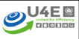
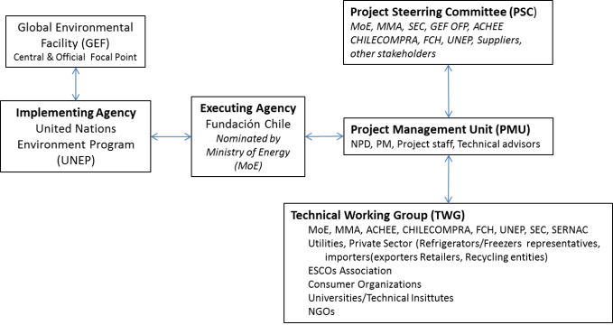

A.7.Benefits
Describe the socioeconomic benefits to be delivered by the project at the national and local levels. How do these benefits translate in supporting the achievement of global environment benefits (GEF Trust Fund) or adaptation benefits (LDCF/SCCF)?

Economics

- The proposed project aims to provide socio-economic benefits at the national and local level. At the national level, the transition to efficient refrigerators and freezers significantly impacts the ability to maximize use of existing electrical power generation without having to build new and expensive generation and distribution facilities. The transition would also reduce power demand and therefore reduce expensive oil imports. Peak power demand and risk of black-outs are also decreased. Figures supplied by U4E Country assessment for Chile shows cumulative potential energy savings (2020-2030) of 7.1 TWh which corresponds to approximately US$ 1.6 million in savings on electricity bills.

- At local level, the project will contribute to economical savings in between 2% and 4% at the level of individual household incomes. Implementation of collection and recycling system will also lead to new green job creation: according to international research, the systematic removal of every 10,000 tons of solid waste creates only six jobs while the same amount of waste if recycled can create recycling jobs for as many as 36 people.

- Considering that Chile´s manufacturers of refrigerators stay continuously in their innovation strategies as they have been in the last decades producing efficient products for domestic markets and exporting to Andean countries, that could mean at least to maintain the national industry, with benefits of at least 2,000 jobs.

Environmental

- In addition to economic benefits this project will cooperate with other initiatives for promoting the transition from HCFC-22 and HCFC-141b to new products with more environmentally friendly refrigerants.

- The collection, recycling and environmentally sound management of old refrigerators will reduce the risk of releasing refrigerant gases to the atmosphere, avoiding to destroy the ozone plate.

- The new technologies offer great potential to avoid CO2 emissions from direct fossil fuel burning for electric power production and reduce related local and regional air pollution (NOx and SO2).

Social benefits and gender

- The project will deliver quality food conservation services and economic and time savings to all Chile citizens because high efficiency refrigerators allow better conservation of food. This improvement will avoid losses and decrease health risks related to bad conservation of inefficient refrigerators and freezers.

- The project will arise gender indicators through different activities, below the framework given by the Agenda Energía y Género of the MoE. Gender as a topic will be addressed in the project team and stakeholder meetings, to help identify other areas where gender goals could be established. For example, purchasers of refrigerators and freezers may have gender-related preferences that could be identified in order to encourage greater participation in market-based promotion and consumer information campaigns.

A.8. Knowledge
Management. Elaborate on the knowledge management approach for the project, including, if any, plans for the project to learn from other relevant projects and initiatives (e.g. participate in trainings, conferences, stakeholder exchanges, virtual networks, project twinning) and plans for the project to assess and document in a user-friendly form (e.g. lessons learned briefs, engaging websites, guidebooks based on experience) and share these experiences and expertise (e.g. participate in community of practices, organize seminars, trainings and conferences) with relevant stakeholders.

- The knowledge management approach for the project will include at least the following critical activities: (a) plans for the project to learn from other relevant projects and initiatives, (b) plans for the project to assess and document in a user-friendly form and (c) share these experiences and expertise with relevant stakeholders.

Activities | Description
Plans for the project to learn from other relevant projects and initiatives | This project was designed based on international experience of enlighten and U4E initiative, and so associated to UNDP, ICA, CLASP, NRDC and UN Environment), So participation in trainings, conferences, stakeholder exchanges, virtual networks will be the tools for a continuing process of transferring knowledge. It is important to say that the free markets scheme of Chilean economy also would give other countries participating in U4E, with strong public utilities, an interesting new perspective which be transferred through participation of the members of the PMU in international conferences and workshop.
Plans for the project to assess and document in a user-friendly form | The challenge of a real and sustainable impact of the project will be not only on the supply side (manufacturers) but also on demand (consumers). Being them non-technical people and from all socials levels, communications campaigns supplier must design campaigns and material for covering different medias (TV, social networks, sales points, etc.) with well-designed and effective messages.
Share these experiences and expertise with relevant stakeholders | Two most important experience will be the replacement campaign and the CRSO business model.  - The first one will have active participation of private companies (utilities, retailers, manufacturers and/or recycling entities) in such a way that this experience could be taken as pilot projects replicated at large scale after GEF project ended.  - The CRSO business model will be developed with private partners who will have the first option of implementing if economic indicators are positive. If they refuse to implement the CRSO a road show to other will be developed.

B. Description of the Consistency of the Project with:
B.1 Consistency with National Priorities. Describe the consistency of the project with national strategies and plans or reports and assessments under relevant conventions such as NAPAs, NAPs, ASGM NAPs, MIAs, NBSAPs, NCs, TNAs, NCSAs, NIPs, PRSPs, NPFE, BURs, INDCs, etc.:

Consistency of the project with national strategies and plans

- The project is in line with national priorities of Chile and will contribute directly to its sustainable development. In line with the 2030 Agenda for Sustainable Development, the project will contribute with two of the 17 Sustainable Development Goals (SDGs) of the adopted by world leaders in September 2015 at the historic UN Summit. Specifically with goal 7 “Ensure access to affordable, reliable, sustainable and modern energy for all” and goal 12 “Ensure sustainable consumption and production patterns”.

- The Government of Chile developed in 2012 a National Energy Strategy which provided guidelines for the country's energy use until 2030. The National Energy Strategy was based on six pillars:(1) energy efficiency as priority public policy, (2) accelerate the incorporation of renewable energy, (3) enhance traditional renewable energy, (4) new approach to transmission, (5) more competitive power market and (6) progress in international electrical interconnection. As part of the National Energy Strategy Chile has set the ambitious goal of reducing final growth and energy demand by 12%. To reach this goal, the country will adopt, among others, the following key measures, including energy efficiency labels and Minimum Energy Performance Standards (MEPS) for lighting products and refrigerators/freezers (already in place).

- The Government of Chile published in 2014 the Agenda de Energía with the common national view of aiming at a reliable, sustainable, and inclusive energy development at reasonable prices. The Agenda recognizes that “…In spite of the fact that the model, weighing supply and demand, was effective in the past, it is obvious that today it is insufficient to face new challenges: to reduce risks as compared with fossil fuels (access and price volatility); to develop energy sources at accessible prices; to diminish and manage the sector’s environmental impacts, increasing the involvement of local communities in the benefits of the energy developments; to use the energy efficiently, both at homes and industries; to cause the investments of the sector to be more dynamic and to promote competition”.

- Specifically, the pillar number five on energy efficiency recognizes country advances on last years and update the goal from 12% to 20% at 2025 of the energy consumption reduction and add MEPs for refrigerators and freezers. The defined five action lines were:
- Energy Efficiency as a State Policy: Energy Efficiency Law with decoupling
- Introduce measures to spread the development of Energy Efficiency projects, continue carrying out the Energy Efficiency Action Plan until year 2020
- Housing and Construction efficiency
- Energy management of the municipalities with emphasis on street lighting
- Massive campaigns and educational programs in Energy Efficiency

- The Second Biennial Update Report to the UNFCCC after the signed Paris Agreement “provides extensive, accurate, and up-to-date information on the progress of Chile in its recent climate activity, with a view to strengthening the implementation of the Paris Agreement itself, both within our borders, and internationally” said Pablo Badenier Minister of Environment. Additionally the process of Third Biennial Update Report had been launched.

- At COP 15 (2009, Copenhagen) the Minister, President of the National Environment Commission (CONAMA) expressed Chile’s voluntary pledge, which affirms that “Chile will take nationally appropriate mitigation actions to achieve a 20% deviation below the “Business as Usual” emissions growth trajectory by 2020, as projected from the year 2007”.

- Today with a Ministry of Environment, Chile developed its Intended Nationally Determined Contributions (INDC) and submitted it to the secretary of the UNFCCC in September 2015. The country’s commitments are divided into 5 pillars: i) Mitigation, ii) Adaptation, iii) Capacity building, iv) Technology Development and Transfer and v) Financing.

- In mitigation issues, Chile has defined the following Carbon Intensity Target:

- Chile is committed to reduce its CO2 emissions per Gross Domestic Product (GDP) unit by 30% below their 2007 levels by 2030, considering a future economic growth which allows implementing adequate measures to reach this commitment.
- In addition, and subject to the grant of international monetary funds, the country is committed to reduce its CO2 emissions per GDP unit by 2030 until it reaches a 35% to 45% reduction with respect to the 2007 levels, considering, in turn, a future economic growth which allows to implement adequate measures to achieve this commitment.

- Energy efficiency is between the areas in which Chile expects to carry out additional sector specific efforts to establish and strengthen its climate change-related capacities. Specifically efficient technologies are seen as an important opportunity tackled with joined national and international efforts.

- The United Nations Development Assistance Framework for Chile (UNDAF) summarizes the joint strategic programming of the agencies, funds and programs of the system for the period 2011-2014. Through this programming exercise the core areas in which the United Nations in Chile focus their cooperation is defined. These areas are identified based on a joint assessment of the situation, the comparative advantages of the system according to their mandates and technical resources and national priorities set out in the Government Program. For the period 2010-2014, one of these areas has been climate change, environmental and energy sustainability. Establishing that the country must had made progress in designing and implementing policies for environmental and energy sustainability. The new proposal for cooperation 2015 – 2018, which was signed on September 2014, keeps the area of environmental sustainability.

C. Describe the budgeted M&E Plan:

- The project will be reviewed yearly through the Project Implementation Review (PIR). Its purpose is to assess project performance, to analyze whether the project is on track, what problems and challenges the project is encountering, and which corrective actions are required so that the project can achieve its intended outcomes by project completion in the most efficient and sustainable way. It is the responsibility of the UN Environment Task Manager to monitor whether the agreed recommendations are being implemented.

- In-line with UN Environment Evaluation Policy and the GEF’s Monitoring and Evaluation Policy the project will be subject to a Terminal Evaluation commissioned by the Evaluation Office.

- The Evaluation Office will be responsible for the Terminal Evaluation (TE) and will liaise with the Task Manager and Executing Agency throughout the process. The TE will provide an independent assessment of project performance (in terms of relevance, effectiveness and efficiency), and determine the likelihood of impact and sustainability. It will have two primary purposes: (i) to provide evidence of results to meet accountability requirements, and (ii) to promote learning, feedback, and knowledge sharing through results and lessons learned among UN Environment, the GEF, executing partners and other stakeholders. The direct costs of the evaluation will be charged against the project evaluation budget. The Terminal Evaluation will be initiated no earlier than six months prior to the operational completion of project activities and, if a follow-on phase of the project is envisaged, should be completed prior to completion of the project and the submission of the follow-on proposal. Terminal Evaluations must be initiated no later than six months after operational completion.

- The draft Terminal Evaluation report will be sent by the Evaluation Office to project stakeholders for comments. Formal comments on the report will be shared by the Evaluation Office in an open and transparent manner. The project performance will be assessed against standard evaluation criteria using a six point rating scheme. The final determination of project ratings will be made by the Evaluation Office when the report is finalised and further reviewed by the GEF Independent Evaluation Office upon submission. The evaluation report will be publicly disclosed and may be followed by a recommendation compliance process.

- While a TE should review use of project funds against budget, it would be the role of a financial audit to assess probity (i.e. correctness, integrity etc.) of expenditure and transactions. A summary of M&E activities envisaged is provided in Annex G. The GEF contribution for M&E activities, including the Audit and the Inception Workshop is USD 57,000.

PART III: CERTIFICATION BY GEF PARTNER AGENCY(IES)
GEF Agency(ies) certification
This request has been prepared in accordance with GEF policies and procedures and meets the GEF criteria for CEO endorsement under GEF-6.

Agency Coordinator, Agency Name | Signature | Date  (MM/dd/yyyy) | Project Contact Person | Telephone | Email Address
Kelly West,  Senior Programme Manager  & Global Environment Facility Coordinator  Corporate Services Division  UN Environment |  | November 15, 2017 | Ruth Coutto | +33.1.44371634 | Ruth.coutto@unep.org

Annex A: Project results framework

Project Objective | N° | Objective level Indicators | Baseline | Targets and Monitoring Milestones | Means of Verification | Assumptions & Risks | UN Environment MTS reference*
Accelerating transformation of Chile’s markets to more energy efficient (EE) residential refrigerators/freezers thereby achieving reduction of GHG emissions and contributing to improved energy access and energy security. | 1 | Increase in market share of more energy efficient refrigerators/freezers | Market share in 2015:  A++ = IEE < 30 = 5%  A+ = 30 ≤ IEE < 42 = 39%  A = 42 ≤ IEE < 55 = 44%  B = 42 ≤ IEE < 55 = 9%  C = 75 ≤ IEE < 90 = 3% | Market share in 2025:  A = IEE < 15 = 50%  B = 15 ≤ IEE < 22 = 40%  C = 22 ≤ IEE < 30 = 10%  D = 30 ≤ IEE < 42 = 0%  E = 42 ≤ IEE < 55 = 0% | • Sales data collected by the SEC on an annual base from national importers in the context of EE Labeling Program  • National customs information | Potential risks:  • Policies might be recommended but not implemented;  • Weak government support  • Low commitment of local laboratories to strengthen capacity for testing of refrigeration products;  • Delayed implementation of activities that are baselines activities;  • Low participation from the private sector actors | Expected Accomplishment (EA) 2: Low emission growth
 | 2 | Reduction of GHG emissions (direct project-related impact estimated based on GEF-STAP methodology) | N/A | 547,462 tCO2e

Project Outcome/ Outputs | N° | Outcome Level Indicators | Baseline | Targets and Monitoring Milestones | Means of Verification | Assumptions & Risks | UN Environment MTS reference*
Outcome 1.Accelerated transformation of the market for EE residential refrigerators/freezers via implementation of advanced MEPS and EE labels in line with international best practices and provision of associated capacity building  Output 1.1: National MEPS and EE Labels for refrigerators updated and implementation plan developed | 3 | Status and level of new MEPS | MEPS currently allow only A-class products (IEE < 55) | New MEPS (IEE< 30) officially adopted | New regulation officially published | Potential risks:  • Limited support from government institutions  • Limited ambition of the authorities and the private sector for an ambitious MEPS  • Complexity to convince the private sector to make a more demanding MEPS  • Administrative deadlines for implementation | EA 2: Low emission growth
 | 4 | Status and level of new EE labels for residential refrigerators/freezers | Energy label exists with the following classes:  A++ = IEE < 30  A+ = 30 ≤ IEE < 42  A = 42 ≤ IEE < 55  because B to G-class products has been phase out of the market by the producers and importers | New energy label adopted with the following classes:  A = IEE < 15  B = 15 ≤ IEE < 22  C = 22 ≤ IEE < 30  D = 30 ≤ IEE < 42  E = 42 ≤ IEE < 55 | New regulation officially published | Potential risks:  • Limited support from government institutions  • Limited ambition of the authorities and the private sector for an ambitious MEPS  • Complexity to convince the private sector to make a more demanding MEPS  • Administrative deadlines for implementation
Outcome 2. Actors comply with improved MVE labeling regulations, testing protocols and measurements methodologies to ensure residential refrigerators/freezers meet improved efficiency levels.  Output 2.1: MVE scheme assessed and improvements documented to ensure products’ compliance with EE labels and MEPS  Output 2.2: National laboratories strengthened to verify compliance with updated standards and protocols  Output 2.3: Monitoring and verification procedures and methodology to measure energy savings from the removal of old-but-operable refrigerators from service developed | 5 | Time taken to gest a certification for new products to be placed on the market | 3 to 6 months | Less than 3 months | Declarations of manufacturers and importers (Electrolux, Daewoo, LG, Samsung) | Potential risks:  • Barrier by the OCs and Testing Laboratories in Chile that wish to maintain the current monopoly they have (only 2 labs at the moment)  • Limited support from government institutions to facilitate the validation of foreign certification, so the laboratory network continues to be limited. | EA 2: Low emission growth
 | 6 | Number of interlaboratory testing program in compliance with international procedures | 0 | 1 | • Assessment report from international expert about Chilean test labs procedures and results | Potential risks:  •To identify in time an international laboratory considered a reference on the subject  • Limited commitment of testing laboratories as there are only 2.  • Limited support from government institutions to update laboratory standards by making improvements mandatory.
3.Enhanced awareness among consumers (by gender) and market players in Chile to understand, afford, and purchase EE refrigerators/freezer  Output 3.1: Communication campaign developed and its impact evaluated to increase user acceptance and understanding of high efficiency products and updated labeling and MEPS, taking gender-sensitive perspective into account  Output 3.2: Replacement demonstration programmes on energy efficient refrigerators implemented in the residential sector | 7 | Increase in the % of consumers (by gender) who understand the EE labelling for refrigerators, including % of those who make their consumer decisions based on EE label | As of 2016: 50% of consumers are aware about EE labels and 70% of those make their consumer decision based on information in the label | By 2025: 80% of consumers are aware about EE labels and 80% of those make their consumer decision based on information in the label | • Report from consumers' associations, Ministry of Energy of other institution.  • Impact assessment on social networks, Google Analytics, events participation about EE in the communication campaign.  • Potential impact data from stakeholders involved in the campaign (municipalities, retailers, etc.) | Possible risks are:  • Limited support from the actors involved in the campaign (retailers, municipalities, etc.)  • Misunderstanding of consumers | EA 2: Low emission growth
4. Voluntary implementation of the national framework for environmentally sound management of refrigerators/freezers started  Output 4.1: Strategy proposal for a national framework and an environmentally sound management of refrigerators/freezers developed and communicated to local stakeholders  Output 4.2: Awareness raising and communication campaigns to promote collection and recycling of refrigerators conducted  Output 4.3: Collection and Recycling Service Organization (CRSO) business model for spent refrigerators developed starting below voluntary scheme, including potential international coordination for the environmentally sound export/import of refrigerators waste/ refrigerant gas proposed/adopted | 8 | Number of companies involved in the CRSO business model for refrigerators | There is not any work group about CRSO business model for refrigerators. | 5 main companies involved in the CRSO business model. | • Report on the impact of the Producer's Extended Responsibility Law for electric appliances (Ministry of Environment)  • Impact assessment on social networks, Google Analytics, events participation about recycling.  • Potential impact data from stakeholders involved in the campaign (municipalities, retailers, etc.) |  | EA 3: Waste
 | 9 | Number of CRSO business plan designed in line with legal framework and validated by private sector stakeholders | 0 | 1 | • Project technical reports (incl. description of waste disposal and management strategy, issues and options)  • Expression of interest between the participating stakeholders. |  | EA 3: Waste

Annex B: Responses to project reviews (from GEF Secretariat and GEF Agencies, and Responses to Comments from Council at work program inclusion and the Convention Secretariat and STAP at PIF).

Scientific and Technical Advisory Panel
The Scientific and Technical Advisory Panel, administered by UNEP, advises the Global Environment Facility
(Version 5)
STAP Scientific and Technical screening of the Project Identification Form (PIF)
Date of screening: May 07, 2016
Screener: Thomas Hammond
Panel member validation by: Ralph E. Sims
Consultant(s):

I. PIF Information (Copied from the PIF)
Full Size Project GEF Trust Fund
GEF Project ID: 9436
Project Duration: 5.5
Countries: Global (Chile, Indonesia, Myanmar, Tunisia, South Africa)
Project Title: Leapfrogging Markets to High Efficiency Products
(Appliances, including Lighting, and Electrical Equipment)
(PFD Resubmission of #9083)
GEF Agencies: UNEP, DBSA and UNDP
Other Executing Partners:
GEF FOCAL AREA: Climate Change

II. STAP Advisory Response (see table below for explanation)
Based on this PIF screening, STAP’s advisory response to the GEF Secretariat and GEF Agency(ies):
Concur

III. Further guidance from STAP

1. The project aim is to increase the uptake of more efficient lighting and appliances in a number of countries by market transformation and building on an earlier UNEP SE4All project. Substantial private sector support is evident. This is a well formulated project proposal with few comments needed.

UN Environment Response: Noted.

2. Gaining success and harmonization by targeting nine specific countries and a wide range of others should prove to be a beneficial approach. Training of trainers is a key component. National and non-national child projects are planned. However, it is not clear how the city level child projects (assuming that is what is meant here by "non-national") will be selected? Will there be only one per nation? Discussion on the non-national child projects does not appear in section 9 â€“ so it is not exactly clear what is intended for this initiative. Or perhaps the term "non-national" here implies global as in "Global child project" as used on page

UN Environment Response: The term “non-national child project” was to refer to 15 partner countries that will receive in-region training, however do not have a GEF national project (child project). The wording has been updated to “15 additional partner projects”.

2. If so, then it is certainly confusing for the reader not to stick to using the same terminology throughout the proposal.

UN Environment Response: Noted. Terms and wording has been defined at the start and now consistent throughout.

3. The MEPS approach has been well tested in many countries and is sound as is labeling but educating the public as is proposed is key. Not only the public but more important are retail sales staff who frequently turn over so continual updating is required. Surveys elsewhere have shown it to be a weak link in the process when the retailers fail to understand the reason for the labels.

UN Environment Response: Noted. This topic has been raised in the Expert Taskforces under the SEforALL Global Project and included in the policy recommendation to countries. It will be in supporting policies alongside labels and consumer campaigns.

4. It is not easy to assess GHG emission reductions in a project like this as there are wide variations and uncertainties. Hence the wide range of 69-150 Mt CO2 is understandable. Taking refrigerators, air conditioners and transformers as examples is OK but of course, a very simplified approach. It is assumed different emission factors where used for electricity grids in each of the participating countries. But are all the appliances in the project assumed to be electrical? What about LPG stoves or water heaters for example? And domestic cook stoves? Are these all included? More robust calculations should be provided for child projects. The revised GHG manual and guidelines could be considered: https://www.thegef.org/gef/ghg-accounting.

UN Environment Response: The GHG estimates have been recalculated and prepared using an updated methodology, which is described in section A.1.5). The national projects conduct a more detailed analysis that takes into account the specific products included in the national project, emission factor and local circumstances (weather, behavioral differences, etc.). The project focuses on on-grid lighting, appliances and equipment. LPG stoves and water heaters are not part of the focus of the project.

5. Due to the complexity, consideration should be given to the Programme Steering Committee meeting more regularly than the proposed once a year at least in the initial stages.

UN Environment Response: Agreed. The number of meetings of the project steering committee has been increased to 6.

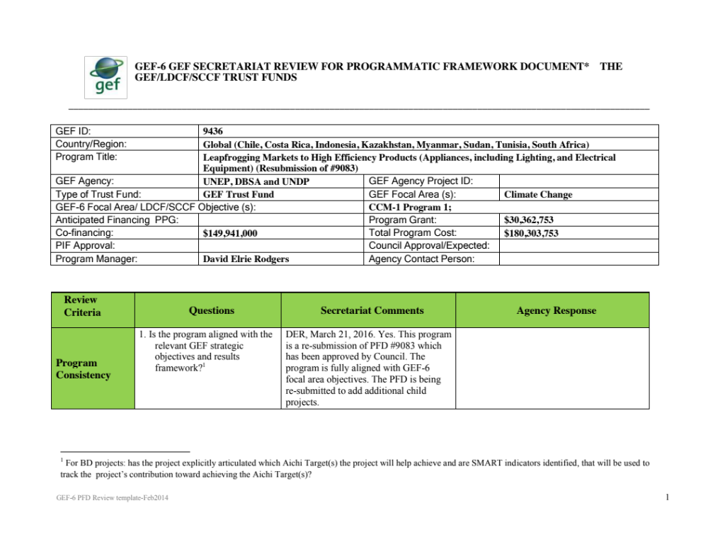
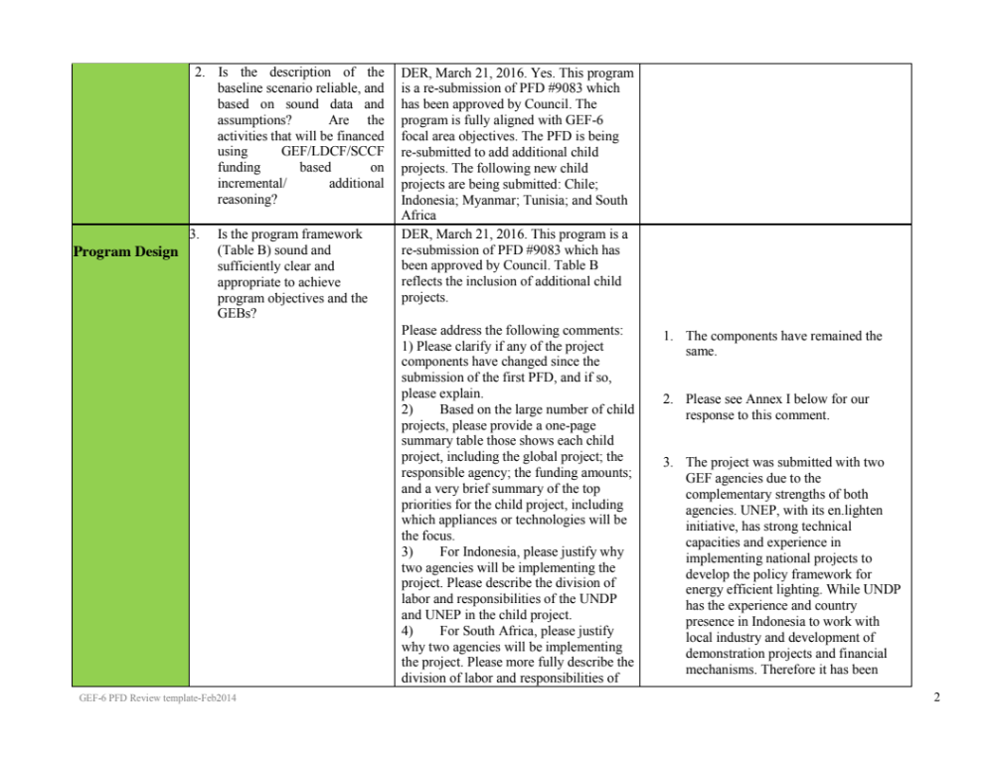
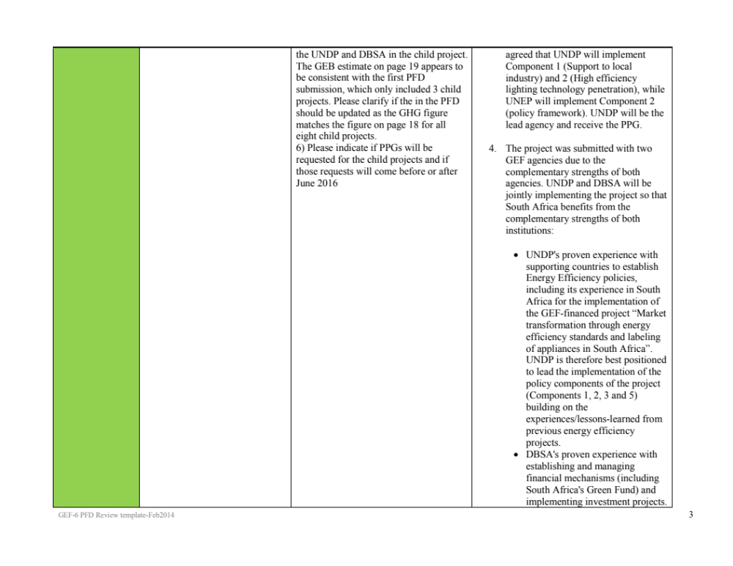
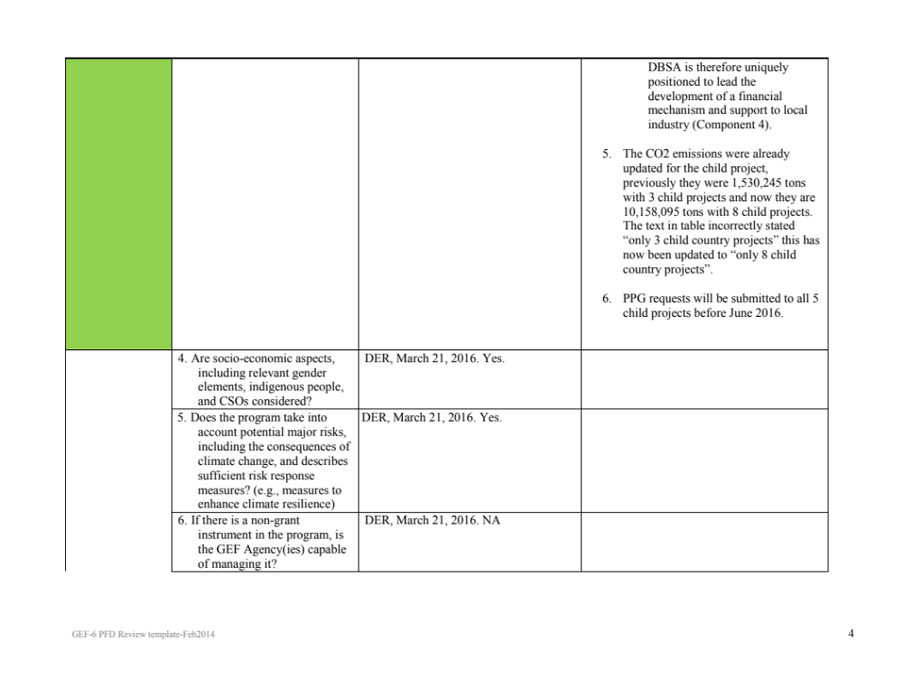
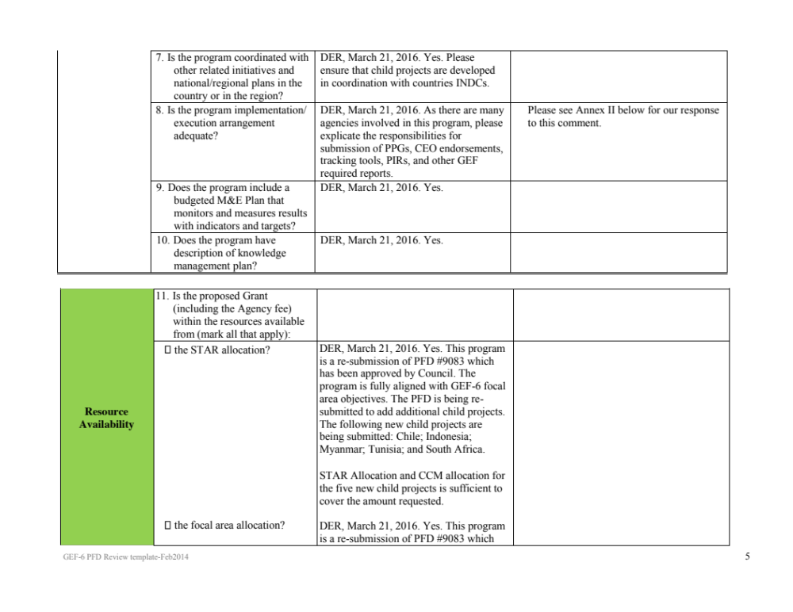
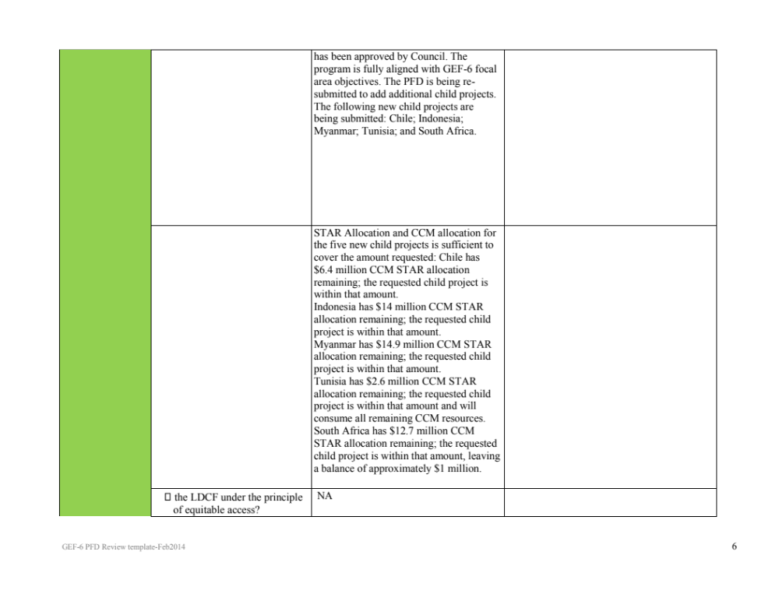
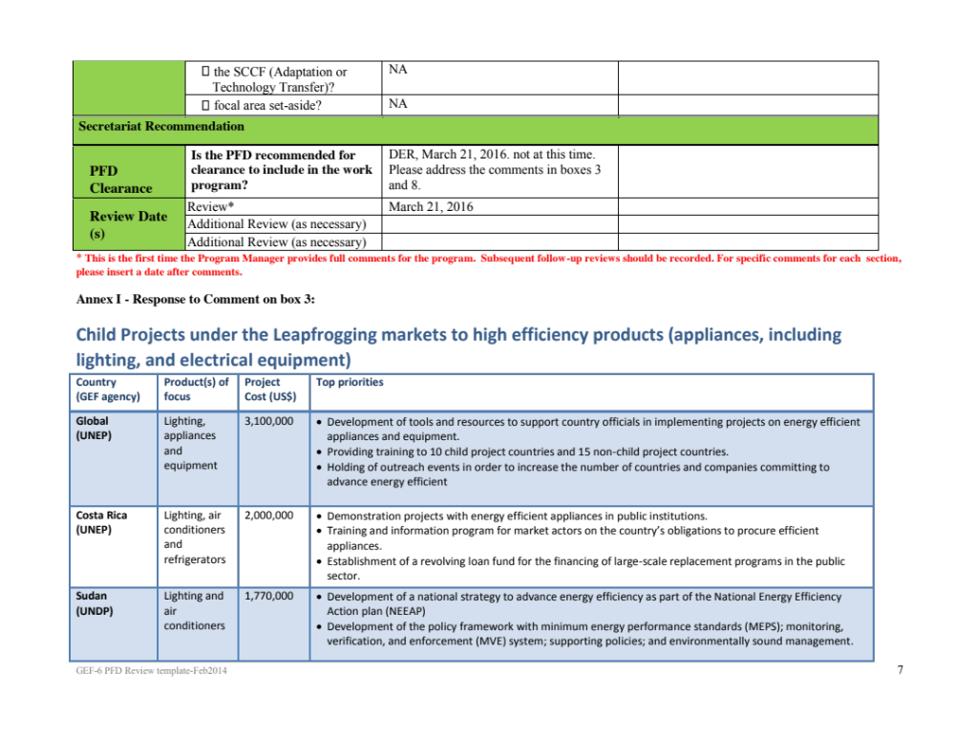
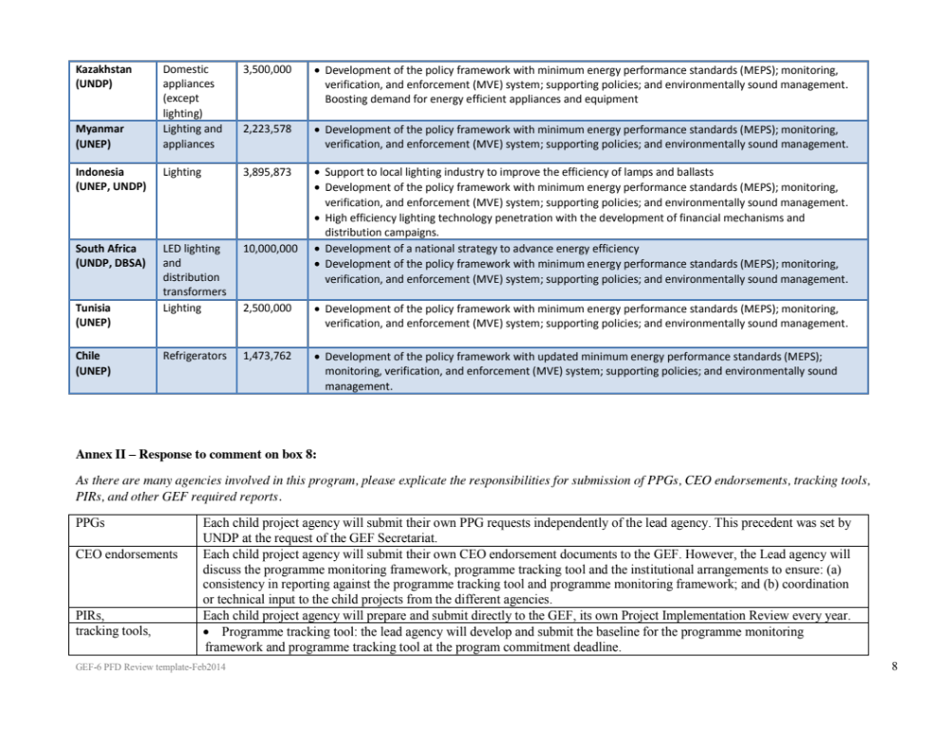
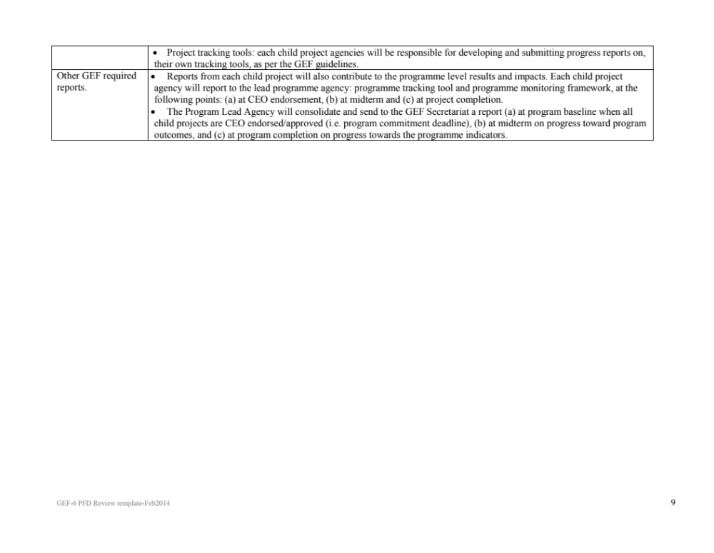

Comments and Responses at GEF Council – October 2015

U.S.

- What is the rationale for pursuing this project as a Programmatic Approach, rather than as a single global project?

Response: Markets for the appliances that will be targeted are increasingly global, with production/manufacturing concentrated in a few countries and then traded to the rest of the world. As such, there is a need for policy harmonization and consistency across countries and this is much easier achieved in a programmatic approach than in a country by country series of not connected national level projects. The programmatic approach proposes the U4E integrated policy approach to meet individual countries’ policy needs and priorities. U4E integrated policy approaches (minimum standards, MVE, supporting policies, and environmentally sound management) have been demonstrated to permanently transition markets to energy efficient products while addressing environmental concerns. The programmatic approach allows for the use of a coherent and consistent integrated approach, providing greater likelihood of a true market transformation success and increased harmonization between countries. Further, child projects under the programmatic approach allow for the best practices to be implemented in the country, such as developing/agreeing to minimum energy performance standards, increasing market surveillance capacities, and/or implementing demonstration projects for energy efficient products.

Countries are at varying levels in developing policies that advance energy efficiency of lighting, appliances and equipment. Some countries do have minimum energy performance standards in place and will be complete a project to enhance those standards and ensure their compliance. Additionally, countries have different priorities in terms of products, with some having larger savings potential for lighting while other countries might prioritize air conditioners due to the savings in their country. The programmatic approach accommodates this as it develops common resources with global funding, such as step-by-step guides on advancing markets to energy efficient products and supporting country officials with training. The child projects allow countries to utilize their STAR allocation under the framework of the programmatic approach yet still crafting the child project to meet the individual countries needs. The child projects are customized to meet the needs of policy development and product prioritization of each country.

- In addition to the three countries with child projects included in the proposal, we see that an additional fifteen countries may be receiving funding for capacity building through the SEforALL program. Which countries will be funded? How will countries be selected?

Response: The criteria to receive this support will be based on the country being a partner to initiative, commitment to advance energy efficiency is shown through national communications; funding for project implementation is available (for example GEF projects not falling under the programmatic approach, and other sources of funding, including domestic funding, Germany’s International Climate Initiative, European Commission); regional diversity of countries supported. These prioritization of countries are currently be reviewed under GEF5 Project 5831: “Foundations of a Partnership to Accelerate the Global Market Transformation for Efficient Appliances and Equipment”.

- We note that there may be a plan to expand this program to include significantly more countries (as many as 100).

Response: There is within the global child project an anticipated light touch support for up to 75 countries. However, the number of child projects that may be added to the programmatic approach is much smaller. Currently, additional child projects are being considered in roughly 5-8 countries. These child projects would be proposed within a revised PFD which would be presented to Council for consideration.

  - What is the commitment deadline for additional child projects?

Response: April 2019 (for submission of full CEO endorsement documents).

  - Will the Council have the opportunity to review a revised project framework document with more details for child projects and country participation prior to GEF CEO Endorsement of new child projects?

Response: All child projects, including the three currently in the PFD and any future child projects added with Council approval of a revised PFD, would be submitted for CEO endorsement no later than the commitment deadline of April 2019.

- Will countries be able to revise their support of the Program after review of the final PFD document?

Response: Countries will work with agencies during the project design period to reflect any changes in project scope in the CEO endorsement request. Revisions to the PFD would be for the purpose of adding child projects; therefore Countries will have ample opportunity to ensure the project designs align country priorities with the PFD objectives.

Germany

Germany welcomes the program proposal in support of a global approach to introducing high-efficiency appliances and electrical products. The ambitious proposal builds on an existing GEF program (SEforALL) and will make a significant contribution to GHG reductions, as well as market transformation, if risks are well-managed and implementation is well-coordinated across a broad spectrum of stakeholders. Germany requests that the following requirements are taken into account during the design of the final project proposal:

General response: All comments will be taken into account during the project development and will be incorporated into the final project proposal.

With regard to Menu Option 4: Supporting policies for the market transformation to energy efficient products. For this menu option, it is written that “campaigns may include working with retailers to train staff to help and advise consumers.” A perhaps more efficient alternative would be to make sure that appliance manufacturers have the capacity to provide trainings to their distributors/retailers rather than the program attempting to train personnel at points of sale.

Response: Thanks for this good suggestion. This is a better approach offering longer-term sustainability and the project can use best practices from the manufacturing partners to the project (OSRAM, Philips, BSH, Mabe, etc.). This suggestion will be integrated into project design.

With regard to demonstration projects: such projects should make energy and monetary savings public knowledge, with for example a digital meter (or low-tech alternative) in the lobby of the targeted ministry building, which compares costs and energy usage between efficient and inefficient systems. The program also intends to enable local manufacturers to produce energy-efficient appliances. It would be helpful to include information as to what extent patent-holders elsewhere may impede this objective, and to what extent lesser-efficient technologies are to be utilized because of high costs for super-efficient technologies?

Response: We have not yet encountered patent issues blocking the way for energy efficient products, contrarily it is often more expensive material or design that makes the product more expensive. For example, using more efficient material (such as copper) and/or using more insulation in refrigerators. Patent issues and clear measures to transparently and effectively present energy and financial savings will be fully integrated during project development. In regards to the lower efficient technologies being used instead of higher cost super-efficient technologies: the project will support countries to make the transition based on their national circumstances. For example, minimum energy performance standards (MEPS) could be put in place to remove the lower performing products (for example inefficient incandescent lamps) from the market to shift to higher efficient (for example CFLs), and also promoting awareness/demand for highly efficient products (for example LEDs) through demonstration or distribution campaigns of highly efficient products.

Regarding gender: during the consultations with end-users, it should be determined if priorities for efficient appliances differ across the gender spectrum in order to pinpoint the priorities at the family-level vs. at a business or institutional level.

Response: Thanks for this good suggestion. This will be integrated into project design.

The benefits section needs clarifications for greater coherence as it is not clear from the outset that the higher emission reduction numbers include the SEforALL Project’s emission reductions.

Response: The savings presented are only for this project. Further clarification will be given during the project design.

A further point of confusion is related to the pie chart on page 14, which does not depict “total potential CO₂ Savings” as it is labelled, but rather shows the share of CO₂ savings that will come from the Leapfrogging (34%) vs. the SE4ALL (66%) Programs. The chart should be labelled accordingly. When one gets to the chart on page 15, then the percent allocations are switched, with 33% of the CO₂ reductions attributed to SEforALL and 67% attributed to the Leapfrogging Program, which creates more confusion when compared with the previous pie chart. The section could generally benefit from more coherent language, as it is difficult to follow.

Response: Comment well noted. The pie chart should have Leapfrogging 33% and SEforALL as 67%. This will be fixed and further clarity on this will be integrated in the final proposal.

A general consideration: experience with switching consumers from, for example, cheap disposable batteries to long-life, rechargeable batteries has shown that in order to have a successful transition, the consumer needs to see the benefit of making the switch, both in terms of money saved and a superior product. Getting consumers hooked on the energy-efficient appliances will require not only innovative financing to overcome higher upfront costs but also clarity that the product is the better choice in the long-run. Communication, training and outreach are, therefore, as crucial as having the product itself available.

Response: Agreed. This is an excellent point in relation to consumer’s confidence. It should be noted that consumer confidence also relates to the actual real life performance of a product compared to what is written on the packaging. Monitoring, verification, and enforcement (MVE), which is included in the project of standards and energy performance claims, is also needed to ensure that consumer confidence in energy efficient. For example, without MEPS and MVE, it is likely that poor performing LEDs will enter the market, which will result in consumers not believing in the energy and lifetime claims on the packaging. With a strong MVE regime, it will ensure that products meet defined criteria (energy efficiency, lifetime, and a defined performance such as amount light provided) and consumers will have strong confidence in the claims on the package. Communication, training and outreach will also be strengthened in the project design.

Annex C: Status of implementation of project preparation activities and the use of funds

Provide detailed funding amount of the PPG activities financing status in the table below:
PPG Grant Approved at PIF: 40,000
Project Preparation Activities Implemented | GEFTF/LDCF/SCCF/CBIT Amount ($)
Project Preparation Activities Implemented | Budgeted Amount | Amount Spent To date | Amount Committed
Contractual Services | 25,000 | 25,000
Staff and other personnel | 15,000 | 2,000 | 13,000
Total | 40,000 | 27,000 | 13,000

Annex D: CALENDAR OF EXPECTED REFLOWS
(if non-grant instrument is used)

Provide a calendar of expected reflows to the GEF/LDCF/SCCF/CBIT Trust Funds or to your Agency (and/or revolving fund that will be set up)

N/A

Annex E: TERMS OF REFERENCE OF PERSONNEL CONSULTANTS TO BE HIRED FOR THE PROJECT USING GEF / LDCF / SCCF RESOURCES
Job Description
National Project Director

Project: Leapfrogging Chilean’s markets to more efficient refrigerator and freezers

Post title: National Project Director

Duration: 3 years

Date Required: January 2018

Duty station: Santiago Chile

Counterpart: Executing Agency Coordinator

Background:
In 2009, the Global Environment Facility (GEF) Secretariat approved the United Nations Environment Programme Global Market Transformation for Efficient Lighting Project, also known as the en.lighten initiative.
Building on the success of the en.lighten initiative, UN Environment and the GEF launched a new United for Efficiency (U4E) initiative in 2015. The initiative supports countries in their transition to the use of energy-efficient lighting, appliances and equipment.
The UN Environment proven integrated policy approach was used in Chile by first time on 2013 allowing the country to be now on the way of implementing its National Efficient Lighting Strategy. Currently, the GEF project “Delivering the transition to energy efficient lighting in Chile” is being executed. Additionally, to other two national projects aiming to transition to efficient lighting are being developed in Peru and Bolivia.
The current Leapfrogging Chilean’s markets to more efficient refrigerator and freezers project is hosted under a Global Leapfrogging Program lead by UN Environment.
Expected Outcomes and deliverables:
The National Project Director must do all the strategic follow-up and analysis of the project, providing all his/her expertise-giving recommendations, orienting the project to reach the goals set in the project. This also includes proposing solutions to the contingencies and problems that arise during the execution of the project, guaranteeing the smooth development of the project components.
The National Project Director will assist the development of strategic alliances with all the stakeholders of the project, for the purpose of increasing synergies and valorization in order to ensure that the proposed objectives are met.
The National Project Director will participate actively in the process of identifying new ideas and opportunities, in the economic evaluation and energy savings impact, choosing partners and defining strategies, like business model, for the sustainability of the project in the future.
Reporting structure:
The National Project Director will report direct to the CEO of Fundación Chile
Qualifications:
Civil or Electrical Engineering with more than 10 years of relevant experience in the environmental, sustainability and innovation space, specializing in the strategic management of projects, at a national and international level.
The National Project Director profile allows integrating diverse fields for the strategic management and planning of a project considering the economic, social, environmental, political, administrative and legal components.
The advisor must have a finished understanding of the national energy industry, and the legal framework.
Languages: Spanish and English
Terms of Reference
Project Manager

Project: Leapfrogging Chilean’s markets to more efficient refrigerator and freezers

Post title: Project Manager

Duration: 3 years

Date Required: January 2018

Duty station: Santiago Chile

Counterpart: Executing Agency Coordinator

Background:
In 2009, the Global Environment Facility (GEF) Secretariat approved the United Nations Environment Programme Global Market Transformation for Efficient Lighting Project, also known as the en.lighten initiative.
Building on the success of the en.lighten initiative, UN Environment and the GEF launched a new United for Efficiency (U4E) initiative in 2015. The initiative supports countries in their transition to the use of energy-efficient lighting, appliances and equipment.

The UN Environment proven integrated policy approach was used in Chile by first time on 2013 allowing the country to be now on the way of implementing its National Efficient Lighting Strategy. Currently, the GEF project “Delivering the transition to energy efficient lighting in Chile” is being executed. Additionally, to other two national projects aiming to transition to efficient lighting are being developed in Peru and Bolivia.
The current Leapfrogging Chilean’s markets to more efficient refrigerator and freezers project is hosted under a Global Leapfrogging Program lead by UN Environment
Expected Outcomes and deliverables:
The PM will be responsible for the day-to-day project operations, financial accounts, periodic reporting to UNEP and the PSC and for allocation of the GEF grant according to the quarterly and annual work plans and budgets in coordination with UNEP and MoE. The PM will also act as secretary of the PSC. The PM will prepare, at the end of the project, the project Terminal Report.
Reporting structure:
The PM will lead the Project Management Unit (PMU) headed by the National Project Director. The PMU will be integrated by Executing Agency Coordinator, Technical Advisors that will be provide advice and guidance in selected project areas and financial support staff as well as Professional and support staff fully financed by MoE and Consultants acting as Technical Advisors (TA) without being permanent staff.
Qualifications:
Environmental or Electrical Engineer with more than 5 years of relevant experience, integral capacities of management, design and operation of environmental projects. Knowledge about energy efficiency is expected.
Following Fundación Chile procedures, it will be required to have competences on: “do tank” oriented, capacity of convening key stakeholders, having a systemic view and being excellence oriented.
Languages: Spanish and English
Terms of Reference
Component 1&2 coordinator / Technical Support

Project: Leapfrogging Chilean’s markets to more efficient refrigerator and freezers

Post title: Component 1&2 coordinator / Technical Support

Duration: 3 years

Date Required: January 2018

Duty station: Santiago Chile

Counterpart: National Project Manager

Background:
In 2009 the Global Environment Facility (GEF) Secretariat approved the United Nations Environment Programme Global Market Transformation for Efficient Lighting Project, also known as the en.lighten initiative.
Building on the success of the en.lighten initiative, UN Environment and the GEF launched a new United for Efficiency (U4E) initiative in 2015. The initiative supports countries in their transition to the use of energy-efficient lighting, appliances and equipment.
The UN Environment proven integrated policy approach was used in Chile by first time on 2013 allowing the country to be now on the way of implementing its National Efficient Lighting Strategy. Currently, the GEF project “Delivering the transition to energy efficient lighting in Chile” is being executed. Additionally, to other two national projects aiming to transition to efficient lighting are being developed in Peru and Bolivia.
The current Leapfrogging Chilean’s markets to more efficient refrigerator and freezers project is hosted under a Global Leapfrogging Program lead by UN Environment
Expected Outcomes and deliverables:
The coordinator will be responsible of the execution of all the activities set in the component 1 and component 2, specifically in:
- Development of a market and regulatory framework analysis
- Update energy efficiency labels of refrigerators/freezers
- Definition of a new MEPS application/implementation plan
-Develop an assessment on MVE practices in Chile and validate with MoE and SEC
- Provide capacity building and technical support to public agencies (MoE, SEC, Customs, others) including technologies advances (High EE, natural refrigerants and smart fridges)
- Develop an interlaboratory performance test
Reporting structure:
Component 1&2 coordinator will report direct to the project manager and will work in collaboration with the U4E consultant and the ministry of energy delegate for the executing of this component.
Qualifications:
Electrical engineering or similar career. Active involvement and expert knowledge in energy policy, energy efficiency strategies and technologies, especially energy-efficient lighting technologies, practices and replacement programs
Following Fundación Chile procedures, it will be required to have competences on: “do tank” oriented, capacity of convening key stakeholders, having a systemic view and being excellence oriented.
Languages: Spanish and English
Terms of Reference
Component 3 coordinator / Technical support

Project: Leapfrogging Chilean’s markets to more efficient refrigerator and freezers

Post title: Component 3 coordinator / Technical support

Duration: 3 years

Date Required: January 2018

Duty station: Santiago Chile

Counterpart: National Project Manager

Background:
In 2009, the Global Environment Facility (GEF) Secretariat approved the United Nations Environment Programme Global Market Transformation for Efficient Lighting Project, also known as the en.lighten initiative.
Building on the success of the en.lighten initiative, UN Environment and the GEF launched a new United for Efficiency (U4E) initiative in 2015. The initiative supports countries in their transition to the use of energy-efficient lighting, appliances and equipment.
The UN Environment proven integrated policy approach was used in Chile by first time on 2013 allowing the country to be now on the way of implementing its National Efficient Lighting Strategy. Currently, the GEF project “Delivering the transition to energy efficient lighting in Chile” is being executed. Additionally, to other two national projects aiming to transition to efficient lighting are being developed in Peru and Bolivia.
The current Leapfrogging Chilean’s markets to more efficient refrigerator and freezers project is hosted under a Global Leapfrogging Program lead by UN Environment.
Expected Outcomes and deliverables:
The Component 3 coordinator will lead the design and implementation of the replacement models including the consumer awareness campaign.
The component 3 coordinator must coordinate the workshops with the different stakeholders to define the best replacement models for the country and will support the identification of the partners to implement the demo programs.
Participate actively in the elaboration of the Communication and Dissemination Plan for the consumer awareness Campaign.
Reporting structure:
Component 3 coordinator / Technical Support will report direct to the project manager. This coordinator will work in collaboration with the marketing area of Fundación Chile.
Qualifications:
Business of administration or similar is required with 5 years of relevant experience in the design, implementation and evaluation of new businesses solutions, market analize, economic modeling and marketing knowledge is expected
Following Fundación Chile procedures, it will be required to have competences on: “do tank” oriented, capacity of convening key stakeholders, having a systemic view and being excellence oriented.
Languages: Spanish and English
Terms of Reference
Component 4 coordinator / Technical support

Project: Leapfrogging Chilean’s markets to more efficient refrigerator and freezers

Post title: Component 4 coordinator / Technical support

Duration: 3 years

Date Required: January 2018

Duty station: Santiago Chile

Counterpart: National Project Manager

Background:
In 2009 the Global Environment Facility (GEF) Secretariat approved the United Nations Environment Programme Global Market Transformation for Efficient Lighting Project, also known as the en.lighten initiative.
Building on the success of the en.lighten initiative, UN Environment and the GEF launched a new United for Efficiency (U4E) initiative in 2015. The initiative supports countries in their transition to the use of energy-efficient lighting, appliances and equipment.
The UN Environment proven integrated policy approach was used in Chile by first time on 2013 allowing the country to be now on the way of implementing its National Efficient Lighting Strategy. Currently, the GEF project “Delivering the transition to energy efficient lighting in Chile” is being executed. Additionally, to other two national projects aiming to transition to efficient lighting are being developed in Peru and Bolivia.
The current Leapfrogging Chilean’s markets to more efficient refrigerator and freezers project is hosted under a Global Leapfrogging Program lead by UN Environment
Expected Outcomes and deliverables:
The component 4 coordinator will be in charge of all the deliverables set in the component 4 of the project, especially he/she will be responsible for the proposal for an operational framework and a strategy for environmentally sound management and collection and recycling system organizations of refrigerators and freezer products
The component 4 coordinator should be focussed in:
- Develop in collaboration with the UN environment consultant a strategy proposal for an environmentally sound management of refrigerators/freezers including refrigerant gases
- Coordinating working meetings with recycling technology suppliers for the development of a business case on ESM and CRSO
- Review the proposal of the design and implementation of a business model for collection and recycling system organization (CRSO) elaborated by the UN Environment consultant.
Reporting structure:
The Component 3 coordinator / Technical Support will report direct to the project manager, but he or she/will work in collaboration with the U4E consultants
Qualifications:
Engineer or Environmental Chemist with more than 5 years of experience. Active involvement and knowledge of international best practices for environmentally sound management of spent refrigerators, including legislative and logistical frameworks for e-waste and gases -added product treatment.
Following Fundación Chile procedures, it will be required to have competences on: “do tank” oriented, capacity of convening key stakeholders, having a systemic view and being excellence oriented.
Languages: Spanish and English

Terms of Reference
Technical Support

Project: Leapfrogging Chilean’s markets to more efficient refrigerator and freezers

Post title: Technical Support

Duration: 3 years

Date Required: January 2018

Duty station: Santiago Chile

Counterpart: National Project Director

Background:
In 2009 the Global Environment Facility (GEF) Secretariat approved the United Nations Environment Programme Global Market Transformation for Efficient Lighting Project, also known as the en.lighten initiative.
Building on the success of the en.lighten initiative, UN Environment and the GEF launched a new United for Efficiency (U4E) initiative in 2015. The initiative supports countries in their transition to the use of energy-efficient lighting, appliances and equipment.
The UN Environment proven integrated policy approach was used in Chile by first time on 2013 allowing the country to be now on the way of implementing its National Efficient Lighting Strategy. Currently, the GEF project “Delivering the transition to energy efficient lighting in Chile” is being executed. Additionally, to other two national projects aiming to transition to efficient lighting are being developed in Peru and Bolivia.
The current Leapfrogging Chilean’s markets to more efficient refrigerator and freezers project is hosted under a Global Leapfrogging Program lead by UN Environment
Expected Outcomes and deliverables:
The technical support will support the team in all the activities related to the whole project (transversely support) especially in gathering information, document analysis, stakeholders mapping, seminars and meetings organization, implementation of the consumer awareness campaign, and demo programs among others.
Reporting structure:
The Technical Support will work in collaboration with the components coordinators and will report direct to the project manager.
Qualifications:
Engineer with 2 year of experience in the sustainability field.
Following Fundación Chile procedures, it will be required to have competences on: “do tank” oriented, capacity of convening key stakeholders, having a systemic view and being excellence oriented.
Languages: Spanish and English

Terms of Reference of Subcontracts needed for the project
National communication and dissemination Coordinator
Project: Leapfrogging Chilean’s markets to more efficient refrigerator and freezers

Post title: National communication and dissemination Coordinator

Duration: 3 years

Date Required: January 2018

Duty station: Santiago, Chile

Counterpart: National Project Director

Background:
In 2009 the Global Environment Facility (GEF) Secretariat approved the United Nations Environment Programme Global Market Transformation for Efficient Lighting Project, also known as the en.lighten initiative.
Building on the success of the en.lighten initiative, UN Environment and the GEF launched a new United for Efficiency (U4E) initiative in 2015. The initiative supports countries in their transition to the use of energy-efficient lighting, appliances and equipment.
The UN Environment proven integrated policy approach was used in Chile by first time on 2013 allowing the country to be now on the way of implementing its National Efficient Lighting Strategy. Currently, the GEF project “Delivering the transition to energy efficient lighting in Chile” is being executed. Additionally, to other two national projects aiming to transition to efficient lighting are being developed in Peru and Bolivia.
The current Leapfrogging Chilean’s markets to more efficient refrigerator and freezers project is hosted under a Global Leapfrogging Program lead by UN Environment
Expected Outcomes and deliverables:
The national communication and dissemination coordinator should be focussed in:
-Coordinate strategic concept of the entire consumer awareness and recycling campaign with all activities and deliverables.
- Communication plan with contents and key partners
- Development of events, meetings, tours, experiences
- Coordinate the communication Medias,
- Contribute to the development of activities that amplify the impact of the initiative
Reporting structure:
The national communication and dissemination coordinator will be responsible for the executing of the consumer awareness Campaign. The national communication and dissemination coordinator will report direct to the project Manager. He/she also must work in collaboration with the marketing team of Fundación Chile.
Qualifications:
Business of administration with specialization in marketing- Specific knowledge in green communication is required
Following procurement procedures, it will be required to have competences on: “do tank” oriented, capacity of convening key stakeholders, having a systemic view and being excellence oriented.
Languages: Spanish and English (at least working proficiency).
Terms of Reference of Consultants needed for the project
Gender Consultant
Project: Leapfrogging Chilean’s markets to more efficient refrigerator and freezers

Post title: Technical Support

Duration: minimum of 10 weeks

Date Required: June 2018

Duty station: Santiago Chile

Counterpart: National Project Director
Background:
In 2009 the Global Environment Facility (GEF) Secretariat approved the United Nations Environment Programme Global Market Transformation for Efficient Lighting Project, also known as the en.lighten initiative.
Building on the success of the en.lighten initiative, UN Environment and the GEF launched a new United for Efficiency (U4E) initiative in 2015. The initiative supports countries in their transition to the use of energy-efficient lighting, appliances and equipment.
The UN Environment proven integrated policy approach was used in Chile by first time on 2013 allowing the country to be now on the way of implementing its National Efficient Lighting Strategy. Currently, the GEF project “Delivering the transition to energy efficient lighting in Chile” is being executed. Additionally, to other two national projects aiming to transition to efficient lighting are being developed in Peru and Bolivia.
The current Leapfrogging Chilean’s markets to more efficient refrigerator and freezers project is hosted under a Global Leapfrogging Program lead by UN Environment
Expected Outcomes and deliverables:
The gender consultant will undertake a stakeholder mapping study in order to identify gender gaps and any vulnerable population that could be negative or positively impacted by the project. This assessment will include rapid assessments, structured interviews or observations to provide insights that will help to take gender and socio-economic aspects for the design of communication campaigns, the selection of the refrigerator model that will be used for the replacement model.
Reporting structure:
The Gender Consultant will report direct to the project manager, but he or she/will work in collaboration with the U4E consultants
Qualifications:
Degree in a relevant discipline including gender, international development or environment, with experience in gender analysis, gender and stakeholders mapping.
Languages: Spanish and English
Terms of Reference of Consultants needed for the project
International Financial Mechanism Specialist

Project: Leapfrogging Chilean’s markets to more efficient refrigerator and freezers

Post title: International Financial Mechanism Specialist

Duration: Minimum of 6 month

Date Required: January 2018

Duty station: Consultant is required to be based in Chile or be able to travel to the project site

Counterpart: U4E Project Manager/National Project Director

Background:
In 2009 the Global Environment Facility (GEF) Secretariat approved the United Nations Environment Programme Global Market Transformation for Efficient Lighting Project, also known as the en.lighten initiative.
Building on the success of the en.lighten initiative, UN Environment and the GEF launched a new United for Efficiency (U4E) initiative in 2015. The initiative supports countries in their transition to the use of energy-efficient lighting, appliances and equipment.
The UN Environment proven integrated policy approach was used in Chile by first time on 2013 allowing the country to be now on the way of implementing its National Efficient Lighting Strategy. Currently, the GEF project “Delivering the transition to energy efficient lighting in Chile” is being executed. Additionally, to other two national projects aiming to transition to efficient lighting are being developed in Peru and Bolivia.
The current Leapfrogging Chilean’s markets to more efficient refrigerator and freezers project is hosted under a Global Leapfrogging Program lead by UN Environment.
Expected Outcomes and deliverables:
The Financial Mechanism Specialist should be focussed in:
- Develop research on successful international demonstrative programmes
- Analyse and evaluate with a view of drawing lessons international demonstrative programmes to be applicable in Chile
-Analyse international experience on financial mechanisms applicable for replacement programme in Chile
- Provide technical advice to the local counterpart to design and implement the demonstration programme, though results presentation.
- Prepare a final report containing all the findings and recommendations to design and implement a demonstration programme for refrigerators including a financial mechanism in Chile.
Reporting structure:
The consultant will act under the direct supervision of the Project Manager of the United for Efficiency (U4E) initiative and in coordination with the Climate Change Mitigation Officer in ROLAC. The deliverables should be approved by national counterpart.
Qualifications:
An advanced university degree in engineering, economics or finance is required and further studies on energy efficiency are desirable.
Experience designing and implementing demonstration programmes for cooling appliances as well as strong technical competencies in financial mechanisms.
Strong writing and analytical skills and capacity to convening key stakeholders, having a systemic view and being excellence oriented.
Languages: Spanish and English (at least working proficiency).

Terms of Reference of Consultants needed for the project
International Environmental Sound Management Specialists
Project: Leapfrogging Chilean’s markets to more efficient refrigerator and freezers

Post title: International Environmental Sound Management Specialists

Duration: Minimum of 6 month

Date Required: January 2018

Duty station: Consultant is required to be based in Chile or be able to travel to the project site

Counterpart: U4E Project Manager/National Project Director

Background:
In 2009 the Global Environment Facility (GEF) Secretariat approved the United Nations Environment Programme Global Market Transformation for Efficient Lighting Project, also known as the en.lighten initiative.
Building on the success of the en.lighten initiative, UN Environment and the GEF launched a new United for Efficiency (U4E) initiative in 2015. The initiative supports countries in their transition to the use of energy-efficient lighting, appliances and equipment.
The UN Environment proven integrated policy approach was used in Chile by first time on 2013 allowing the country to be now on the way of implementing its National Efficient Lighting Strategy. Currently, the GEF project “Delivering the transition to energy efficient lighting in Chile” is being executed. Additionally, to other two national projects aiming to transition to efficient lighting are being developed in Peru and Bolivia.
The current Leapfrogging Chilean’s markets to more efficient refrigerator and freezers project is hosted under a Global Leapfrogging Program lead by UN Environment.
Expected Outcomes and deliverables:
The Environmental Sound Management Specialists should be focussed in:
- Develop a strategy proposal for an environmentally sound management of refrigerators/freezers including refrigerant gases
- Working meetings with recycling technology suppliers for the development of a business case on ESM and CRSO
-Prepare capacity building for main stakeholders
- Design and implementation of a business model for collection and recycling system organization (CRSO) elaborated in a participative stakeholder process
Reporting structure:
The consultant will act under the direct supervision of the Project Manager of the United for Efficiency (U4E) initiative and in coordination with the Climate Change Mitigation Officer in ROLAC. The deliverables should be approved by national counterpart.
Qualifications:
An advanced university degree in engineering or sciences with further specialization in environmental engineering and/or sustainable development is required.
Competences on: electronic waste, specifically refrigerators and freezers product treatment, international best practices including legislative and logistical frameworks and experience in implementing the environmental principle of extended producer responsibility regulation. Additionally, capacity of convening key stakeholders, having a systemic view and being excellence oriented.
Languages: Spanish and English (at least working proficiency).

Terms of Reference of Consultants needed for the project
International Minimum Energy Performance Standard (MEPS) Specialist

Project: Leapfrogging Chilean’s markets to more efficient refrigerator and freezers

Post title: International Minimum Energy Performance Standard (MEPS) Specialist

Duration: Minimum of 6 month

Date Required: January 2018

Duty station: Consultant is required to be based in Chile or be able to travel to the project site

Counterpart: U4E Project Manager/National Project Director

Background:
In 2009 the Global Environment Facility (GEF) Secretariat approved the United Nations Environment Programme Global Market Transformation for Efficient Lighting Project, also known as the en.lighten initiative.
Building on the success of the en.lighten initiative, UN Environment and the GEF launched a new United for Efficiency (U4E) initiative in 2015. The initiative supports countries in their transition to the use of energy-efficient lighting, appliances and equipment.
The UN Environment proven integrated policy approach was used in Chile by first time on 2013 allowing the country to be now on the way of implementing its National Efficient Lighting Strategy. Currently, the GEF project “Delivering the transition to energy efficient lighting in Chile” is being executed. Additionally, to other two national projects aiming to transition to efficient lighting are being developed in Peru and Bolivia.
The current Leapfrogging Chilean’s markets to more efficient refrigerator and freezers project is hosted under a Global Leapfrogging Program lead by UN Environment.
Expected Outcomes and deliverables:
The Minimum Energy Performance Standard (MEPS) Specialist should be focussed in:
- Conduct a research on international energy efficiency labelling for refrigerators/freezers
- Preparation of report including main findings on international experience
- Conduct research on international MEPS planning of at least 10 countries
-Preparation of report including main findings on international experience
- Provide technical advice to the local counterpart in labelling and MEPS
-Present final results to main stakeholders
Reporting structure:
The consultant will act under the direct supervision of the Project Manager of the United for Efficiency (U4E) initiative and in coordination with the Climate Change Mitigation Officer in ROLAC. The deliverables should be approved by national counterpart.
Qualifications:
Advanced university degree in electrical engineering or similar with further specialization in energy efficiency is required.
Experience on the development of labeling and MEPS proposals for appliances specifically refrigerators and freezers for the residential sector is required.
Competences on: design and/or implementation of energy efficiency projects, specifically refrigerators and freezers. Capacity of convening key stakeholders, having a systemic view and being excellence oriented.
Languages: Spanish and English (at least working proficiency).

Terms of Reference of Consultants needed for the project
International Monitoring Verification and Enforcement (MVE) Specialist or expert from Laboratory

Project: Leapfrogging Chilean’s markets to more efficient refrigerator and freezers

Post title: International Monitoring Verification and Enforcement (MVE) Specialist or expert from Laboratory

Duration: Minimum of 6 month

Date Required: January 2018

Duty station: Consultant is required to be based in Chile or be able to travel to the project site

Counterpart: U4E Project Manager/National Project Director

Background:
In 2009 the Global Environment Facility (GEF) Secretariat approved the United Nations Environment Programme Global Market Transformation for Efficient Lighting Project, also known as the en.lighten initiative.
Building on the success of the en.lighten initiative, UN Environment and the GEF launched a new United for Efficiency (U4E) initiative in 2015. The initiative supports countries in their transition to the use of energy-efficient lighting, appliances and equipment.
The UN Environment proven integrated policy approach was used in Chile by first time on 2013 allowing the country to be now on the way of implementing its National Efficient Lighting Strategy. Currently, the GEF project “Delivering the transition to energy efficient lighting in Chile” is being executed. Additionally, to other two national projects aiming to transition to efficient lighting are being developed in Peru and Bolivia.
The current Leapfrogging Chilean’s markets to more efficient refrigerator and freezers project is hosted under a Global Leapfrogging Program lead by UN Environment.
Expected Outcomes and deliverables:
The Monitoring Verification and Enforcement (MVE) Specialist should be focussed in:
- Development of assessment of MVE practices in Chile to enhance monitoring, surveillance, control, and testing system
-Conduct validation workshop, presentation of MVE final report
-Provide capacity building and technical support to public agencies including advance technologies
-Provide final recommendations to develop/improve laboratory capacities at national level
Reporting structure:
The consultant will act under the direct supervision of the Project Manager of the United for Efficiency (U4E) initiative and in coordination with the Climate Change Mitigation Officer in ROLAC. The deliverables should be approved by national counterpart.
Qualifications:
Advanced university degree in engineering or sciences with further specialization in energy efficiency is desirable. Experience on MVE system in order to strength national laboratories, testing methods and quality control system is required.
Competences on: market surveillance, testing methods to guarantee the verification process
Capacity of convening key stakeholders, having a systemic view and being excellence oriented.
Languages: Spanish and English (at least working proficiency).

Terms of Reference
Administrative personnel
Project: Leapfrogging Chilean’s markets to more efficient refrigerator and freezers

Post title: Administrative personnel

Duration: 3 years

Date Required: January 2018

Duty station: Santiago, Chile

Counterpart: National Project Director

Background:
In 2009 the Global Environment Facility (GEF) Secretariat approved the United Nations Environment Programme Global Market Transformation for Efficient Lighting Project, also known as the en.lighten initiative.
Building on the success of the en.lighten initiative, UN Environment and the GEF launched a new United for Efficiency (U4E) initiative in 2015. The initiative supports countries in their transition to the use of energy-efficient lighting, appliances and equipment.
The UN Environment proven integrated policy approach was used in Chile by first time on 2013 allowing the country to be now on the way of implementing its National Efficient Lighting Strategy. Currently, the GEF project “Delivering the transition to energy efficient lighting in Chile” is being executed. Additionally, to other two national projects aiming to transition to efficient lighting are being developed in Peru and Bolivia.
The current Leapfrogging Chilean’s markets to more efficient refrigerator and freezers project is hosted under a Global Leapfrogging Program lead by UN Environment.
Expected Outcomes and deliverables:
The Administrative personnel will assist the Project Manager in monitoring and evaluation tasks related to financial reporting of the project. He or she will provide assistance to the project during the conduction of annual external audits and evaluations.
Reporting structure:
The Administrative personnel will assist the Project Manager. He or she will be supervised and will report to the project manager and the Finance Director.
Qualifications:
Business administration or Economics with more than 3 years of relevant experience working with development profitable projects.
Languages: Spanish and English (at least working proficiency).

Annex F1: Detailed GEF budget
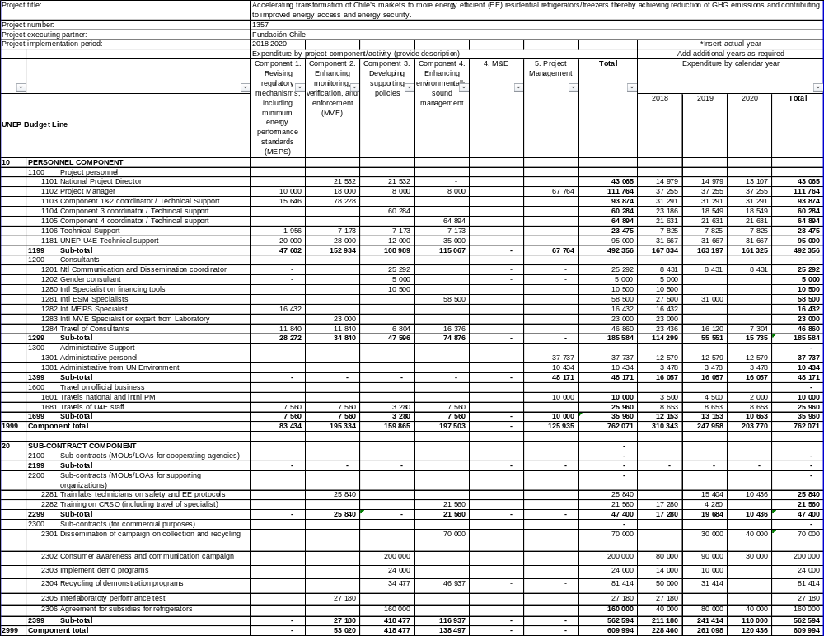
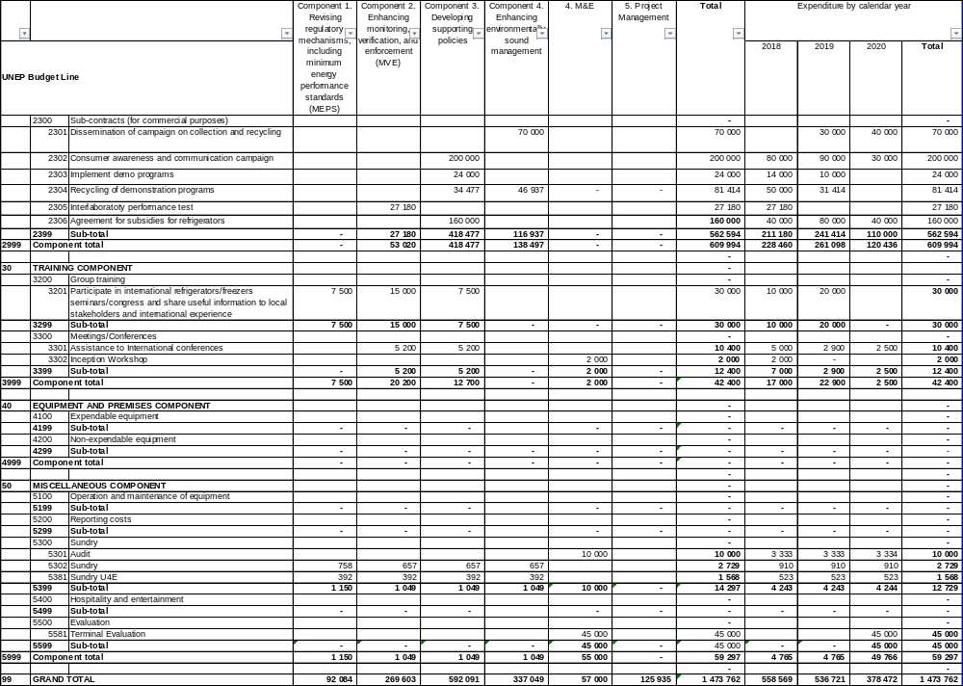

Annex F2: Cofinance budget
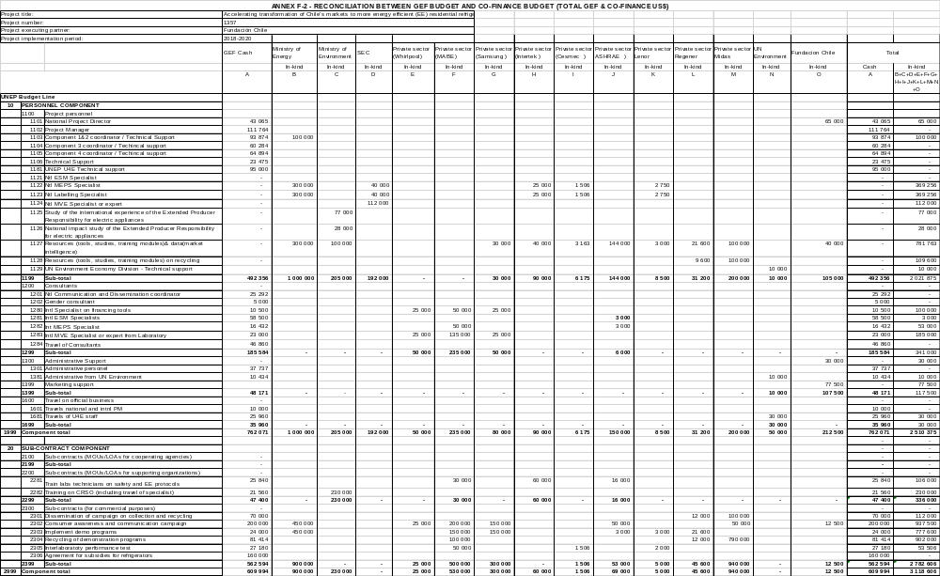
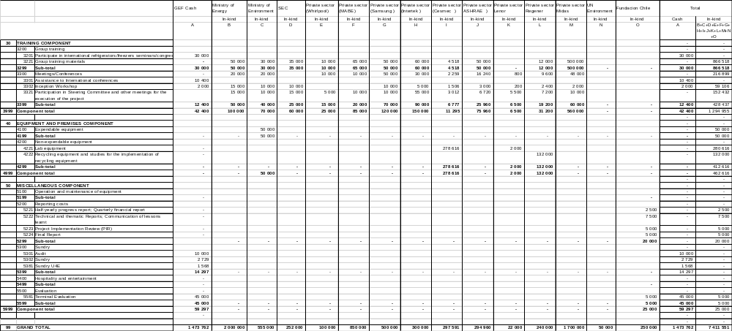

Annex G: M&E budget and work plan

M&E Activity | Description | Responsible Parties | Timeframe | Indicative GEF budget (USD)
Inception Workshop (IW) and Report | Report prepared immediately following the IW; it includes: | Execution:  PMU, UN ENVIRONMENT  Support:  FCh, Minister of Energy and Minister of Environment | Immediately following, within 2 months of project start-up
Inception Workshop (IW) and Report | Detailed Work Plan and budget for the first year, as well as an overview of AWPs for subsequent years, divided per output and inputs (budget lines). |  | Immediately following, within 2 months of project start-up | GEF 2,000
Inception Workshop (IW) and Report | A more detailed narrative of roles of UN Environment, PMU and PSC: institutional responsibilities, coordinating actions and feedback mechanisms  Detailed Project Supervision and a M&E Plan |  | Immediately following, within 2 months of project start-up
Half-yearly progress report; Quarterly financial reports; | Part of UN Environment procedures for project monitoring.  Quarterly financial: Detailed financial reports (in Excel), with justification of any change; Bi-annual progress: | Execution:  UN Environment  Support: PMU | Two (2) bi-annual reports for any given year (July 31 and January 31);  Quarterly financial reports  Last progress & financial Reports within 60 days of project closure of operations | GEF: Part of Project management  Co-fin: 2,500
 | Analyzes project performance over the reporting period UN Environment; Describes constraints experienced in the progress towards results and the reasons | Execution:  UN Environment  Support: PMU |  | GEF: Part of Project management  Co-fin: 2,500
 | Describes Work Plan for the next period in an Annex and the detailed budget divided per output and inputs (budget lines) | Execution:  UN Environment  Support: PMU |  | GEF: Part of Project management  Co-fin: 2,500
Technical and thematic Reports; Communication of lessons learnt | Technical and thematic periodic reports could also be prepared to focus on specific issues or areas of activity covered by the project, | Execution: PMU  Support: MoE | As necessary for the thematic reports | GEF: Part of Project management  Co-fin:7,500
Project Implementation Review (PIR) | Analyzes project performance over the reporting period UN Environment; Describes constraints experienced in the progress towards results and the reasons.  Draws lessons and makes clear recommendations for future orientation in addressing the key problems in the lack of progress. | Execution: PMU  Support: UN Environment, Minister of Energy and Minister of Environment | Yearly, by 31 July latest | GEF: Part of Project management  Co-fin: 5,000
Project Implementation Review (PIR) | The PIR is discussed at PSC meetings | Discussed and accepted at PSC (Project Steering Committee) meetings
Final Report | The project team will draft and submit a Project Final Report, with other docs (such as last PIR) can serve as Project Final Report to the UN Environment, at least two weeks before the PSC meeting for their review and comments; this meeting decides whether any action is needed to achieve the sustainability of project results; and draws lessons to be captured into other projects; | Execution: PMU  Support: Government counterparts, UN Environment | Final report at least two-three months of the project completion date; | GEF: : Part of Project management  Co-fin:5,000
Final Report | Comprehensive report summarizing all activities, achievements, lessons learned, objectives met or not achieved structures and systems implemented, etc. Lays out recommendations for any further steps that may need to be taken to ensure the sustainability and replication of project activities. |  |  | GEF: : Part of Project management  Co-fin:5,000
Terminal Evaluation | Looks at the impacts and sustainability of the results, including the contribution to capacity development and the achievement of global environmental goals. | Execution: Independent consultants  Support: PMU, UN Environment and Government counterparts | One-three months prior to the end of the project | GEF: 45,000  Co-fin: 5,000
Audits | Financial audits | Execution: Independent auditors  Support: PMU | Annually | GEF:10,000
TOTAL indicative COST |  |  | GEF: USD 57,000
(Excluding project team staff time and UN Environment staff and travel expenses) |  |  | Co-fin: USD 25,000

Annex H: Project implementation arrangements
Describe here the project implementation arrangements (Project Steering Committee, Project Management Unit and structure, stakeholders involved, workgroups, institutional setting, organization chart, workflow, etc.)
The Project is funded by the Global Environment Facility (GEF) with the United Nations Environment Programme (UN Environment) acting as the GEF Implementing Agency. The Ministry of Energy has designated Fundación Chile as the executing body. Fundación Chile will be accountable to the Ministry of Energy, Government and UN Environment/GEF for ensuring the Executing Agency activities as per the table below.

Project Governance Structure
Body | Composition | Role and description | Frequency of meetings
Project Steering Committee (PSC) | - National Project Director (NPD)  - Project Manager (PM)  - GEF Operational Focal Point (GEF OFP)  - UN Environment  - Ministry of Energy  - Ministry of Environment  - SEC  - AChEE  - Chilecompra  - Suppliers  - Other stakeholders | - The PSC will be multi-disciplinary and multi-sectoral in fields related to energy efficiency, public procurement and environmentally-sound end-of-life integrated waste management and will be responsible for:  - Oversight of the project progress and implementation of outputs in each of the 4 project components;  - Approve annual work plans and budget;  - Approve management decisions to ensure timely delivery of quality outputs;  - Provide overall guidance and strategic direction;  - Mobilize national stakeholders to support project implementation, as well as provide synergies with other complementing initiatives and ongoing projects;  - Address logistical issues, e.g. through organization of meetings and provision of relevant facilities;  - Provide insight on national policy barriers and proposed stages of national policy development | Twice a year
Implementing Agency (IA) | UN Environment Climate Change Mitigation (CCM) Unit | - Ensure timely disbursement/sub-allotment to executing agency, based on agreed legal document and in accordance with UN Environment and GEF fiduciary standards  - Follow-up with Executing agency for progress, equipment, financial and audit reports  - Provide consistent and regular oversight on project execution and conduct project supervisory missions as per Supervision Plans and in doing so ensures that all UN Environment and GEF criteria, rules and regulations are adhered to by project partners;  - Technically assess and oversee quality of project outputs, products and deliverables – including formal publications  - Provide on-objection to main TORs and subcontracts issued by the project, including selection of project manager or equivalent  - Attend and facilitate inception workshops, field visits where relevant, and selected steering committee meetings  - Asses project risks, and monitor and enforce a risk management plan  - Regularly monitors project progress and performance and rates progress towards meeting project objectives, project execution progress, quality of project monitoring and evaluation, and risk;  - Monitor reporting by project executing partners and provides prompt feedback on the contents of the report;  - Promptly informs management of any significant risks or project problems and takes action and follows up on decisions made;  - Apply adaptive management principles to the supervision of the project  - Review of reporting, checking for consistency between execution activities and expenditures, ensuring that it respects GEF rules,  - Clearance of cash requests, and authorization of disbursements once reporting found to be complete  - Approve budget revision, certify fund availability and transfer funds  - Ensure that GEF and UN Environment quality standards are applied consistently to all projects, including branding and safeguards  - Certify project operational completion  - Link the project partners to any events organized by GEF and UN Environment to disseminate information on project results and lessons  - Manage relations with GEF
Executing Agency (EA) | Fundación Chile (delegated by the Ministry of Energy) | - Ensure that the project meets its objectives and achieves expected outcomes;  - Ensure technical execution according to the execution plan laid out in the project document;  - Ensure technical quality of products, outputs and deliverables;  - Ensure compilation and submission of progress, financial and audit reporting to IA;  - Submit of budget revisions to IA for approval;  - Address and rectifying any issues or inconsistencies raised by the IA;  - Bring issues raised by or associated with clients to the IA for resolution;  - Facilitate Steering Committees and other oversight bodies of the project;  - Day to day oversight of project execution;  - Submit all technical reports and completion reports to IA (realized outputs, inventories, verification of co-finance, terminal reporting, etc.)  - Monitoring and evaluation of the project outputs and outcomes;  - Effective use of both international and national resources allocated to it;  - Timely availability of financing to support project execution;  - Proper coordination among all project stakeholders; in particular national parties;  - Timely submission of all project reports, including work plans and financial reports.  - Follow-up with, or progress, procurement, financial and audit reports;  - Identify funding sources from donor countries, banks and other financing institutions to help leverage funding for revolving fund; | Internal quarterly meetings with PM and NPD
Project Management Unit (PMU) | National Project Director (NPD) | - Will be represented by an officer from the executing agency;  - Act as member of the PSC;  - Report to and receive advice from the PSC;  - Identify and secure partner support for the implementation of project activities;  - Advice on hiring process | Regular meetings with PM
Project Management Unit (PMU) | Project Manager (PM) | - The PM will be paid with GEF funds, will be hosted by Fundación Chile and be responsible for:  - Day-to-day project operations and financial accounts;  - Take responsibility for the execution of the project in accordance with the project objectives, activities and budget;  - Deliver the outputs and demonstrate its best efforts in achieving the project outcomes;  - Coordinate project execution and liaison with national counterparts (relevant ministries, electric utilities, private sector, NGOs etc.).  - Undertake field visits;  - Manage financial resources and processing all financial transaction relating to sub-allotments;  - Prepare all annual/year-end project revisions;  - Attend and facilitate inception workshops and national steering committee meetings;  - Assess project risks in the field, monitor risk management plan;  - Ensure technical quality of products, outputs and deliverables;  - Coordinate the project work team;  - Coordinate with strategic taskforces;  - Act as secretary of the PSC;  - Plan and host/chair the PSC annual meetings;  - Periodic reporting to UN Environment and the PSC for allocation of the GEF grant according to the quarterly and annual work plans and budgets in coordination with UN Environment and NPD;  - Notify UN Environment and the PSC in writing if there is need for modification to the agreed implementation plan and budget, and to seek approval;  - Address and rectify any issues or inconsistencies raised by the Executing Agency;  - Support compilation and submission of progress, financial and audit reporting to the Executing Agency;  - Prepare, at the end of the project, the project Terminal Report. | Regular meetings with NPD and DPWT (at least once a month)  Internal quarterly meetings with Executing Agency
Technical Workgroup | Led by PMU  - National Project Director (NPD)  - Project Manager (PM)  - GEF Operational Focal Point (GEF OFP)  - UN Environment  - Ministry of Energy  - Ministry of Environment  - SEC  - AChEE  - Chilecompra  - SERNAC  - Utilities  - Private sector: refrigerators/freezers representatives, importers, retailers, recycling entities  - ESCOs Association  - Consumer Organizations  - Universities/Technical institutes  - NGOs | Technical workgroups supports the development of project components and allow to coordinate efforts with national and international partners.  - Advise and support the project with the development of, and access to, technical information, tools, methodologies and guidelines;  - Identify opportunities/address barriers to market development and;  - Support implementation of pilot replacement programme  - Support strengthening of capacities for environmentally sound end-of-life integrated management | Quarterly meetings and periodic coordination calls
Technical Support | UN Environment - United for Efficiency Centre of Excellence (U4E) | - Provide strategic, technical and methodological support to the Executing Agency’s PMU, contribute to PWT and the PSC.  - Provide technical assistance for:  - Update energy label classification for refrigerators and freezers: Conduct research on international energy efficiency labeling for refrigerators/freezers  - Define new MEPS application/implementation plan: Conduct research on international MEPS planning of at least 10 countries  - Component 2. Enhancing monitoring, verification, and enforcement (MVE)  - Develop an assessment on MVE practices in Chile and validate with Ministry of Energy (MoE) and Superintendence of Electricity and Fuels (SEC)  - Provide capacity building and technical support to public agencies  - Improve capacities and facilities for refrigeration safety and efficiency test protocols according to international experts recommendations : Train labs technicians on safety and energy efficiency protocols  - Evaluate relevant international experience: Develop research on successful international replacement demonstration programmes  - Develop a strategy proposal for an environmentally sound management of refrigerators/freezers including refrigerant gases  - Develop CRSO business model for end of life refrigerators able to start below voluntary scheme, including potential international coordination for the environmentally sound export/import of refrigerators waste/ refrigerant gas  - Training on potential private business models to governmental authorities, retailers and recycling companies  - Facilitate the engagement and support of U4E partners notably the co-financing partners (Whirlpool, Mabe), relevant expert organizations and international experts;  - Support the dissemination of project results and outputs;  - Facilitate synergies and links between the project and the Global U4E programme and related national projects. | Periodic meetings with PMU and EA
Project Work Team (PWT) | Led by PMU  It will consist of consultants and contractors to be hired to develop specific project outputs or activities | - Hired as required by the project work plan to implement specific activities and outputs;  - Report to PMU;  - Take responsibility for the execution and ensure technical quality of the activities or outputs they conduct;  - Undertake field visits (if required); | Periodic meetings with PMU

These agreements are based on the Ministry willing of delegating the Eecuting Agency role to Fundacion Chile as well as to requesting the technical support of the U4E Un Enviroment programme, as per the letter below.
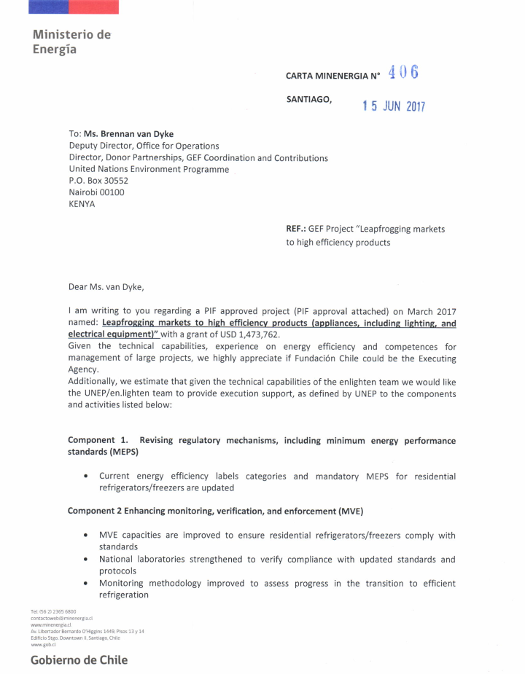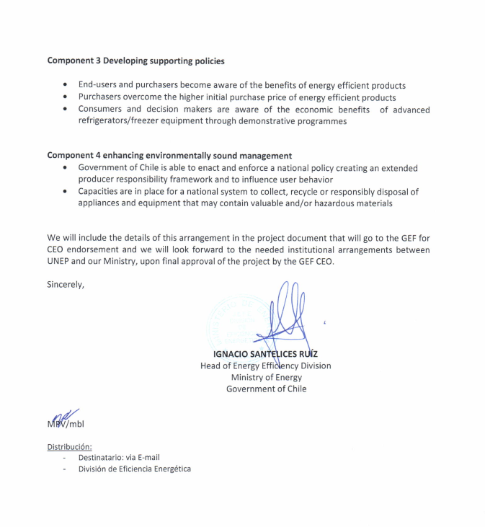

ANNEX I: Work plan with deliverables and benchmarks

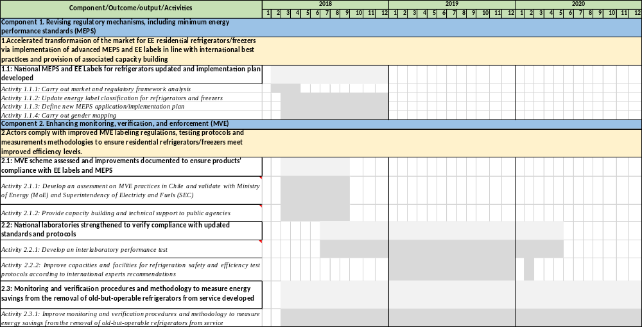

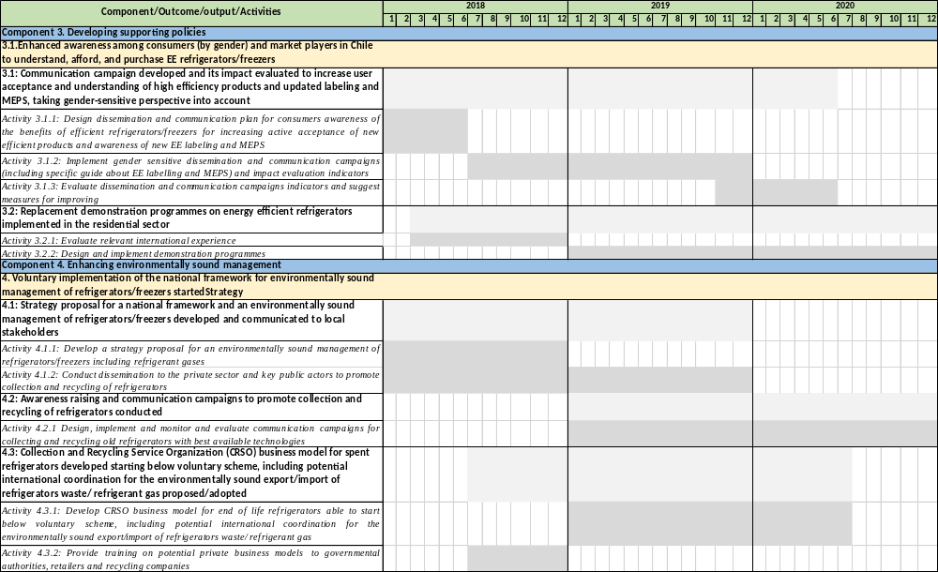

Annex J-2: Estimates of Direct and Indirect greenhouse gas emission reduction

The estimates of direct and indirect GHG emission reductions for this project is as follows:
Direct GHG Emission Savings (tCO2) - Allocated to this child project | 547,462
Direct Post-project GHG Emission Savings (tCO2)- Allocated to this child project | 3,093,088
Total Direct (including Post-project) GHG Emission Savings (tCO2)- Allocated to this child project | 3,640,551
Indirect Bottom-up Emission Savings (tCO2) | 12,355
Indirect Top-down Emission Savings (tCO2) | 3,855,109

This has been estimated using the GEF Energy Efficiency Tool results (shown below) but allocating only 50% of these estimations to the actual child project and considering only a 10 years period of influence after project closure. This gives the project a more conservative target and also avoids double-counting emissions that have been allocated to global projects.
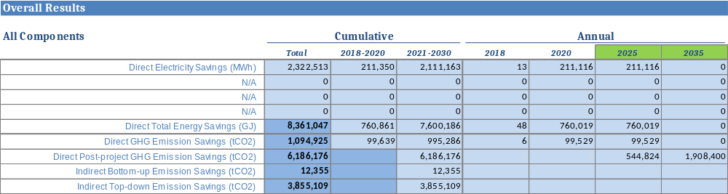
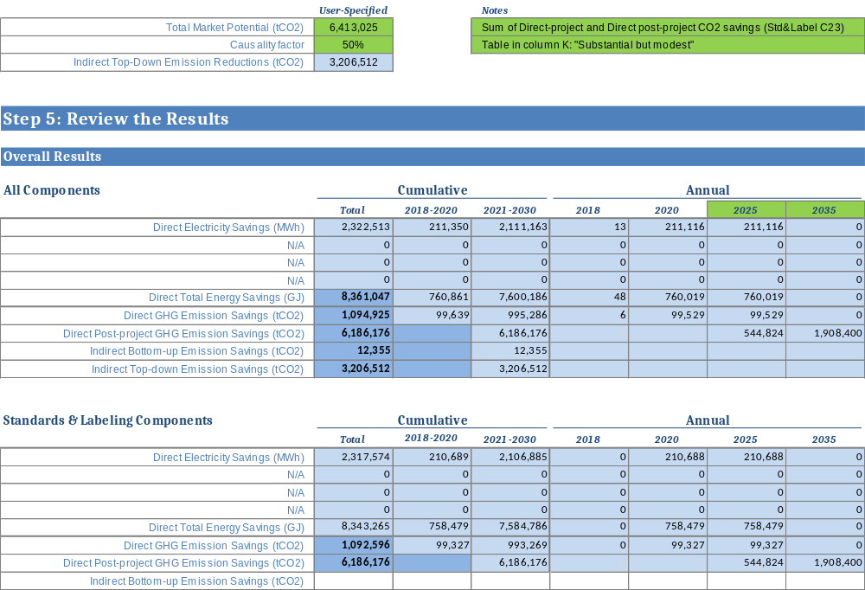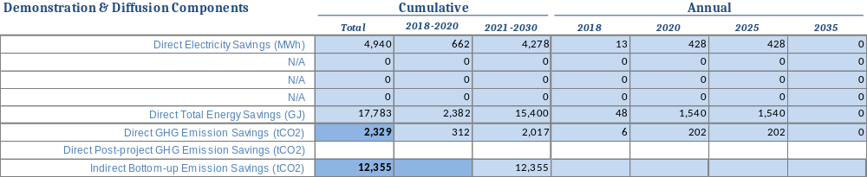

Annex K: OFP EndoRsement Letter

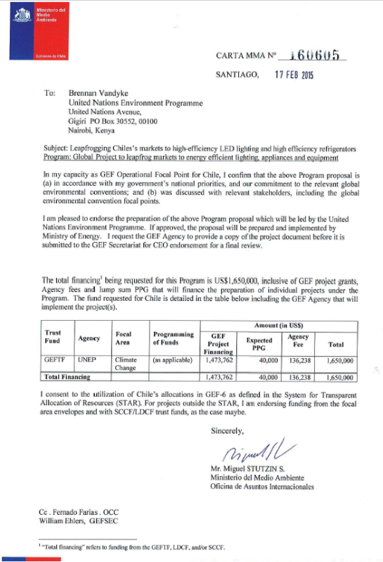

Annex L: Co-Financing Commitment Letters

- Ministry of Energy
- SEC
- Ministry of Environment
- Fundación Chile
- ASHRAE
- UN Environment
- Samsung
- MABE
- Whirlpool
- CESMEC
- Intertek
- Lenor
- Regener Chile
- Midas
- Electrolux

Ministry of Energy

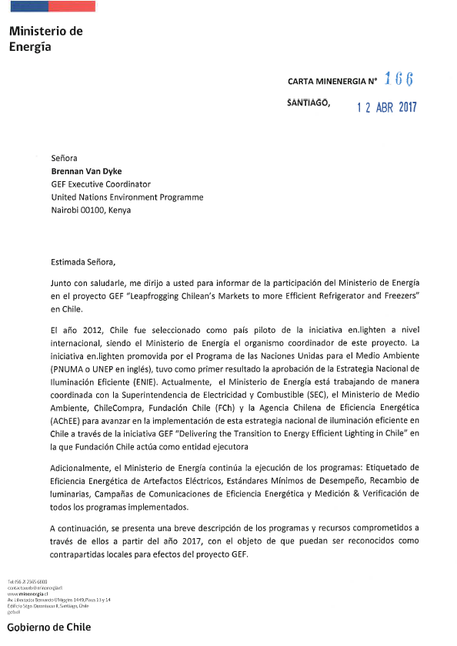
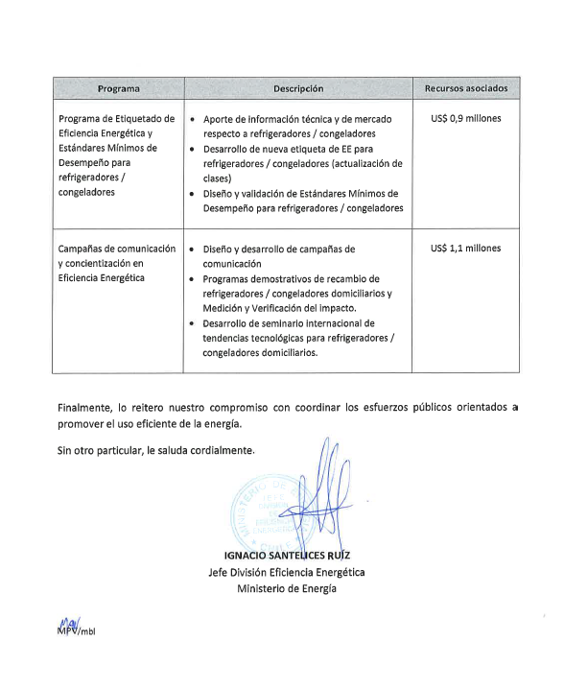

Translation of Ministry of Energy Letter

Santiago, 12 April, 2017
Ms. Brennan Van Dyke,
GEF Executive Coordinator
United Nations Environment Programme
Nairobi 00100, Kenya

Dear Ms. Van Dyke,

In addition to greet you, I write to you to inform you about the participation of the Ministry of Energy in the GEF project “Leapfrogging Chilean´s markets to more efficient refrigerator and freezers - United for Efficiency (U4E) initiative” in Chile.
In 2012, Chile was selected as a pilot country of the international en.lighten initiative, being the Ministry of Energy the coordinator of this project. The en.lighten initiative, promoted by the United Nations Environment Programme (UNEP), had as a first result the approval of the National Efficient Lighting Strategy (ENIE). Currently, the Ministry of Energy is working in a coordinated way with the Superintendence of Electricity and Fuels (SEC), the Ministry of Environment, ChileCompra, Fundación Chile (FCh) and the Chilean Agency for Energy Efficiency (AchEE) to advance in the implementation of the National Efficient Lighting Strategy in Chile through the GEF initiative “Delivering the transition to Energy Efficient Lighting in Chile” in which Fundación Chile acts as the Executing Agency.
Additionally, the Ministry of Energy continues with the execution of the programmes: Labeling of Energy efficiency of Electric Appliances, Minimum Performance Standards, Lamps replacements, Communication campaigns on Energy Efficiency and Monitoring and Verification of all the implemented programmes.
A brief description of the programmes and committed resources are presented below from 2017 with the objective that they could be recognized as local co-financing for the GEF project.

Programme | Description | Associated resources
Programme of Labeling of Energy efficiency and Minimum Performance Standards for refrigerators/freezers | - Technical and market information regarding refrigerators/freezers  - Development of new label of Energy Efficiency for refrigerators/freezers (update of classes)  - Design and validation Minimum Performance Standards for refrigerators/freezers | US$ 0.9 millions
Communication campaigns of awareness raising on Energy Efficiency | - Design and development of communication campaigns  - Demonstration replacement programmes of residential refrigerators/freezers and Monitoring and Verification of the impact  - Development of an International Seminar of technology trends for residential refrigerators/freezers | US$ 1.1 millions

Finally, I reiterate our commitment to coordinate the public efforts towards the promotion of an efficient use of energy.

Yours sincerely,

Ignacio Santelices Ruiz
Head of Energy Efficiency Division
Ministry of Energy

SEC

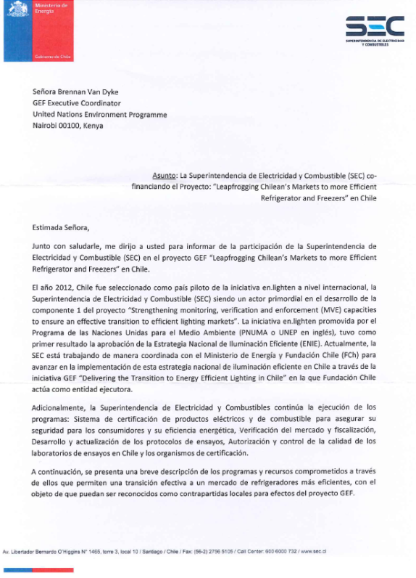
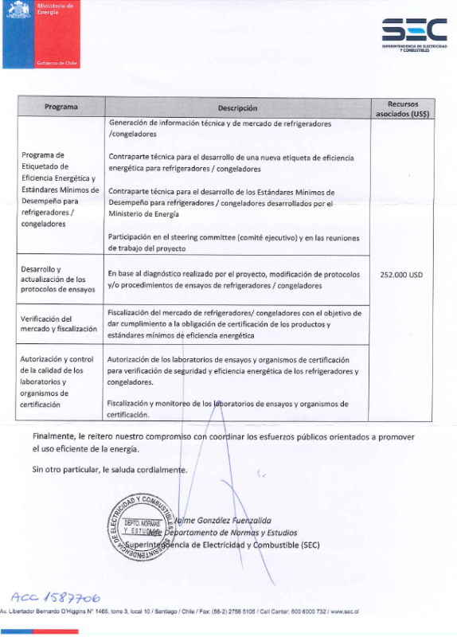
Translation of SEC Letter

Ms. Brennan Van Dyke,
GEF Executive Coordinator
United Nations Environment Programme
Nairobi 00100, Kenya

Subject: the Superintendence of Electricity and Fuels (SEC) co-financing the project: “Leapfrogging Chilean´s markets to more efficient refrigerator and freezers - United for Efficiency (U4E) initiative” in Chile.

Dear Ms. Van Dyke,

In addition to greet you, I write to you to inform you about the participation of the Superintendence of Electricity and Fuels (SEC) in the GEF project “Leapfrogging Chilean´s markets to more efficient refrigerator and freezers - United for Efficiency (U4E) initiative” in Chile.
In 2012, Chile was selected as a pilot country of the international en.lighten initiative, being the Superintendence of Electricity and Fuels (SEC) a key actor of project Component 1 “Strengthening monitoring, verification and enforcement (MVE) capacities to ensure an effective transition to efficient lighting markets”. The en.lighten initiative, promoted by the United Nations Environment Programme (UNEP), had as a first result the approval of the National Efficient Lighting Strategy (ENIE). Currently, SEC is working in a coordinated way with the Ministry of Energy and Fundación Chile (FCh) to advance in the implementation of the National Efficient Lighting Strategy in Chile through the GEF initiative “Delivering the transition to Energy Efficient Lighting in Chile” in which Fundación Chile acts as the Executing Agency.
Additionally, SEC continues with the execution of the programmes: Certification system of appliances and fuels to ensure safety for the consumers and energy efficiency, Market verification and enforcement, Development and update of testing protocols, Authorization and quality control of testing laboratories in Chile and certification organisms.
A brief description of the programmes and committed resources that will allow an effective transition to more efficient refrigerators market with the objective that they could be recognized as local co-financing for the GEF project.

Programme | Description | Associated resources
Labeling of Energy efficiency and Minimum Performance Standards for refrigerators/freezers programme | Development of technical and market information for refrigerators/freezers  Technical counterpart for the development of the new energy efficiency label for refrigerators/freezers  Technical counterpart for the development of Minimum Performance Standards for refrigerators/freezers developed by the Ministry of Energy  Participation in the Steering Committee and working meetings of the project | 252,000 USD
Development and update of testing protocols | Based on the diagnostic realized by the project, modification of protocols and/or testing procedures of refrigerators/freezers | 252,000 USD
Market verification and enforcement | Enforcement of refrigerators/freezers market with the objective of complying with the certification obligation of products and with minimum energy efficiency standards | 252,000 USD
Authorization and quality control of laboratories and certification organisms | Authorization of testing laboratories and certification organisms for verification of safety and energy efficiency of refrigerators and freezers.  Enforcement and monitoring of testing laboratories and certification organisms. | 252,000 USD

Finally, I reiterate our commitment to coordinate the public efforts towards the promotion of an efficient use of energy.
Yours sincerely,

Jaime Gonzalez Fuenzalida
Head of Norms and Studies Division
Superintendence of Electricity and Fuels (SEC)

Ministry of Environment
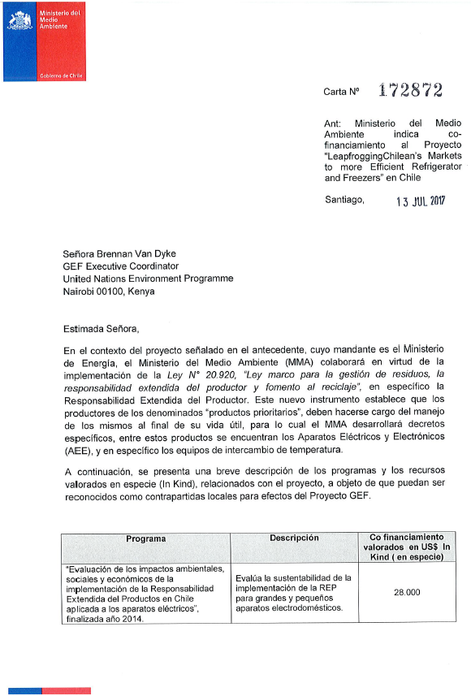
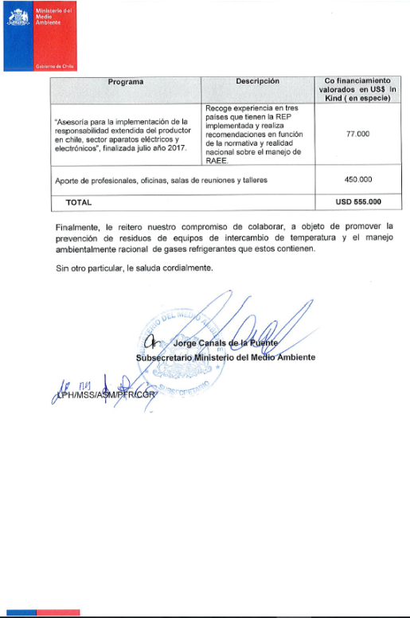

Translation of Ministry of Environment Letter

Ref: Ministry of Environment states co-finance to the project: “Leapfrogging Chilean´s markets to more efficient refrigerator and freezers - United for Efficiency (U4E) initiative” in Chile.
Santiago, 13 April, 2017
Ms. Brennan Van Dyke,
GEF Executive Coordinator
United Nations Environment Programme
Nairobi 00100, Kenya

Dear Ms. Van Dyke,
In the context of the project mentioned above, which mandatory is the Ministry of Energy, the Ministry of Environment (MMA) will collaborate in regards to the implementation of the Law N°20.920, “Legal frame for waste management, producer extended responsibility and recycling promotion”, specifically the Producer Extended Responsibility. This new tool establishes that producers of the denominated “priority products”, must be in charge of their management at the end of the useful lifetime, for which the MMA will develop specific decrees, among these products there are the Electric and Electronic Appliances (AEE), and in specific equipment for temperature exchange.
A brief description of the programmes and committed resources valued as In-kind, related with the project with the objective that they could be recognized as local co-financing for the GEF project.
Programme | Description | US$ In-kind  Co-finance
“Assessment of environmental, social and economic impacts of the implementation of the Extended Responsibility of the Producer in Chile applied for electric appliances”, finalized in 2014 | - It assesses the sustainability of the REP implementation for large and small residential appliances | 28,000
“Support for the implementation of the Extended Responsibility of the Producer in Chile, for the sector of electric and electronic appliances”, finalized in july 2017. | - Design and development of communication campaigns  - Demonstration replacement programmes of residential refrigerators/freezers and Monitoring and Verification of the impact  - Development of an International Seminar of technology trends for residential refrigerators/freezers | 77,000
Support from professionals, offices, rooms for meetings and workshops |  | 450,000
Total |  | USD 555,000

Finally, I reiterate our commitment to contribute, with the objective of promoting the reduction of waste of exchange temperatures equipment and environmentally sound management of refrigerant gases that they contain. Yours sincerely,
Jorge Canales de la Puente
Vice-Minister of Ministry of Environment

Fundación Chile

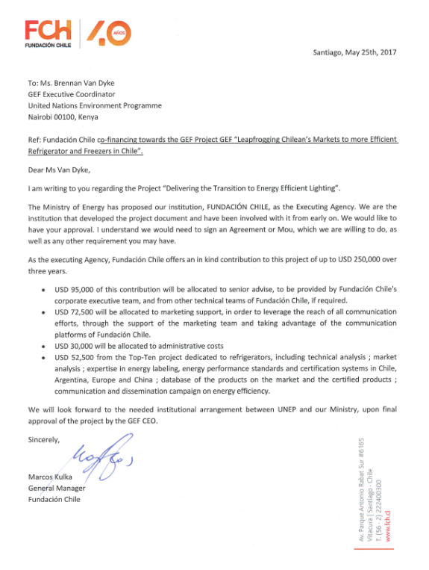

ASHRAE

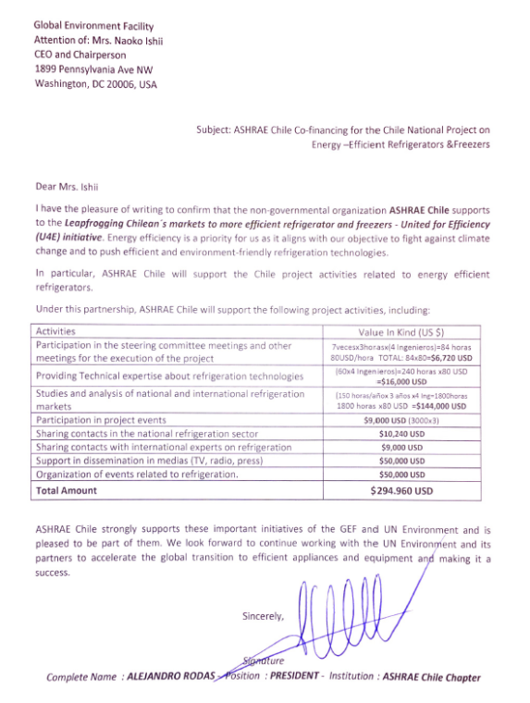

UN Environment
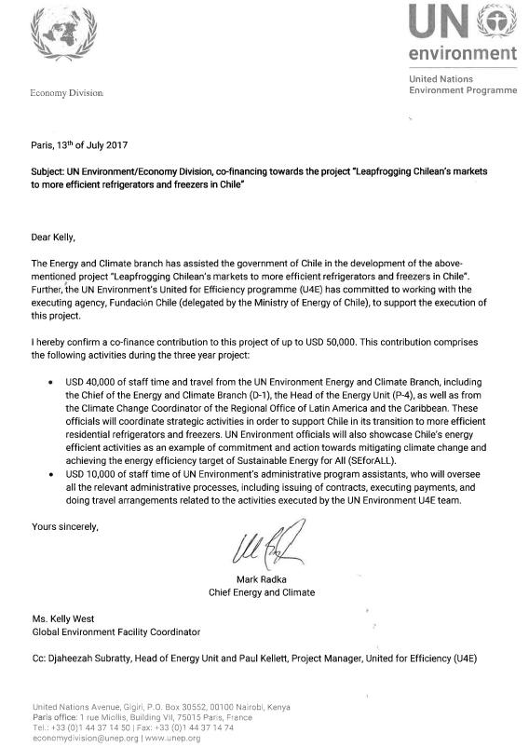
Samsung

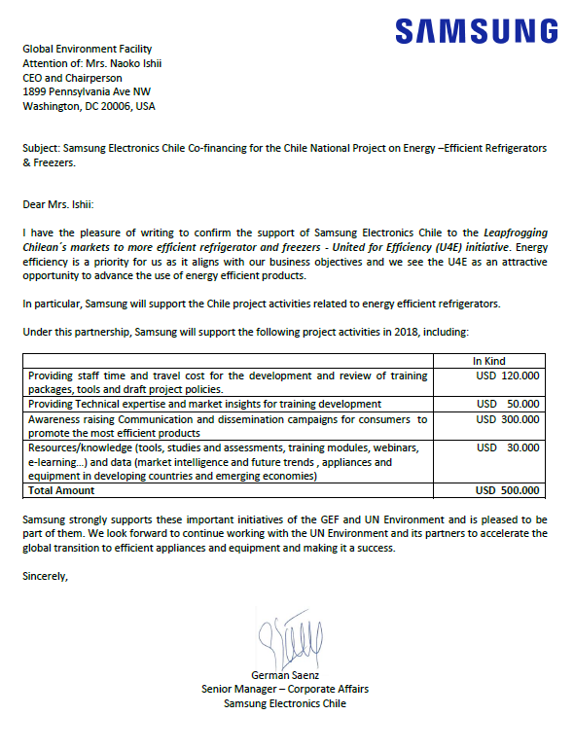

MABE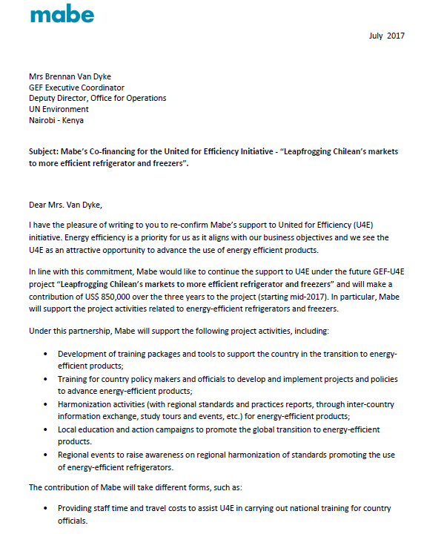 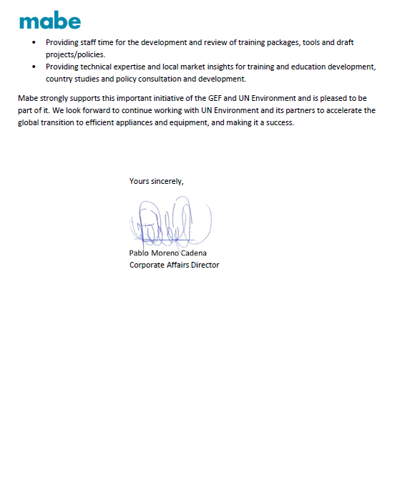

Whirlpool
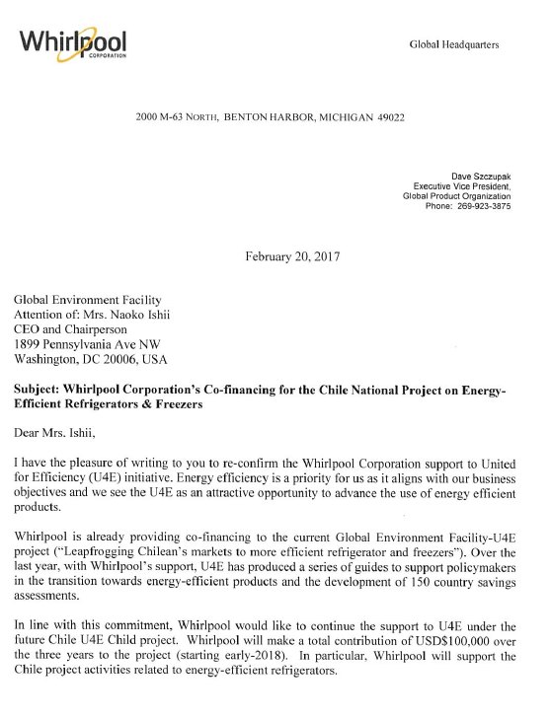
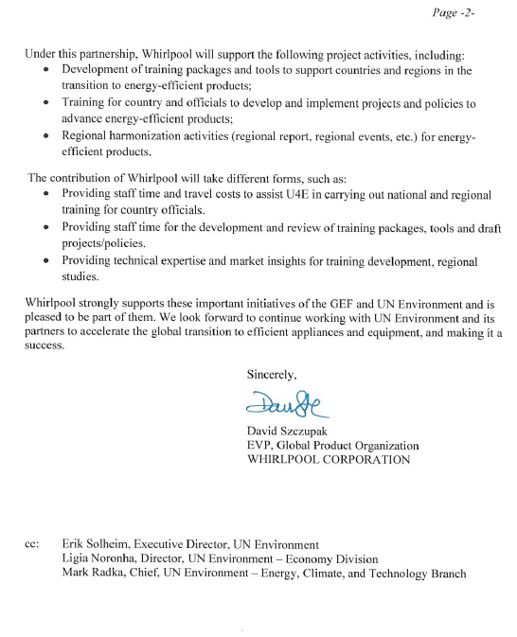
CESMEC

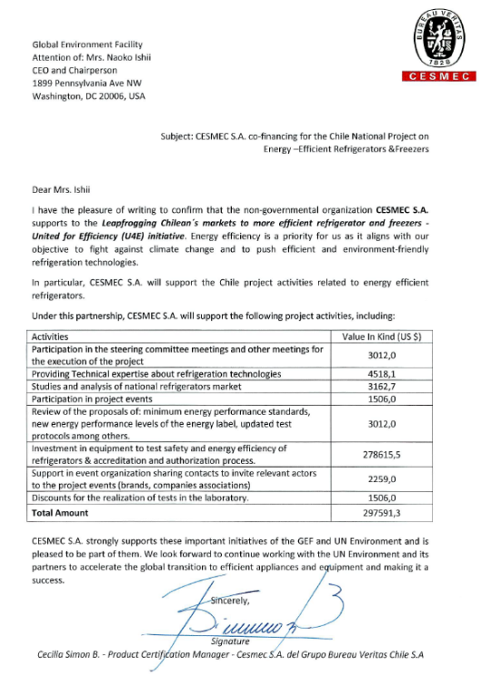

Intertek
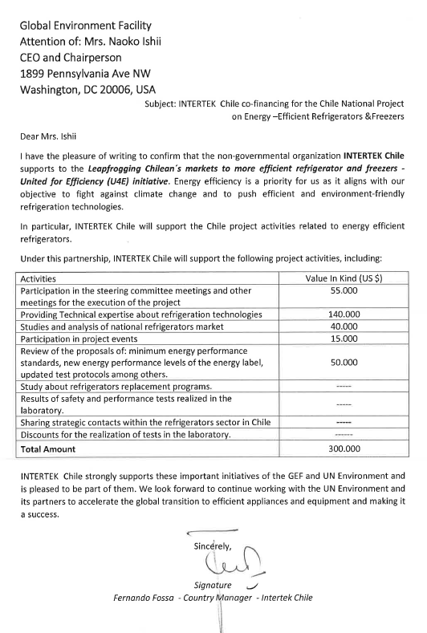

Lenor

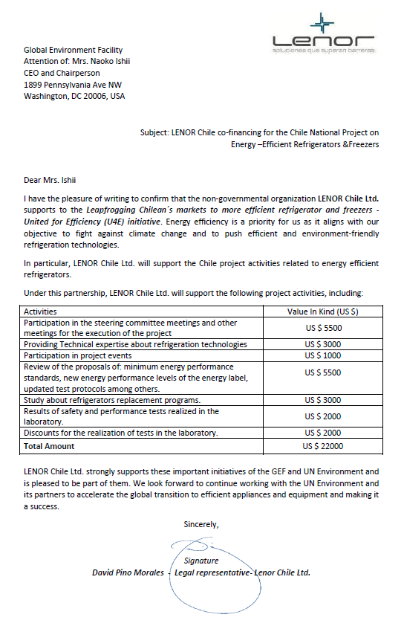
Midas
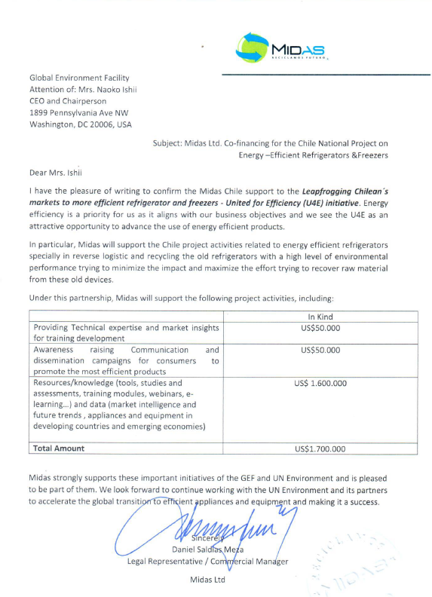

Regener Chile
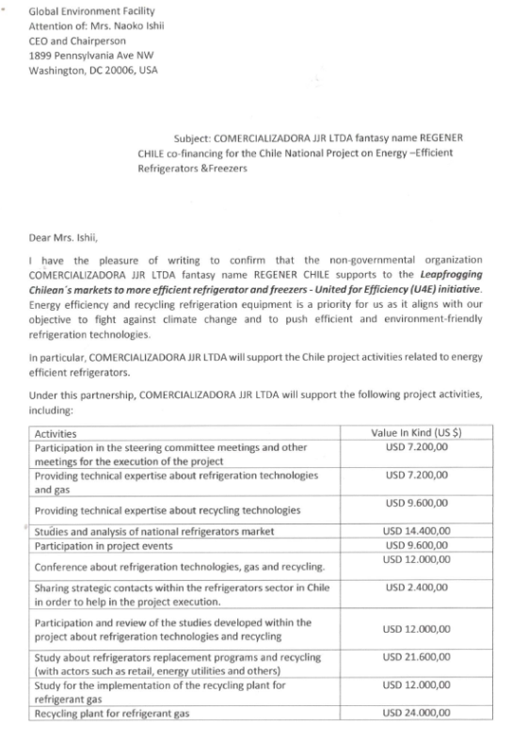
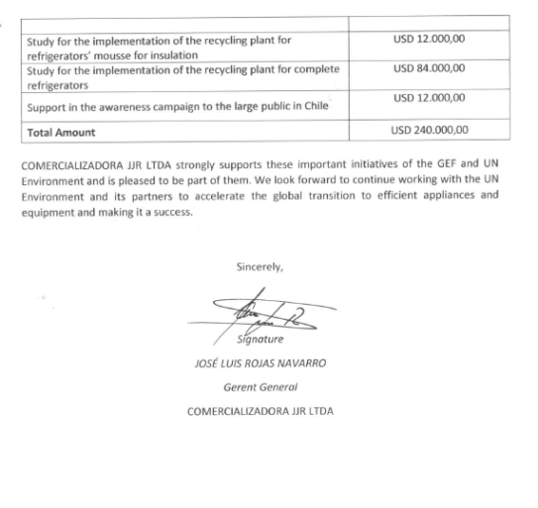
Electrolux
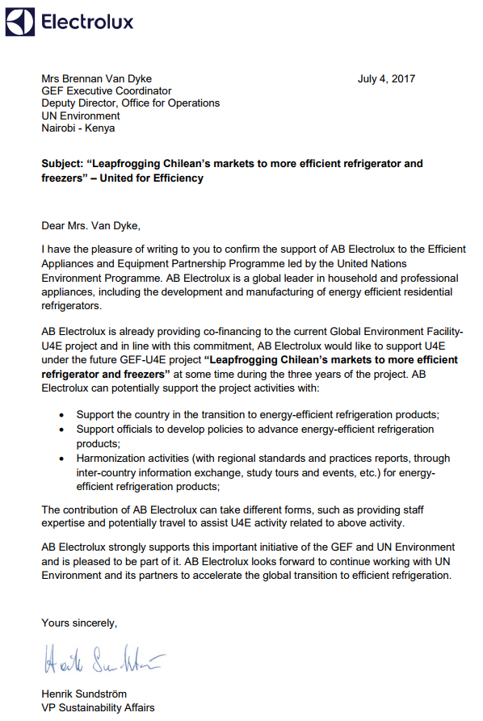

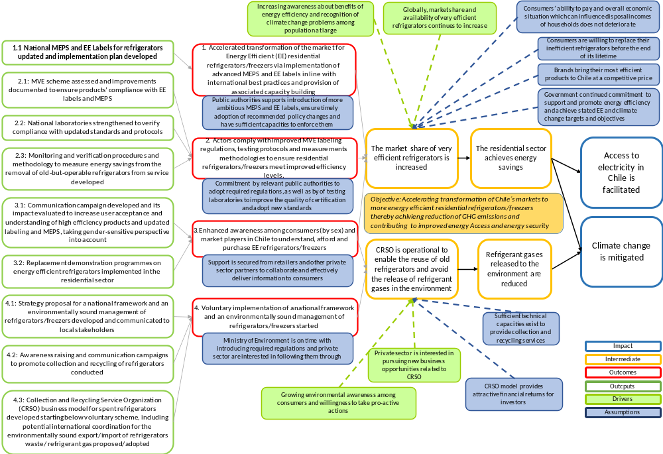
Annex M – Theory of Change

Annex N - Environmental and Social Safeguards Checklist
UN Environment Environmental, Social and Economic Review Note (ESERN)

- Project Overview

Identification | 9496
Project Title | Leapfrogging Chilean’s markets to more efficient refrigerator and freezers
Managing Division | UNEP
Type/Location | Regional
Region | LCR
List Countries | Chile
Project Description | The “Leapfrogging Chilean’s markets to more efficient refrigerator and freezers” project seeks to transform Chile’s markets to energy efficient residential refrigerators/freezers providing benefits of climate change mitigation and increased energy access.  This Child Project is under the "Leapfrogging Markets to High Efficiency Products (Appliances, including Lighting, and Electrical Equipment)” programmatic approach, which will support the expansion of existing efforts to identify and support countries ready to commit to transforming national and regional markets to energy efficient products as a key step to combat climate change.
Estimated duration of project: | 36 months
Estimated cost of the project : | USD 1,473,762 from GEF Grant; USD 7,500,000 from co-finance

II. Environmental Social and Economic Screening Determination

A. Summary of the Safeguard Risks Triggered
Safeguard Standard Triggered by the Project | Impact of Risk (1-5) | Probability of Risk (1-5) | Significance of Risk (L, M, H)
SS 1: Biodiversity, natural habitat and Sustainable Management of Living Resources | 1 | 1 | L
SS 2: Resource Efficiency, Pollution Prevention and Management of Chemicals and Wastes Design can affect the resource efficiency, food waste. Recycling approach can potentially affect the resource efficiency depending on the technology and cost issues. | 1 | 3 | L
SS 3: Safety of Dams | 1 | 1 | L
SS 4: Involuntary resettlement | 1 | 1 | L
SS 5: Indigenous peoples | 1 | 1 | L
SS 6: Labor and working conditions | 1 | 1 | L
SS 7: Cultural Heritage | 1 | 1 | L
SS 8: Gender equity Understanding gender needs and roles are important for household durables. | 2? | 2 | L
SS 9: Economic Sustainability | 1 | 1 | L
Additional Safeguard questions for projects seeking GCF-funding (Section IV)

B. ESE Screening Decision (Refer to the UNEP ESES Framework (Chapter 2) and the UNEP’s ESES Guidelines.)

Low risk Moderate risk High risk Additional information required

C. Development of ESE Review Note and Screening Decision:

Prepared by: Name: Tania Daccarett_____________ Date: 16/02/2017______

Safeguard Advisor: Name: Yunae Yi________________ Date: 24/08/2017______

Project Manager: Name: ______________________ Date: ________

D. Recommended further action from the Safeguard Advisor:
I agree that the project is in the low safeguard risk category. However, I have following comments.
The project stated that the refrigerants like HCFCs will be replaced with HFCs. HFCs have high Global Warming Potential (GWP) and Kigali Amendment of the Montreal Protocol agreed to slowly replace them with other climate friendly chemicals. With replacement of HCFCs with other than HFCs, the GHG emission reduction effect of the project will be greater than what was estimated in the project. This will also help Chile achieve the Kigali Amendment.
Gender information seems to be weak and not directly relevant to this project. It will be nice to see gender dimension within the socio-economic context--how men and women use the refrigerators and if the designs address their different needs adequately. The energy efficiency can be thought through not only from the purchase of energy efficient refrigerators but also from understanding on how the consumers use the refrigerators. For example, bigger and energy efficient refrigerators in many societies encourage large stocking of vegetables, which increases food waste. Such unexpected consequences can happen if we don’t think through the entire consumption pattern. The project can analyse how they use the refrigerators and what kind of food they shop, cook and eat and keep in the refrigerators. What are the types of food waste? Do designs of the refrigerators meet the consumption patterns of the consumer needs?
The project stated that Chile refrigerators are exported to Andes Region. Therefore, the labeling, related policies and consumer analysis can be perhaps, extended to the larger Latin American consumers.
The project stated that consumers were insufficiently aware of the EE labeling. While EE may be one of the critical factors in consumers’ purchase decisions, it is important to understand consumers from their perspectives. What make consumers to select one product over the others? The prices are higher for EE products. Even with the full understanding of energy efficiency, overall quality, brand awareness, durability, design or prices also play key roles in consumer choices. Would there be any financing schemes that the project can explore to attract consumers to buy energy efficient refrigerators at the affordable prices? These aspects should be considered simultaneously.
Replacement of old models may or may not be successful especially for low income and marginalized communities who are usually less informed of the trends and government initiatives and more likely to use refrigerators for long time. Can the project also consider working with refrigerator technicians who can replace the HCFC refrigerant with less GWP for those who can’t afford to replace the old models? This will bring a quick win for reducing carbon emission.
Recycling programme is estimated to generate more jobs. How about the overall costs of recycling? Is it resource efficient? Is there adequate infrastructure and technology for that?
Consumer representatives or NGOs that advocate consumers should be visible in representing in the project.

(Section III and IV should be retained in UNEP)
Precautionary Approach
The project will take precautionary measures even if some cause and effect relationships are not fully established scientifically and there is risk of causing harm to the people or to the environment.
Human Rights Principle
The project will make an effort to include any potentially affected stakeholders, in particular vulnerable and marginalized groups; from the decision making process that may affect them.
The project will respond to any significant concerns or disputes raised during the stakeholder engagement process.
The project will make an effort to avoid inequitable or discriminatory negative impacts on the quality of and access to resources or basic services, on affected populations, particularly people living in poverty or marginalized or excluded individuals or groups.

Screening checklist | Y/N/  Maybe | Comment
Safeguard Standard 1: Biodiversity, natural habitat and Sustainable Management of Living Resources
Will the proposed project support directly or indirectly any activities that significantly convert or degrade biodiversity and habitat including modified habitat, natural habitat and critical natural habitat? | N | The project is an energy efficiency project, which aims to promote the use of energy efficient residential refrigerator and freezers, in urban areas. Therefore, the location of the project is not an issue.
Will the proposed project likely convert or degrade habitats that are legally protected? | N
Will the proposed project likely convert or degrade habitats that are officially proposed for protection? (e.g.; National Park, Nature Conservancy, Indigenous Community Conserved Area, (ICCA); etc.) | N
Will the proposed project likely convert or degrade habitats that are identified by authoritative sources for their high conservation and biodiversity value? | N
Will the proposed project likely convert or degrade habitats that are recognized- including by authoritative sources and /or the national and local government entity, as protected and conserved by traditional local communities? | N
Will the proposed project approach possibly not be legally permitted or inconsistent with any officially recognized management plans for the area? | N
Will the proposed project activities result in soils deterioration and land degradation?
Will the proposed project interventions cause any changes to the quality or quantity of water in rivers, ponds, lakes or other wetlands? | N
Will the proposed project possibly introduce or utilize any invasive alien species of flora and fauna, whether accidental or intentional? | N
Safeguard Standard 2: Resource Efficiency, Pollution Prevention and Management of Chemicals and Wastes
Will the proposed project likely result in the significant release of pollutants to air, water or soil? | N | The Project will accelerate market transformation for energy efficient refrigerators. Refrigerators and freezers contain refrigerant gases and may cause contamination when they are disposed at the end of their operational lifetime unless appropriate mitigation measures are taken. The Project is expected to minimize any contamination since project activities to recycle and safely dispose discarded refrigerators will be carried out in component 4. The impacts are not considered significant.
Will the proposed project likely consume or cause significant consumption of water, energy or other resources through its own footprint or through the boundary of influence of the activity? | N
Will the proposed project likely cause significant generation of Green House Gas (GHG) emissions during and/or after the project? | N | On the contrary, the project aims to contribute to enhanced ambitions in reducing GHG emissions from the countries.
Will the proposed project likely generate wastes, including hazardous waste that cannot be reused, recycled or disposed in an environmentally sound and safe manner? | N | The environmental impact assessment has identified the presence of refrigerant gases in refrigerators and freezers as the main potential environmental threat. During the lifetime usage of refrigerator, the refrigerant gas remains inside the equipment. However, when at the end of their operational lifetime refrigerators are discarded, the gas may be released if persons without technical knowledge disassemble the refrigerator. The project requires the establishment of and operation of a good recycling and disposal system to effectively avoid the release of refrigerant gas to the environment. Such a system is being developed and the Project Component 4 support policy makers with regard to framing regulations and guidelines on recycling and safe disposal of the used refrigerators and freezers.
Will the proposed project use, cause the use of, or manage the use of, storage and disposal of hazardous chemicals, including pesticides? | N
Will the proposed project involve the manufacturing, trade, release and/or use of hazardous materials subject to international action bans or phase-outs, such as DDT, PCBs and other chemicals listed in international conventions such as the Stockholm Convention on Persistent Organic Pollutants or the Montreal Protocol? | N
Will the proposed project require the procurement of chemical pesticides that is not a component of integrated pest management (IPM) or integrated vector management (IVM) approaches? | N
Will the proposed project require inclusion of chemical pesticides that are included in IPM or IVM but high in human toxicity? | N
Will the proposed project have difficulty in abiding to FAO’s International Code of Conduct in terms of handling, storage, application and disposal of pesticides? | N
Will the proposed project potentially expose the public to hazardous materials and substances and pose potentially serious risk to human health and the environment? | N | The refrigerant gas is a pollutant dangerous for the environment but without risks to human health. The design, implement and monitoring and evaluating communication campaigns for collecting and recycling old refrigerators will be implemented during the project. These campaigns seek to raise consumer awareness about the correct disposal of refrigerators at the end of their useful life.
Safeguard Standard 3: Safety of Dams
Will the proposed project involve constructing a new dam(s)? | N
Will the proposed project involve rehabilitating an existing dam(s)? | N
Will the proposed project activities involve dam safety operations? | N
Safeguard Standard 4: Involuntary resettlement
Will the proposed project likely involve full or partial physical displacement or relocation of people? | N
Will the proposed project involve involuntary restrictions on land use that deny a community the use of resources to which they have traditional or recognizable use rights? | N
Will the proposed project likely cause restrictions on access to land or use of resources that are sources of livelihood? | N
Will the proposed project likely cause or involve temporary/permanent loss of land? | N
Will the proposed project likely cause or involve economic displacements affecting their crops, businesses, income generation sources and assets? | N
Will the proposed project likely cause or involve forced eviction? | N
Will the proposed project likely affect land tenure arrangements, including communal and/or customary/traditional land tenure patterns negatively? | N
Safeguard Standard 5: Indigenous peoples
Will indigenous peoples be present in the proposed project area or area of influence? | N
Will the proposed project be located on lands and territories claimed by indigenous peoples? | N
Will the proposed project likely affect livelihoods of indigenous peoples negatively through affecting the rights, lands and territories claimed by them? | N
Will the proposed project involve the utilization and/or commercial development of natural resources on lands and territories claimed by indigenous peoples? | N
Will the project negatively affect the development priorities of indigenous peoples defined by them? | N
Will the project potentially affect the traditional livelihoods, physical and cultural survival of indigenous peoples? | N
Will the project potentially affect the Cultural Heritage of indigenous peoples, including through the commercialization or use of their traditional knowledge and practices? | N
Safeguard Standard 6: Labor and working conditions
Will the proposed project involve the use of forced labor and child labor? | N
Will the proposed project cause the increase of local or regional un-employment? | N
Safeguard Standard 7: Cultural Heritage
Will the proposed project potentially have negative impact on objects with historical, cultural, artistic, traditional or religious values and archeological sites that are internationally recognized or legally protected? | N
Will the proposed project rely on or profit from tangible cultural heritage (e.g., tourism)? | N
Will the proposed project involve land clearing or excavation with the possibility of encountering previously undetected tangible cultural heritage? | N
Will the proposed project involve in land clearing or excavation? | N
Safeguard Standard 8: Gender equity
Will the proposed project likely have inequitable negative impacts on gender equality and/or the situation of women and girls? | N
Will the proposed project potentially discriminate against women or other groups based on gender, especially regarding participation in the design and implementation or access to opportunities and benefits? | N | The project considers the implementation of gender sensitive dissemination and communication campaigns (including specific guide about EE labelling and MEPS) and impact evaluation indicators
Will the proposed project have impacts that could negatively affect women’s and men’s ability to use, develop and protect natural resources, taking into account different roles and positions of women and men in accessing environmental goods and services? | N
Safeguard Standard 9: Economic Sustainability
Will the proposed project likely bring immediate or short-term net gain to the local communities or countries at the risk of generating long-term economic burden (e.g., agriculture for food vs. biofuel; mangrove vs. commercial shrimp farm in terms of fishing, forest products and protection, etc.)? | N
Will the proposed project likely bring unequal economic benefits to a limited subset of the target group? | N

Annex O – Policy Assessment

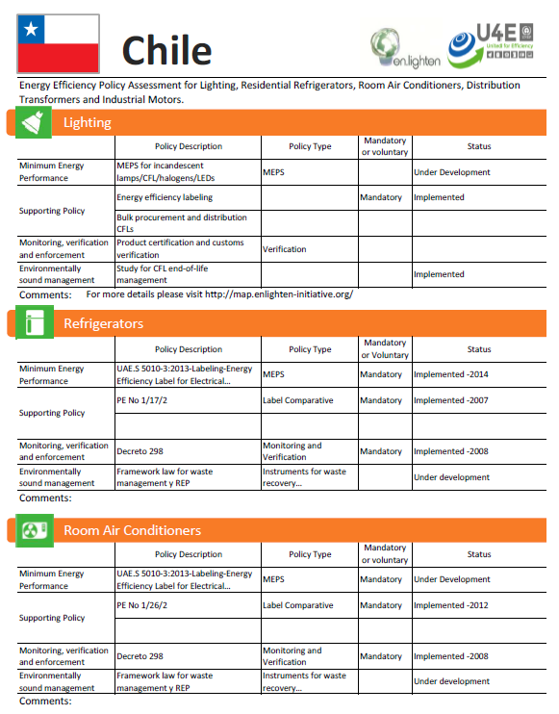
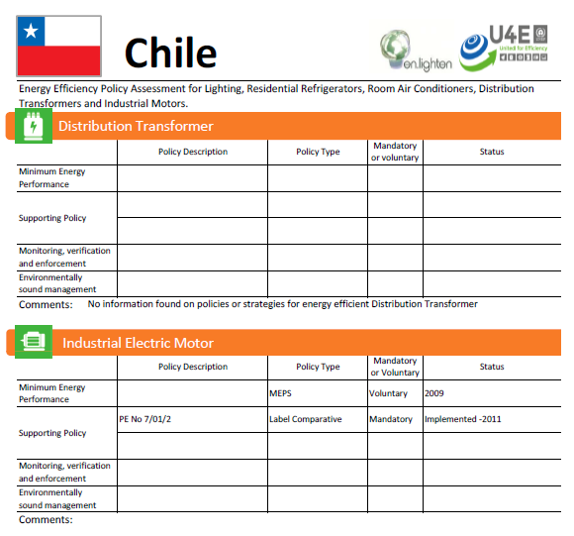

Annex P –Savings Assessment
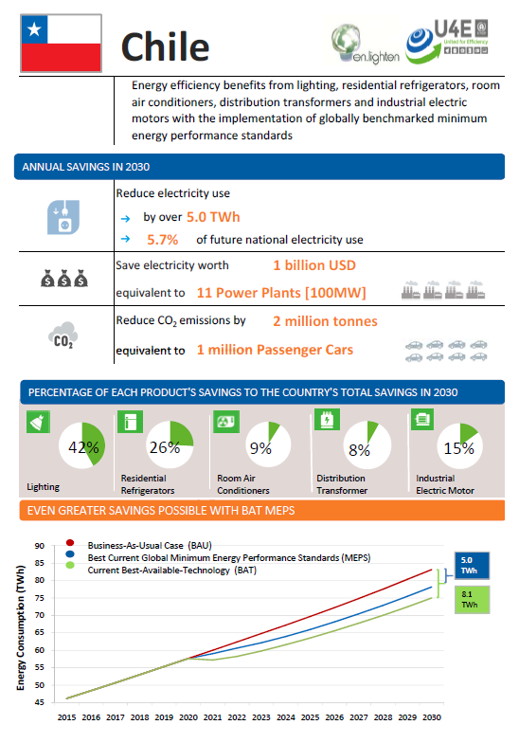
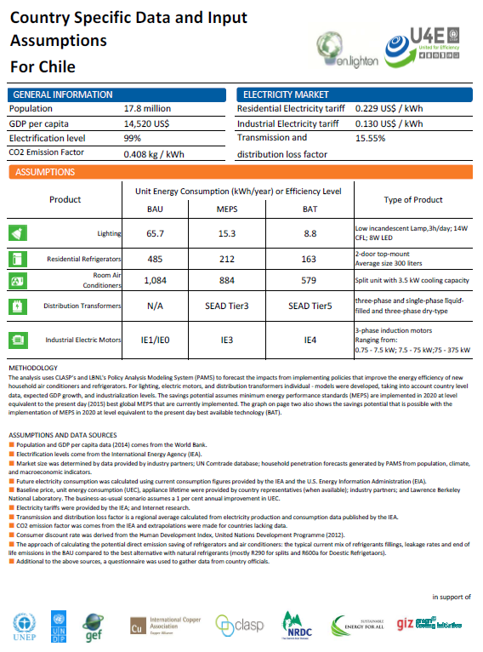

Annex Q - program level results framework

Since this is a child project under a programmatic approach, the “Global Project to leapfrog markets to energy efficient lighting, appliances and equipment” (GEF ID: 9337) has defined the following indicators to be used at the program level to track progress to a market transformation. To do this the project will the global project will track the status of policies at baseline (using the U4E Country Assessments), at mid-term and at project finalization.

This project has stated the following Mid-Term and Final project targets based on the current situation and the level of ambition of this project.

Monitoring Framework for National Child Projects under the Global Leapfrogging Program
Country | U4E Integrated Policy Approach | Baseline | Mid-term of project | Final of project
Chile (refrigerators) | Regulations and standards | - Mandatory MEPS since 2014 | Draft of the new MEPS delivered to the policy makers | New MEPS approved and ready to be enacted.
Chile (refrigerators) | Supporting Policies | - Mandatory comparative label since 2007.  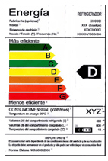 | Draft of the new energy label delivered to the policy makers | New energy label approved and ready to be enacted.
Chile (refrigerators) | Finance | - None | Pilot financing program designed with the relevant stakeholders of the market. | Pilot financing program implemented and evaluated to be considered for scaling up.
Chile (refrigerators) | MVE | - Framework in place to complete MVE activities | Relevant activities identified with the public and private stakeholders and work plan defined. | Work plan of MVE activities implemented and compliance rate improved.
Chile (refrigerators) | Environmental sustainability | - Proposal submitted to parliament (2013) to Instruments for enhanced waste recovery and better environmental management (Extended Producer Responsibility to be further implemented) | Extended Producer Responsibility law enacted in 2016.  Draft of the specific decree for electrical appliances presented to the Ministry of Environment.  Main private stakeholders identified and contacted to be part of the project. | CRSO model plan designed with the main private stakeholders (refrigerators manufacturers and recycling companies)

Annex R - Acronyms and abreviations

AChEE Chilean Energy Efficiency Agency
AWP Annual Work Plan
CC Climate Change
CA U4E Country Assessment
CCM Climate Change Mitigation Results Framework (GEF)
CFL Compact Fluorescent Lamp
CLASP Collaborative Labeling and Appliance Standards Program
CONAMA National Environment Commission
CRSO Collection Recycling System Organization
EE Energy Efficiency
EEI Energy Efficiency Index
ENIE Estrategia Nacional de Iluminación Eficiente (National Efficient Lighting Strategy)
EO The Evaluation Office of UN Environment
EU European Union
FCH Fundación Chile
GDP Gross Domestic Product
GEF Global Environment Facility
GEFTF Global Environment Facility Trust Fund
GW Gigawatt
GWP Global Warming Potential
GWh Gigawatt-hour
hr Hour
ICA International Cupper Association
IDMA Environment Institute
INDC Intended Nationally Determined Contributions
ktCO2 kiloton of carbon dioxide
kWh kilowatt-hour
LA Latin America
LCR Latin America and Caribbean Region
M&E Monitoring and Evaluation
MEPS Minimum Energy Performance Standards
MMA Ministry of Environment Chile
MoE Ministry of Energy Chile
MTS UN Environment Medium-Term Strategy
MVE Monitoring, Verification and Enforcement
MW Megawatt
NAMA Nationally Appropriate Mitigation Action
NCRE Non-Conventional Renewable Energy
NGO Non-Governmental Organization
NRDC Natural Resources Defense Council
ODECU Consumers and Users Organization of Chile
OFP GEF Operational Focal Point
PAMS Policy Analysis Modelling System
PFD Program Framework Document
PIF Project Identification Form
PIR Project Implementation Review
PM Project Manager
PMC Project Management Cost
PMU Project Management Unit
PPEE Energy Efficiency National Program (2005 – 2010)
PPG Project Preparation Grant
PSC Project Steering Committee
PTR Project Terminal Report
S&L Standards and Labeling
SEA Aysen Region System
SE4ALL Secretary General’s Sustainable Energy for All
SEC Superintendencia de Electricidad y Combustibles Chile (Superintendence of Electricity and Fuels)
SEM Magellan Region System
SIC Central Interconnected System
SING Great North Interconnected System
SERNAC Servicio Nacional del Consumidor (Consumer National Agency)
tCO2 ton of Carbon Dioxide (-equivalent)
TA Technical Assistance
TC Technical Committee
TE Terminal Evaluation
TWG Technical Working Group
TWh Terawatt-hour
UNDAF United Nations Development Action Framework
UNDP United Nations Development Programme
UNEA First UN Environment Assembly
UNEP United Nations Environment Programme
UNFCCC United Nations Framework Convention on Climate Change
USD US Dollar
WWF World Wildlife Fund
yr year

Annex S - Table of Content

PART I: PROJECT INFORMATION 1
A. Focal Area Strategy Framework and Other Program Strategies 1
B. Project Description Summary 1
C. Confirmed Sources of Co-financing for the Project by Name and by Type 3
D. Trust Fund Resources Requested by Agency(ies), Country(ies), Focal Area and the Programming of Funds 4
E. Project’s Target Contributions to Global Environmental Benefits 5
F. Does the Project include a “Non-grant” Instrument? 5
PART II: PROJECT JUSTIFICATION 5
A.0. Describe any changes in alignment with the project design with the original PIF 5
A.1. Project Description. 8
A.2. Child project 29
A.3. Stakeholders 30
A.4. Gender equality and an women’s empowerment 35
A.5. Risk 36
A.6. Institutional arrangement and coordination 38
A.7.Benefits 39
A.8. Knowledge 40
B. Description of the Consistency of the Project with: 41
C. Describe the budgeted M&E Plan: 42
PART III: CERTIFICATION BY GEF PARTNER AGENCY(IES) 44
Annex A: Project results framework 45
Annex B: Responses to project reviews (from GEF Secretariat and GEF Agencies, and Responses to Comments from Council at work program inclusion and the Convention Secretariat and STAP at PIF). 51
Annex C: Status of implementation of project preparation activities and the use of funds 69
Annex D: CALENDAR OF EXPECTED REFLOWS 70
Annex E: TERMS OF REFERENCE OF PERSONNEL CONSULTANTS TO BE HIRED FOR THE PROJECT USING GEF / LDCF / SCCF RESOURCES 71
Annex F1: Detailed GEF budget 88
Annex F2: Cofinance budget 90
Annex G: M&E budget and work plan 92
Annex H: Project implementation arrangements 94
Annex I: Work plan with deliverables and benchmarks 101
Annex J-2: Estimates of Direct and Indirect greenhouse gas emission reduction 103
Annex K: OFP EndoRsement Letter 105
Annex L: Co-Financing Commitment Letters 106
Annex M – Theory of Change 134
Annex N - Environmental and Social Safeguards Checklist 135
Annex O – Policy Assessment 147
Annex P –Savings Assessment 149
Annex Q - program level results framework 151
Annex R - Acronyms and abreviations 153
Annex S - Table of Content 156

Project ID number remains the same as the assigned PIF number.
When completing Table A, refer to the excerpts on GEF 6 Results Frameworks for GETF, LDCF and SCCF and CBIT programming directions.
Financing type can be either investment or technical assistance
For GEF Project Financing up to $2 million, PMC could be up to10% of the subtotal; above $2 million, PMC could be up to 5% of the subtotal. PMC should be charged proportionately to focal areas based on focal area project financing amount in Table D below.
Update the applicable indicators provided at PIF stage. Progress in programming against these targets for the projects per the Corporate Results Framework in the GEF-6 Programming Directions, will be aggregated and reported during mid-term and at the conclusion of the replenishment period.
Capacidad Instalada de generación CNE Enero 2017
www.energiabierta.cl
http://www.energia.gob.cl/tema-de-interes/historica-licitacion-de-suministro
http://www.gob.cl/nueva-ley-transmision-electrica-mas-competencia-menores-precios-mayor-acceso-energias-limpias/
http://www.energia2050.cl/documentos
UN Environment U4E country assessment
Evaluación de los impactos ambientales, sociales y económicos de la implementación de la responsabilidad extendida del productor en Chile aplicada a los aparatos eléctricos http://portal.mma.gob.cl/wp-content/uploads/2015/07/Impactos-aparatos-electricos-2014.pdf
Exchange rate 665 Ch$/USD June 6th, 2017 www.bcentral.cl
Minimum salary Ch$ 264,000 (USD 397) by month http://www.dt.gob.cl/consultas/1613/w3-printer-60141.html
Chapter 12 Depletion of the ozone layer Available at http://www.mma.gob.cl/1304/articles-52016_Chapter12.pdf
http://ccacoalition.org/ru/node/1874
https://www.cne.cl/wp-content/uploads/2016/11/Res.-Ext.-N°-23-Plan-Normativo-2017.pdf
https://www.leychile.cl/Navegar?idNorma=1090894
Informe Técnico Final Estándar Mínimo de Eficiencia Energética Refrigeradores de Uso Doméstico. Dic 2014
http://www.energia.gob.cl/tema-de-interes/mujer-y-energia-0
http://www.acee.cl/
http://www.minenergia.cl/usabienlaenergia/
http://calificacionenergetica.minvu.cl/
http://www.minenergia.cl/etiquetate
www.top-ten.cl
Segundo Informe Bienal de Actualización de Chile sobre Cambio Climático Ante la Convención Marco de las Naciones Unidas sobre Cambio Climático 2016. ISBN: 978-956-7204-55-7
http://united4efficiency.org/wp-content/uploads/2015/11/U4E-Savings-Assessment_CHL.pdf
EE opportunities in lighting sector are being addressed by the project “Delivering the transition to energy efficient lighting in Chile” (GEF Project ID: 5150 under execution 2016-2019)
http://united4efficiency.org/wp-content/uploads/2015/11/U4E-Savings-Assessment_CHL.pdf
http://eur-lex.europa.eu/legal-content/EN/TXT/?uri=CELEX:32010R1060
Based on regulation NCh 3000
http://www.sec.cl/pls/portal/docs/PAGE/SECNORMATIVA/PRODUCTOS/RESOLUCIONES/RE_2118-2010.PDF
www.inn.cl
The not well understand issue of a refrigerator Class A and different consumption index as a function of volumes and functions seen in the Report Qualitative Study Energy Efficiency Labeling of Refrigerators and Light bulbs Perception of its use, assessment and compression of Information by sales agents and consumers.2010
Evaluación de los impactos ambientales y sociales de la implementación de la Responsabilidad Extendida del productor en Chile aplicada a los aparatos eléctricos. Amphos para el Ministerio de Medio ambiente. 2015.
http://www.nrel.gov/docs/fy13osti/53827.pdf. Chapter 7: Refrigerator Recycling Evaluation Protocol The Uniform Methods Project: Methods for Determining Energy Efficiency Savings for Specific Measures NREL 2013
Secondary refrigerators are units not located in the kitchen
http://evo-world.org/en/products-services-mainmenu-en/certification-mainmenu-en
Plan de Gestión para la Eliminación de los HCFC en Chile 2016 - 2021
Evaluación de los impactos ambientales, sociales y económicos de la implementación de la responsabilidad extendida del productor en Chile aplicada a los aparatos eléctricos. Ministerio de Medio Ambiente 2015
Meyers, S, J. McMahon, and M. McNeil. 2004. Realized and Prospective Impacts of U.S. Energy Efficiency Standards for Residential Appliances: 2004 Update. Berkeley, CA, Lawrence Berkeley National Laboratory, LBNL-56417
IEA (International Energy Agency). 2003. Cool Appliances: Policy Strategies for Energy-Efficient Homes, OECD/IEA, Paris, France.
http://www.ministeriodesarrollosocial.gob.cl/noticias/2015/04/11/ministras-de-desarrollo-social-y-sernam-dan-a-conocer-resultados-de-casen-2013-genero-y-resaltan-politica-publica-en-la-materia
http://www.energia.gob.cl/sites/default/files/agenda_energia_y_genero_0803.pdf
http://atacamanoticias.cl/2017/03/06/cerca-de-5-mil-familias-seran-capacitadas-en-eficiencia-energetica-durante-2017-en-atacama/
http://www.minenergia.cl/archivos_bajar/Documentos/Agenda_Energetica/Agenda_de_Energia-Documento_Completo_Ingles.pdf
Project Number 83919
http://dataset.cne.cl/Energia_Abierta/Estudios/Minerg/24.Estrategia%20E3%20-20Informe%20Final%20Definitivo%20(1091).pdf
http://www.minrel.gob.cl/cgi-bin/prontus_imprimir.cgi?_URL=http%3A//www.minrel.gob.cl/minrel/site/artic/20140926/pags/20140926104553.html
GEF policies encompass all managed trust funds, namely: GEFTF, LDCF, SCCF and CBIT
Interlaboratory evaluation carried out in 2012 by SEC in which it is shown that frequent errors in the determination of fridge volumes and EE index are made.
If at CEO Endorsement, the PPG activities have not been completed and there is a balance of unspent fund, Agencies can continue to undertake the activities up to one year of project start. No later than one year from start of project implementation, Agencies should report this table to the GEF Secretariat on the completion of PPG activities and the amount spent for the activities. Agencies should also report closing of PPG to Trustee in its Quarterly Report.
The remaining funds are committed and will be used in project preparation activities within the first year
Refer to UNEP Environment, Social and Economic Sustainability (ESES): Implementation Guidance Note to assign values to the Impact of Risk and the Probability of Risk to determine the overall significance of Risk (Low, Moderate or High).
Low risk: Negative impacts negligible: no further study or impact management required. Moderate risk: Potential negative impacts, but less significant; few if any impacts irreversible; impact amenable to management using standard mitigation measures; limited environmental or social analysis may be required to develop a ESEMP. Straightforward application of good practice may be sufficient without additional study. High risk: Potential for significant negative impacts, possibly irreversible, ESEA including a full impact assessment may be required, followed by an effective safeguard management plan.
Prohibited grounds of discrimination include race, ethnicity, gender, age, language, disability, sexual orientation, religion, political or other opinion, national or social or geographical origin, property, birth or other status including as an indigenous person or as a member of a minority. References to “women and men” or similar is understood to include women and men, boys and girls, and other groups discriminated against based on their gender identities, such as transgender people and transsexuals.
“Integrated Pest Management (IPM) means the careful consideration of all available pest control techniques and subsequent integration of appropriate measures that discourage the development of pest populations and keep pesticides and other interventions to levels that are economically justified and reduce or minimize risks to human health and the environment. IPM emphasizes the growth of a healthy crop with the least possible disruption to agro-ecosystems and encourages natural pest control mechanisms http://www.fao.org/agriculture/crops/thematic-sitemap/theme/pests/ipm/en/
"IVM is a rational decision-making process for the optimal use of resources for vector control. The approach seeks to improve the efficacy, cost-effectiveness, ecological soundness and sustainability of disease-vector control. The ultimate goal is to prevent the transmission of vector-borne diseases such as malaria, dengue, Japanese encephalitis, leishmaniasis, schistosomiasis and Chagas disease." (http://www.who.int/neglected_diseases/vector_ecology/ivm_concept/en/)
Find more information from http://www.fao.org/fileadmin/templates/agphome/documents/Pests_Pesticides/Code/CODE_2014Sep_ENG.pdf
Refer to the Toolkit for the application of the UNEP Indigenous Peoples Policy Guidance for further information.

